A Web-Based FSKTM FYP Management System
Sarvine Arumugam¹, Suhaimi Abd Ishak^{1*}
Faculty of Computer Science and Information Technology,
Universiti Tun Hussein Onn Malaysia, Parit Raja, Batu Pahat, 86400, MALAYSIA

*Corresponding Author: suhaimiabd@uthm.edu.my
DOI: https://doi.org/10.30880/aitcs.2025.06.02.019
Article Info | Abstract
Received: 12 June 2025  Accepted: 3 November 2025  Available online: 30 November 2025 | The FSKTM FYP Management System (FFMS) is a web-based platform designed to streamline FSKTM final year project management for final year students. The system desires to resolve issues such as time-consuming manual task tracking, inefficient communication and delays in project administering. It offers features such as real-time progress tracking, automated deadline reminders, role-based access for students, supervisors and project coordinators and productive reporting mechanisms. The objective is to improve operational efficiency, enhance interactivity, and ensure timely project completion while addressing current project management challenges. The project advantages advanced technology to optimize processes, using a systematic approach with detailed user acceptance testing to ensure a reliable, error-free system. FFMS is developed to be scalable and customizable to meet the needs of various academic institutions, promoting better organization and performance. The system is expected to transform the management of final year projects, effecting data management more accessible, comprehensive and accurate.
Keywords
FSKTM FYP management , web-based system, waterfall methodology, automated notification, system development phases.
- Introduction
The web-based FSKTM FYP Management System is designed to streamline the submission and record management of final year projects. It allows students to submit topics, proposals, and reports, while enabling supervisors to provide feedback through detailed text. The system prevents duplication of project topics, ensuring a unique focus for each student’s task. With a web-based interface, it offers an organized, efficient way for students and supervisors to manage projects. The system also benefits administrators by providing consistent management of project records. Students can register project details remotely, with the system generating comprehensive reports that include session and year data for timely publication. Built using HTML, CSS, PHP, JavaScript and MySQL, the system ensures security, efficiency, and accessibility. It provides a user-friendly platform for students and administrators, allowing them to manage final year projects effectively, check progress, and generate reports. The system is an essential tool for FSKTM FYP management.
  - Problem Statement
The web-based FSKTM FYP Management System faces several challenges that can affect its efficiency and effectiveness for both students and faculty. One significant concern is the high cost for students, who often need to photocopy multiple documents for submissions, revisions, and meetings. These expenses can accumulate, particularly for students who already face financial difficulties. In addition, time and transportation costs add to the burden, as in-person meetings are required for submission and feedback. By implementing an automated system that enables online communication and document sharing, these costs could be minimized, providing a more accessible and efficient solution for students. Another challenge is the inefficient use of time by both students and supervisors, as they are required to meet physically for consultations and reviews. This process takes away from valuable time that could be used for project work, research, or other academic activities. Supervisors, who manage multiple students, often struggle with scheduling conflicts, which can delay project progress. With online submissions and communication, the system would help save time, allowing students and supervisors to focus on more productive tasks. Finally, topic duplication remains a critical issue, with students sometimes submitting similar or identical project topics, reducing the diversity and quality of academic research. The system addresses this problem by providing a centralized database of approved topics, allowing supervisors to check for topic duplication before final approval. This ensures that each student works on a unique and innovative project, enhancing the academic value of the projects and supporting the overall goals of the institution.
  - Objective
The objectives of this system are as follows:
- To design a web-based FSKTM FYP management system according to user and stakeholder requirements.
- To develop web-based FSKTM FYP management system according to user requirements by using PHP
technology and MySQL as backend.
- To test the web-based FSKTM FYP management system.
  - Project Scope
The web-based FSKTM FYP Management System is an extensive web-based system designed to streamline student project management. It supports three user roles: students, supervisors, and project coordinators. The system includes key modules, such as user management for secure account registration, project topic management to prevent topic duplication, schedule management to coordinate supervisor meetings, document management for centralized file storage, and evaluation management to facilitate supervisor feedback as tabulated in Table 1. Each module enhances project coordination and improves overall efficiency.
Table 1 Modules system of A Web-Based FSKTM FYP Management System
Modules | Description
User Management | Users can enter the system by entering username and password
Project Topic Management | Submit, approve project topics to prevent duplication
Schedule Management | Check available supervisor, manage meeting times
Document Management | Store project related documents
Evaluation Management | Facilitate feedback
Send Notifications | Receive alerts/notifications for pending works
Generate Report | View reports
- Related Work
This section explains the current understanding of a computerized system and compares it with the proposed through a literature review. Before the third year of study, final year students must standby prepare one to three ideas to be proposed to a supervisor. Students should propose the idea and make an appointment with the potential supervisor to discuss the project topic in detail. Communication among students and supervisors is conducted via WhatsApp or Email and some might also have face-to-face discussion sessions at suitable places. Students must check the lecturer’s availability before making an appointment to ensure there are no timetable clashes. After the first meeting, the lecturer may suggest changes or decide on title acceptance. If the lecturer has reached the student limit, students are required to find another available supervisor.
  - UTAR Education Portal
The literature emphasizes the key features of the UTAR Education Portal, including its structured navigation, final year project management section, project submission guidelines, and supervisor contact details. These features significantly enhance the management of final year projects, streamlining the process and improving communication between students, supervisors, and project coordinators. By integrating these resources into a single platform, the UTAR Portal facilitates efficient project management, reduces the chances of miscommunication, and boosts the overall academic project experience. As shown in Fig. 1, the UTAR Education Portal’s interface effectively supports these features, optimizing the management of final year projects.

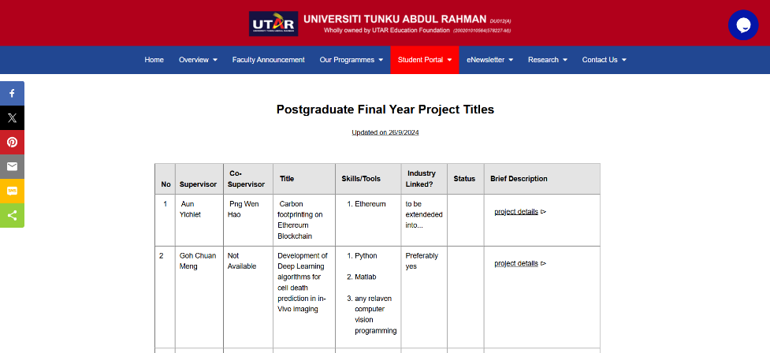
Fig. 1 Homepage for UTAR Education Portal
  - Public Sector ICT Project Management Portal (PPrISA)
The Public Sector ICT Project Management Portal guideline was advocated to improve efficiency in public service 2024. Over five decades, ICT has revolutionized delivery services. The government, through MAMPU, developed the PPrISA methodology in January 2016 to oversee ICT projects. It provides standardized processes for each phase. On 1st March 2018, Circular No.3 appointed PPrISA as the main endorsement. It targets public sector officers and PMO’s and benefits private sector officers too. The PPrISA portal aims to increase project productivity through structured instruction. Figure 2.2 shows the portal and its procedures.

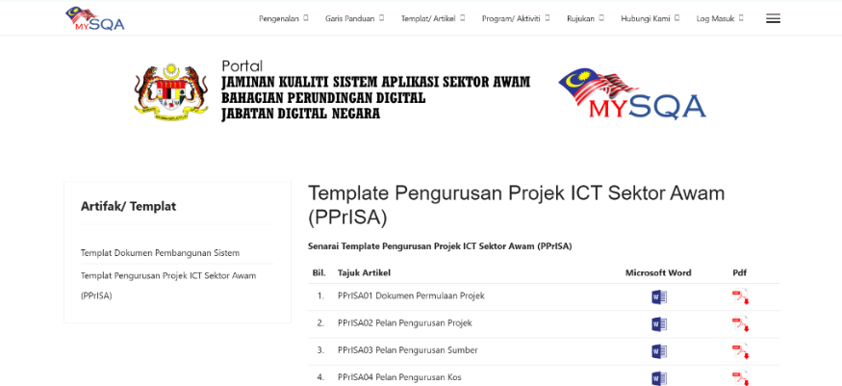
Fig. 2 Homepage for PPrISA Portal
  - UTM Final Year Project System
The Final Year Project System at the University of Technology Malaysia (UTM, 2021) is part of the academic experience, particularly in the School of Mechanical Engineering. The system provides students with a structured platform to manage the knowledge and skills they have gained throughout. The system guide students through the project’s scope, offers solutions to challenges, and presents research as reports and technical papers. Supervisors provide guidance through meetings. The system helps students manage tasks effectively, ensuring successful completion of final year projects (Jiang et al., 2021). It includes features for submitting project drafts, final reports, and technical papers. Students are required to present and defend their research. Detailed instructions help manage timelines and assessments. The system supports project management and helps develop skills like problem-solving and time management. Fig.3 illustrates the integration of features within the UTM Final Year Project System.

Fig. 3 Homepage for UTM FYP Portal
  - Comparison between Related System
Three similar systems have been chosen for comparison purposes. The systems are UTAR Education Portal, Public Sector ICT Project Management Portal, and UTM Final Year Project System. Table 2 shows the comparison between the characteristics of the existing system and the proposed system.
Table 2 Comparison Between Existing System and Proposed System
Comparison System | UTAR  Education  Portal |  | Public  Sector  ICT Portal |  | UTM  FYP  Portal |  | FSKTM FYP  Management  System
Technology:
Web-based system | Yes |  | Yes |  | Yes |  | Yes
Online System | Yes |  | Yes |  | Yes |  | Yes
Modules:
Login | Yes |  | Yes |  | Yes |  | Yes
Manage Supervision | Yes |  | No |  | Yes |  | Yes
Manage Document | Yes |  | Yes |  | Yes |  | Yes
Manage Submission | Yes |  | Yes |  | No |  | Yes
Track Progress | Yes |  | No |  | No |  | Yes
Schedule Meetings | Yes |  | No |  | No |  | Yes
Notification System | Yes |  | No |  | No |  | Yes
Generate Report | Yes |  | Yes |  | Yes |  | Yes
Manage Evaluation | No |  | No |  | No |  | Yes
Manage AI Suggestions | No |  | No |  | No |  | Yes
- Methodology
This section explains the methodology used in the project. The waterfall model is a well-established project management workflow that formed the substructure of the FSKTM FYP Management System. This model was preferred due to its extensibility for smaller projects with well-defined requirements. The methodology includes five phases: such as requirements, design, implementation, verification and maintenance. The waterfall model is convenient for as each phase has clearly defined start and end points where each phase starts after one is achieved. Its benefits such as administrative control where it allows project managers to monitor the progress of projects, promotes organization, and helps to maintain the timeline or complicated projects. The model is a sequential approach that helps projects to stay updated. Emphasis was directed on the testing phase to achieve the reliability and effectiveness of the system. Unit and integration tests were performed to troubleshoot mistakes made at the unit and integration levels. Table 3 shows the summary of system development activities tasks. Each activity in each phase has been listed together with the outcomes of the activities completed.

Table 3 Software Development Activities Task
Phases | Task/Activities |  | Deliverables
Requirement & Analysis |  | - Identify system scope and  requirement  - Analyze requirements  - Collect data  - Project timeline: Gantt Chart |  | - Proposal  - Gantt Chart
Design |  | - Design user interfaces  - Design database  - Design DFD, ERD, Flowchart |  | - Context Diagram  - Data Flow Diagram  - Entity Relationship Diagram  - Flowchart  - Use Case Diagram  - Interface
Implementation |  | - Implemented design in code |  | - System execution
Testing |  | - User acceptance testing |  | - Functionality and user acceptance test
Maintenance |  | - Fix bugs or errors |  | - Serves as a productive system and provides effectiveness and satisfaction for the system users.
- Analysis and Design
This section will discuss the analysis and design phases of the system, including system requirement analysis, which consists of both functional and non-functional requirements, database design, and implementation. The design phase involves detailed the components and interfaces to address these requirements and constraints.
  - System Requirement Analysis
A context diagram is drawn to define and represent the entire system. A context diagram is known as a data flow diagram and considered as an overview of the system that shows boundaries, external entities that interact with the system and the major information flows between the entities and the system. Fig.5 shows the context diagram of the web-based FSKTM FYP Management System. In the context diagram, consists of three entities such as Students, Supervisors and Project Coordinators.

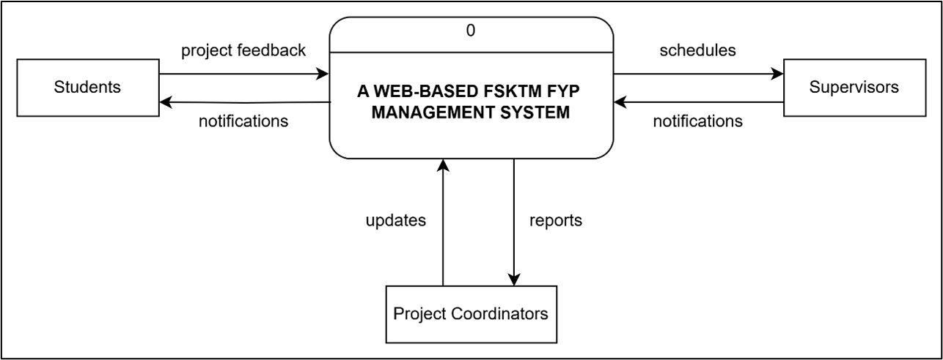
Fig. 5 Context Diagram
  - System Design
The system design phase translates the requirements and analysis into a structured solution that can be implemented. This phase includes the architectural design of the system, user interface designs, and overview of how the system components interact.
  - Data Flow Diagram
A Level 0 Data Flow Diagram, also known as a context diagram, provides a high-level overview of a system. It illustrated the entire system as a single process, showing its interaction with external entities and the main data flows between the system and the entities. The Level 0 DFD identifies the system’s boundaries and explains how the system communicates with users or other systems. Besides, Fig.6 showcases how the system interacts with students, supervisors and coordinators. The main processes such as login/register, project management, schedule management, document management, evaluation management, and notification system are represented as a single process.

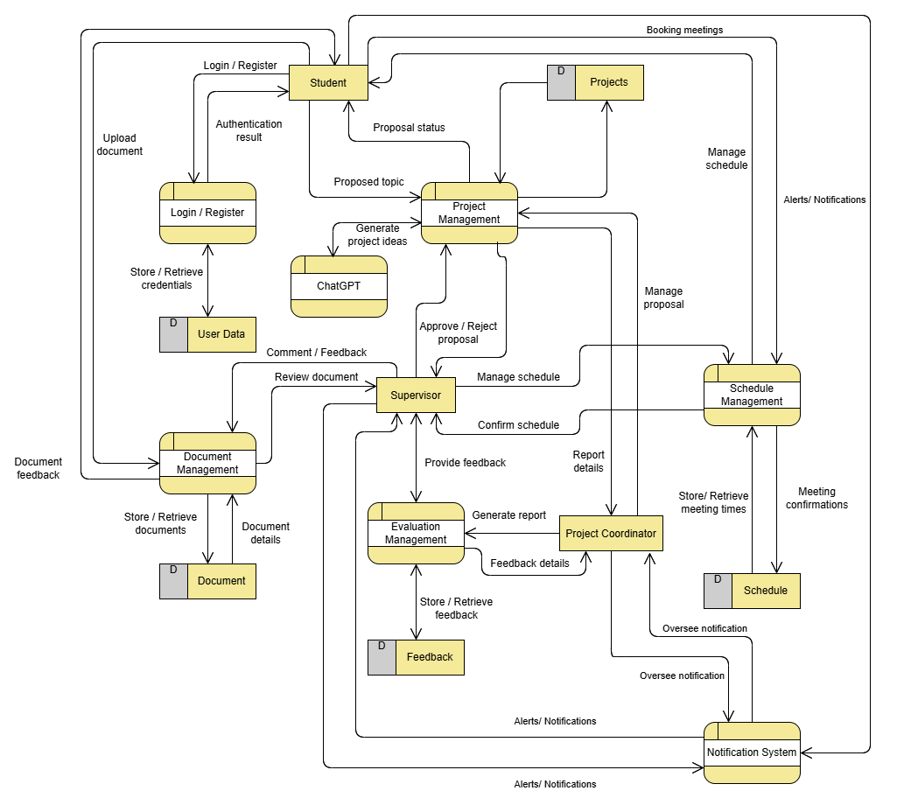
Fig. 6 Data Flow Diagram Level 0
  - Use Case Diagram
A use case diagram is a graphical representation of the functional requirements of a system, showing the interactions between various actors (users or external systems) and the system itself. It helps in visualizing the key functionalities that a system must support and how different user roles interact with those functionalities. The diagram typically includes actors, use cases, and their relationships, such as associations, inclusions, or extensions. Fig.7 illustrated the use case diagram for the proposed system.

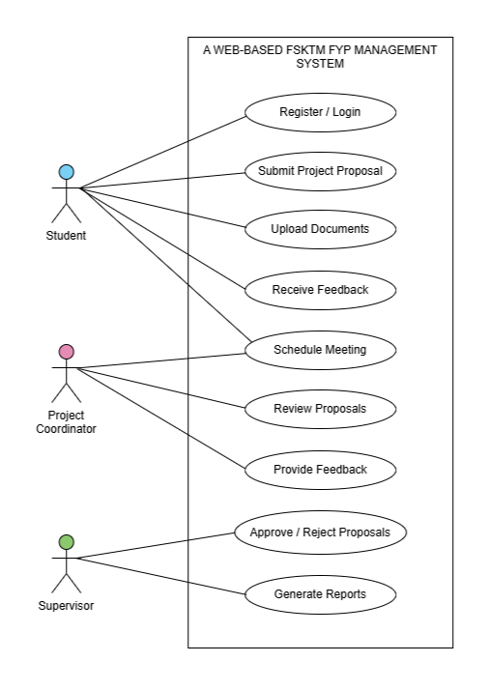
Fig. 7 Use Case Diagram
  - Entity Relationship Diagram
This section visualizes the database structure, showing entities, attributes and relationships. It ensures the database design supports all functional requirements efficiently. Fig.8 shows the Entity Relationship Diagram that illustrates the database structure for the proposed system including key entities and their relationships.

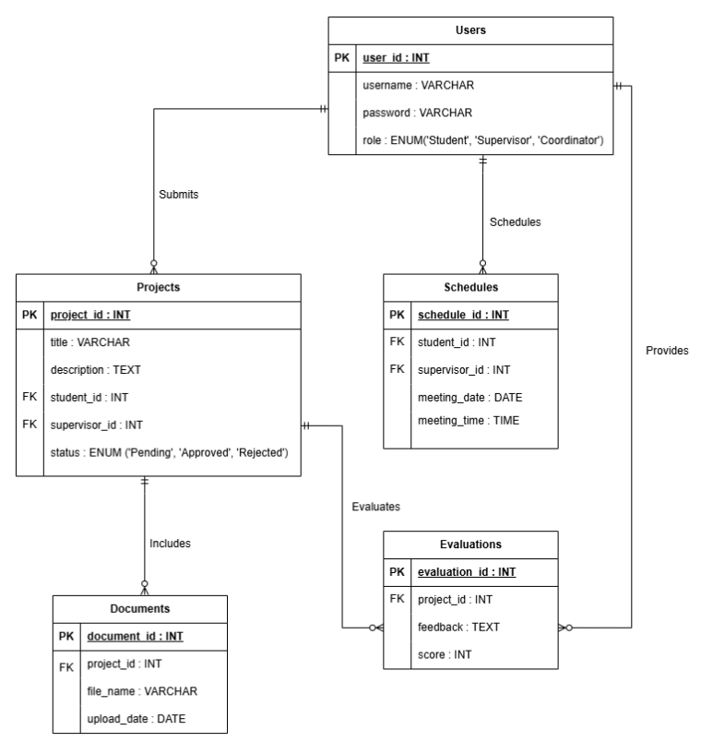
Fig. 8 Entity Relationship Diagram
  - Interface Design
This section emphasizes the interface design on creating user-friendly and intuitive interfaces for the three main user roles including students, supervisors and project coordinators. Below are some of the key interfaces from the FSKTM FYP Management System.

Login Interface: Allows users to authenticate and access their respective dashboards.
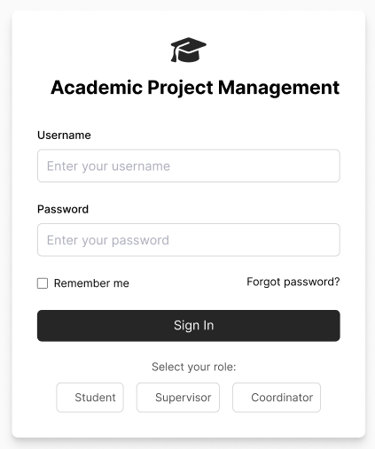
Fig. 9 Login Interface
Dashboard Interface: Includes options for project proposal submission, document upload, and schedule management. Supervisor dashboard provides functionalities for reviewing proposals, providing feedback, and managing meeting schedules. Coordinator dashboard Offers tools for approving/rejecting proposals, generating reports, and monitoring system activity.
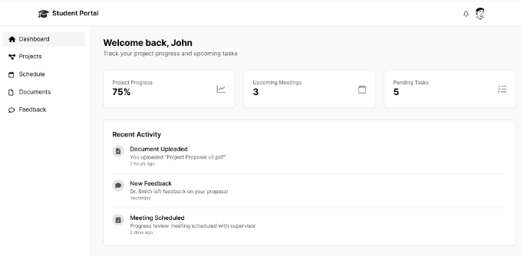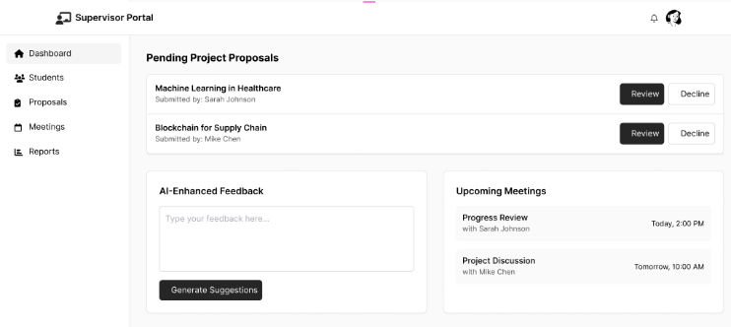
Fig. 10 Student Dashboard Interface Fig. 11 Supervisor Dashboard Interface
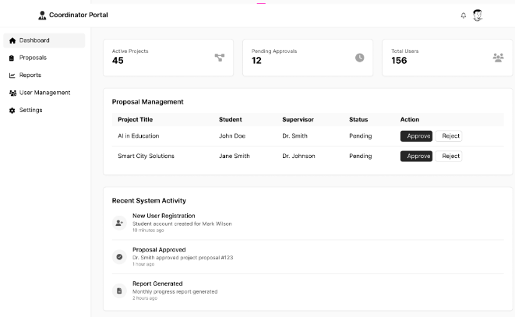
Fig. 12 Coordinator Dashboard Interface
- Results and Discussion
The results and discussion section outlines the results derived from the project and discusses based on the objectives stated. It describes the significance of the results, evaluates the implications and influences on the area of research and explores how the results can be used or expanded upon in subsequent research.
  - Implementation
The front end of the system utilizes HTML, CSS, and JavaScript to create a responsive, user-friendly interface, with pre-built CSS classes which helps development process to avoid the time-consuming necessity of writing CSS code from scratch for HTML elements. For the back end of the system, which primarily utilizes PHP for server-side functions, the system uses CSV for generating Excel documents and creating interactive charts. This setup is presented in such a way to provide a streamlined development process and maintainable code structure.
    - User Login Interface
The login interface for the web-based FSKTM FYP Management System is shown in Figure 13. Users must enter their username, password, and select a role. If all credentials are correct, the system grants access. Otherwise, an error message appears indicating invalid username, password, or role. The login and registration processes are displayed in Figures 14(a) and Figure 14(b) respectively. The system first checks the credential's validity, in the case of a valid login request, it redirects user based on user role; otherwise, it shows an error page. In the case of registration, it validates the user input, checks for duplicity, hashes the password, and inserts the new user into the database before redirecting the user to the login page.
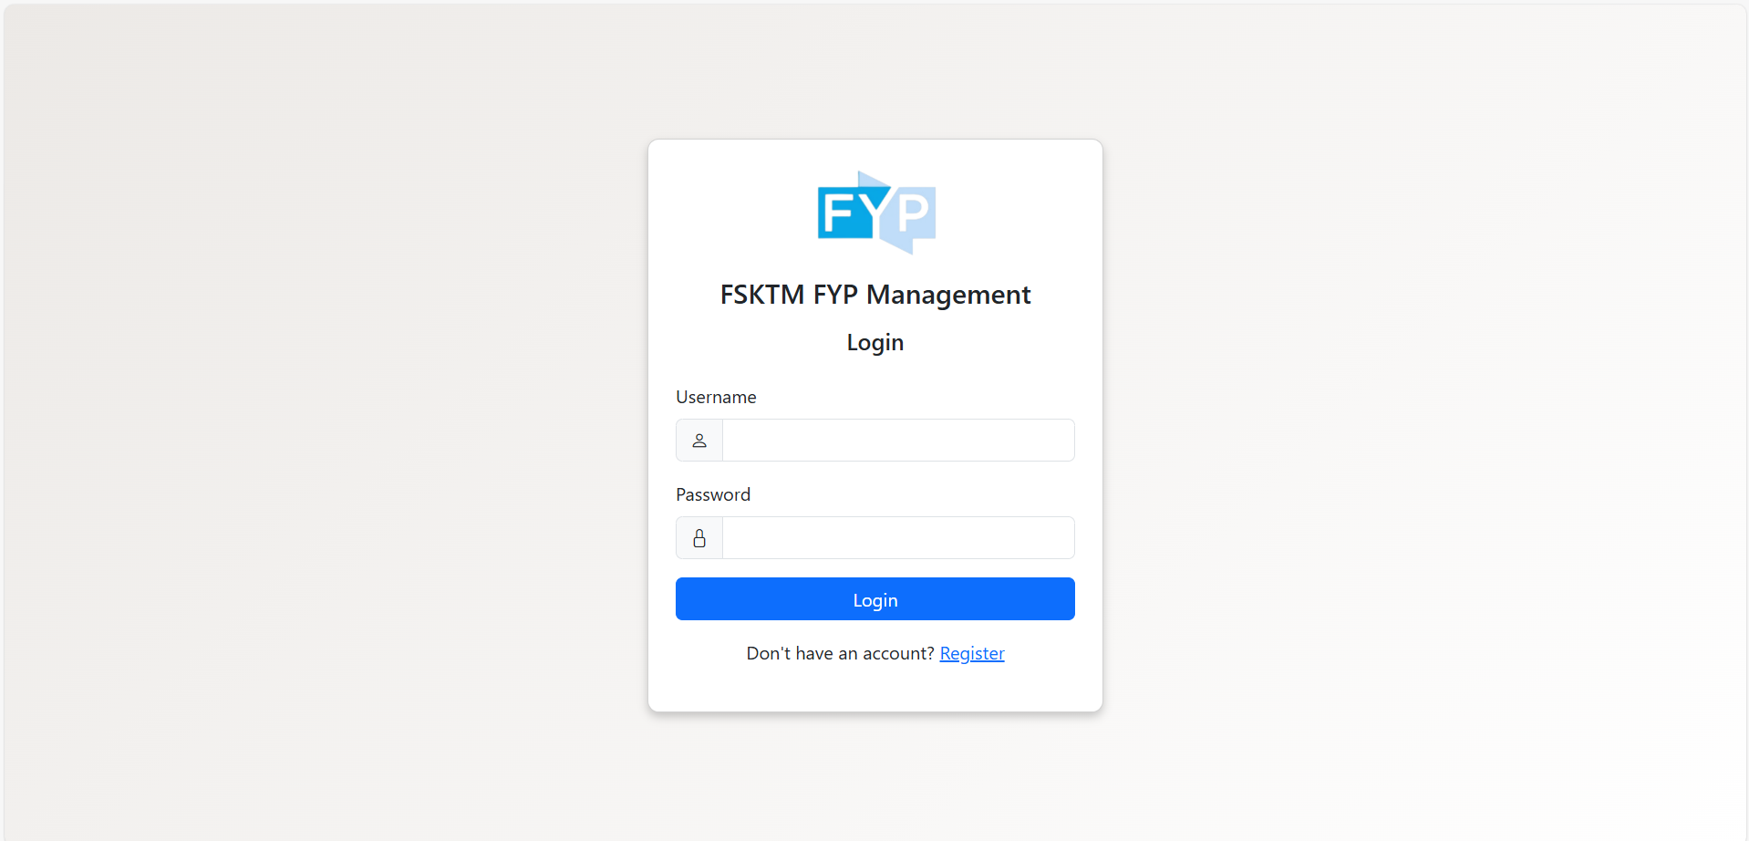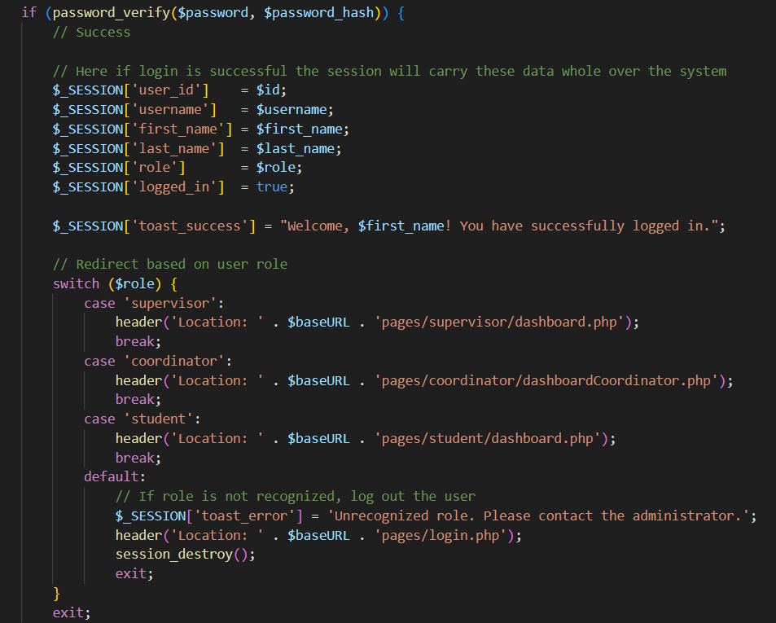
Fig. 13 Login Interface Fig. 14(a) Login Authentication Code
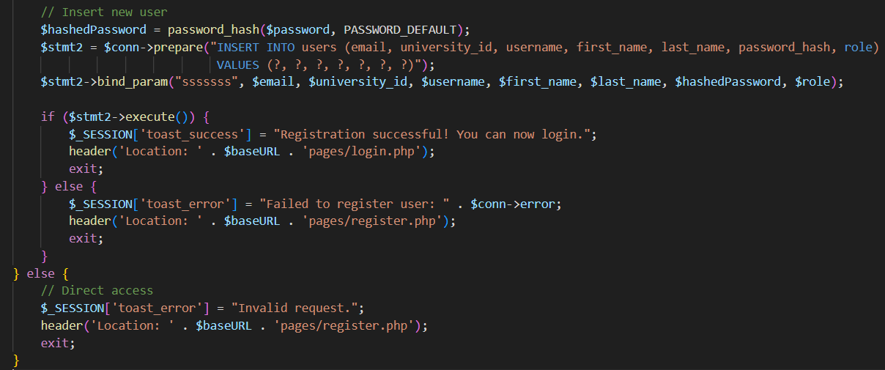
Fig. 14(b) Register Authentication Code
    - Manage Student-Supervisor Assignment Interface
Figure 15(a) and Figure 15(b) shows an assign management of student-supervisor interface for project coordinators. The interface provides an overview of current assignments and detail student-supervisor assignments in a table form which includes the assignment ID, student matric ID, student name, supervisor staff ID, supervisor name, and assignment date. The interface provides pagination to navigate between records to improve user experience. The interface provides a simple way for project coordinators to monitor, manage, audit assignments, and manage student-supervisor assignments.
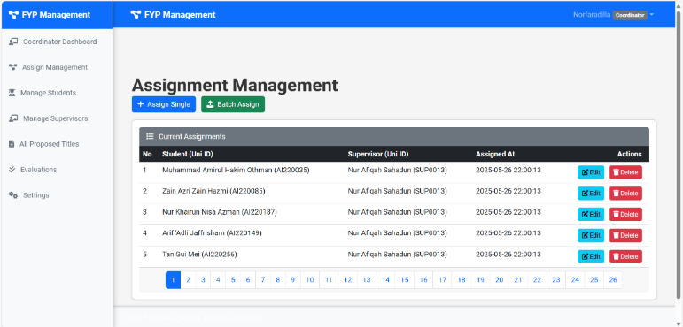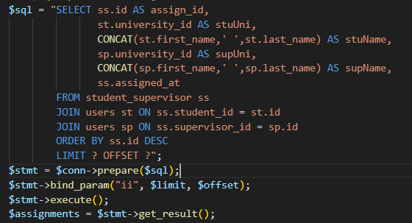
Fig. 15(a) Student-Supervisor Assignment Interface Fig. 15(b) Student-Supervisor Assignment Code
    - Manage Document Interface
Figure 16(a) and Figure 16(b) shows the document management interface contains a list of files where students uploaded documents with metadata of file type, date, title, evaluation status, and feedback. The students upload files with drag-and-drop capabilities with semi-controlled parameters and can view the document history. Supervisors can preview the documents, give feedback and evaluate the documents through scores or rubrics. The interface provides an effective document management process.
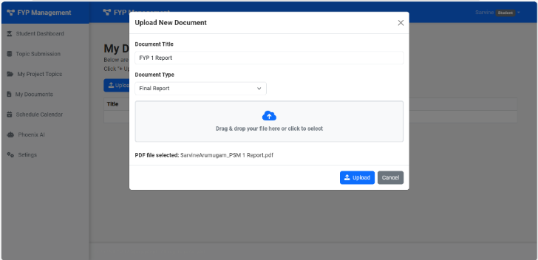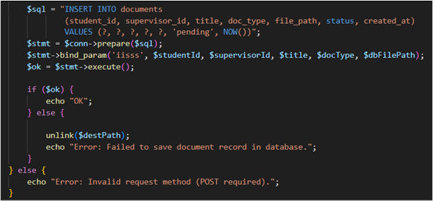
Fig. 16(a) Document Management Interface Fig. 16(b) Document Management Code
    - Manage Submission Interface
Figure 17(a) and Figure 17(b) shows the submission management interface with the following table with the submission type, date, file name, status and administrative functions like view, update, delete. Students upload one file for each type, so the submission is accurate and can be traced, if necessary. There is a history available of submissions with dates for supervisors to monitor changes made between submissions, which can support effective supervision of the student and their feedback. It also ensures that the students’ documentation submission is flowing smoothly.
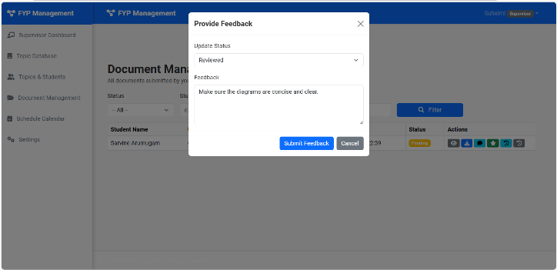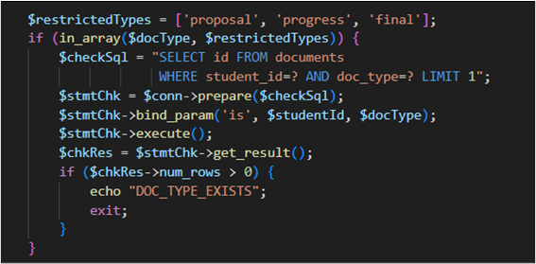
Fig. 17(a) Manage Submission Interface Fig. 17(b) Manage Submission Code
    - Track Progress Interface
Figure 18(a) and Figure 18(b) shows the interface for students, supervisors, and coordinators to view progress. It shows status updates, major milestones, and upcoming deadlines. Supervisors can update the status of students, add remarks with timestamps, and this provides history. Students can see the timelines, comments about their feedback, and their scheduled dates. Supervisors can see the to-do list, prioritize their tasks, and can also see the due dates when they were due to perform each task. This reflects the administration's transparency and twice the oversight of the project.
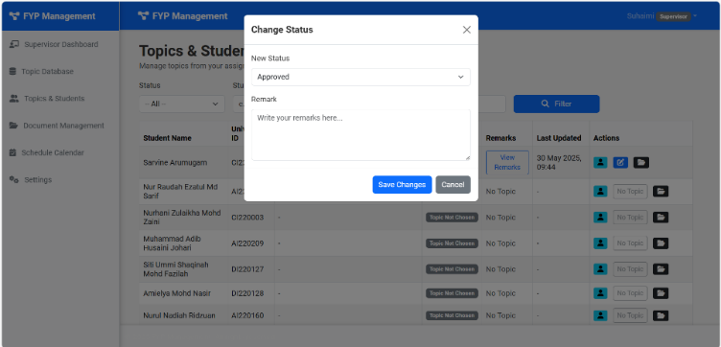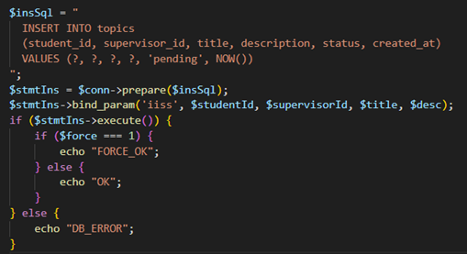
Fig. 18(a) Track Progress Interface Fig. 18(b) Track Progress Code
    - Schedule Meeting Interface
Figure 19(a) and Figure 19(b) shows the schedule meeting interface for students and supervisors. Supervisors can set available dates and timings and students able to request for meetings on available slots. Requests remain in pending status until accepted, rejected or updated by supervisors. Both users can view the current and past meetings history with statuses. Supervisors can change meeting status to accepted, rejected, or cancelled with remarks. Students receive notifications on status change for smooth communication and scheduling.
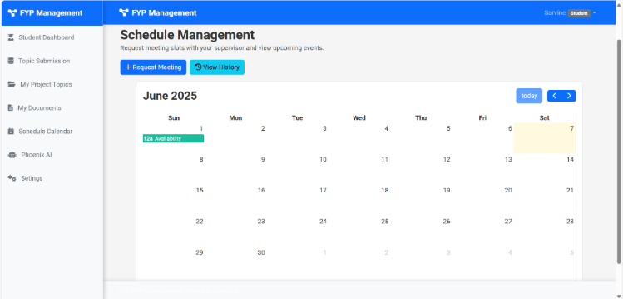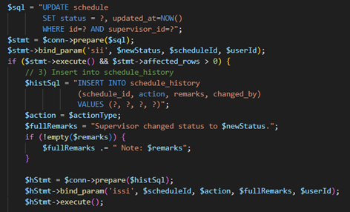
Fig. 19(a) Schedule Meeting Interface Fig. 19(b) Schedule Meeting Code
    - Generate Report Interface
Figure 20(a) and Figure 20(b) are an interface that allows project coordinators, supervisors, and students to generate reports related to the final year project. Report types include student progress, documentation submissions, meetings scheduled, and evaluation summary. This interface assembles information contained in the database and produces reports in a readable way often with the ability for the user to create reports as exportable PDF or Excel files. It allows for timely and accurate tracking of performance and milestones and ensures that stakeholders have access to relevant information for decisions related to their project.

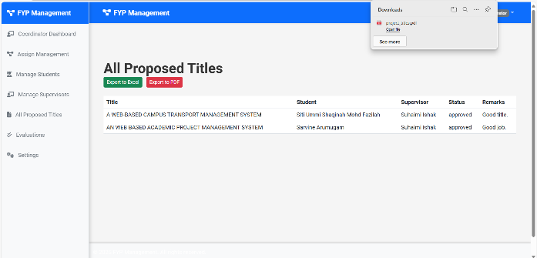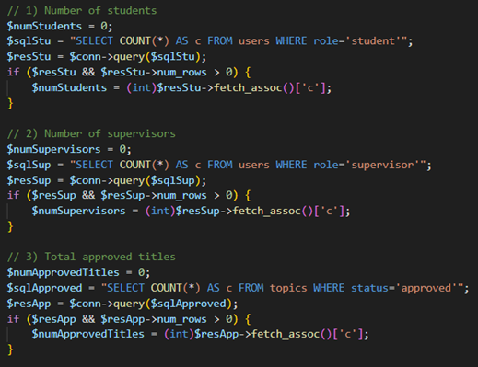
Fig. 20(a) Generate Report Interface Fig. 20(b) Generate Report Code
    - Manage Evaluation Interface
Figure 21(a) and Figure 21(b) shows an evaluation management interface on how supervisors can manage their students' evaluations. They can view uploaded documents, comment on submissions, and assign scores based on rubric. The evaluation, comments, and scores are all included in the system so that both students and supervisors can refer to their previous evaluations. This structure encourages effective supervision while providing students with a detailed overview of the evaluation and their performance over time.
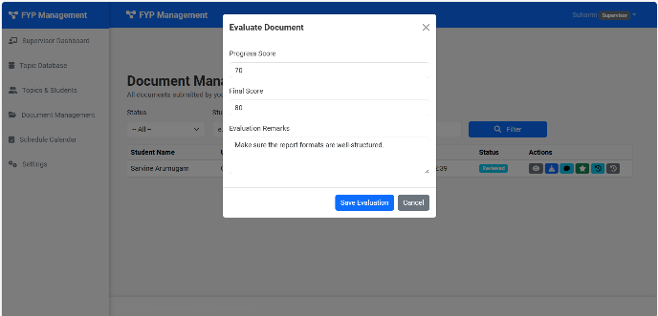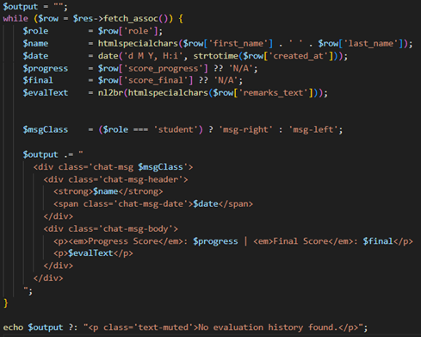
Fig. 21(a) Manage Evaluation Interface Fig. 21(b) Manage Evaluation Code
    - Manage AI Suggestions Interface
Figure 22(a) and Figure 22(b) highlights the interface that is designed to offer students AI-assisted guidance when proposing project titles. Students enter their proposed topic information to the interface, where the AI will evaluate it for possible similarities using comparisons to find overlaps with existing titles even considering synonyms. The interface will warn a student if it detects an overlap in existing titles and will show detail regarding the title, such as the year proposed, to minimize duplicated work. Students can submit unique and relevant project titles when utilizing AI to guide the title proposal, in addition to maintaining academic integrity throughout the title proposal process.
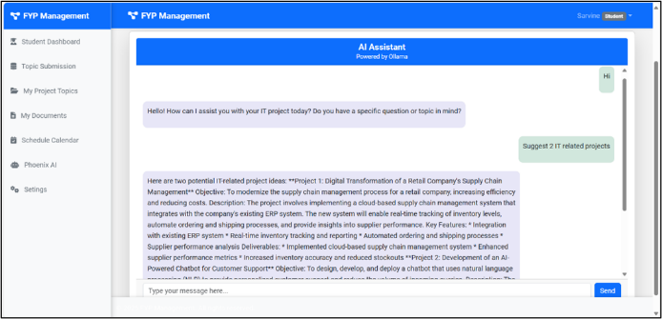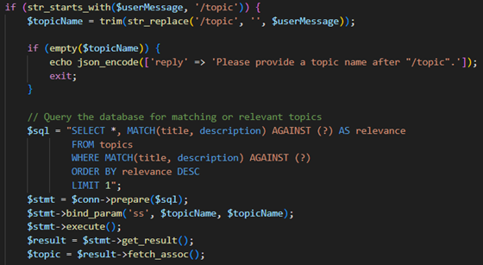
Fig. 22(a) Manage AI Suggestions Interface Fig. 22(b) Manage AI Suggestions Code
  - Testing
Table 4 List of Test Cases
Modules | Description | Test Result  (PASS/FAIL)
TEST_100_001  TEST_100_002  TEST_100_003  TEST_100_004  TEST_100_005  TEST_200_001  TEST_200_002  TEST_200_003  TEST_200_004  TEST_200_005  TEST_300_001  TEST_300_002  TEST_300_003  TEST_300_004  TEST_300_005  TEST_400_001  TEST_400_002  TEST_400_003  TEST_400_004  TEST_500_001  TEST_500_002  TEST_500_003  TEST_500_004  TEST_500_005  TEST_500_006  TEST_600_001  TEST_600_002  TEST_600_003  TEST_600_004  TEST_700_001  TEST_700_002  TEST_700_003  TEST_700_004  TEST_700_005 | Verify that a student can log in without any issues.  Verify that a supervisor can log in without any issues.  Verify that a coordinator can log in without any issues.  Verify system displays error message for incorrect password.  Verify the login page can be accessed.  Verify that students can upload a document.  Verify that students can view uploaded documents.  Verify that supervisors can view uploaded documents.  Verify that supervisors can provide feedback.  Verify that document history is viewable and recorded.  Verify that students can upload a submission for a specific type.  Verify that each submission is recorded with correct status.  Verify that previous submission versions are stored.  Verify that a student can update or delete a submission.  Verify that supervisors can view or track submission changes.  Verify that supervisors can update project status.  Verify that progress changes are timestamped and recorded.  Verify students can view project status and feedback.  Verify to-do-list feature allows supervisors to manage tasks.  Verify that supervisors can set available dates and times.  Verify that students can view supervisor availability.  Verify that students can request a meeting from available slots.  Verify meeting requests remain pending until accept/reject.  Verify supervisors can update meeting status and add remarks.  Verify that students are notified of meeting status updates.  Verify that supervisors can access evaluation interface.  Verify supervisors can view documents and provide scores.  Verify the feedback and rubric scores are saved correctly.  Verify that evaluation history is viewable by both users.  Verify that users can view AI generated suggestions.  Verify that AI suggestions are relevant.  Verify system flags repeated or duplicate topics as overlapping.  Verify that AI generates suggestions only for IT-related content.  Verify that AI detects overlapping topics. | PASS  PASS  PASS  PASS  PASS  PASS  PASS  PASS  PASS  PASS  PASS  PASS  PASS  PASS  PASS  PASS  PASS  PASS  PASS  PASS  PASS  PASS  PASS  PASS  PASS  PASS  PASS  PASS  PASS  PASS  PASS  PASS  PASS  PASS
The user and profile management module feedback, as shown in Figure 23(a) and 23(b) provides user experience, allows user to log in to the system by entering username, password and profile updates. When the credentials entered are incorrect it shows error messages and assist users to return to begin the process correctly. The system encourages users to reset their passwords conveniently. The login page can be easily accessed. Based on the usability testing for user management module feedback provided, six participants evaluated as “Strongly Agree” while one participant evaluated as “Agree” and “Neutral”.

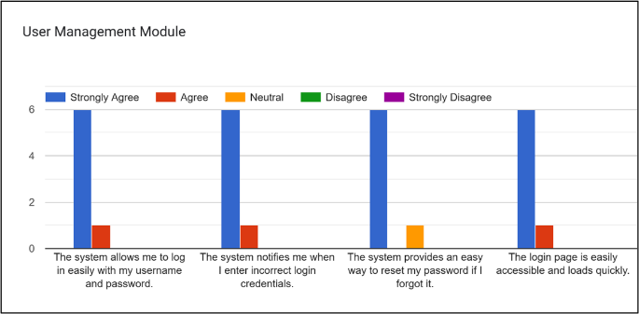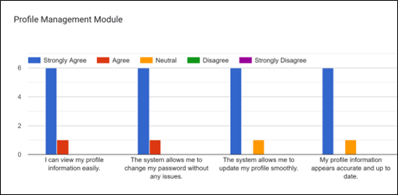
Fig. 23(a) User Management Module Feedback Fig. 23(b) Profile Management Module Feedback

The document management module feedback, as shown in Figure 24(a) allows users to upload, view, and download documents with drag-and-drop features. Documents are organized systematically for easy access. Based on usability testing, five participants “Strongly Agree” while two participants as “Agree” and “Neutral”. The project topic management module feedback, as shown in Figure 24(b), allows users to submit new topics, search by keyword, filter, and avoid topic duplication through notifications. Based on usability testing, six participants “Strongly Agree,” while one participant as “Agree” and “Neutral”.

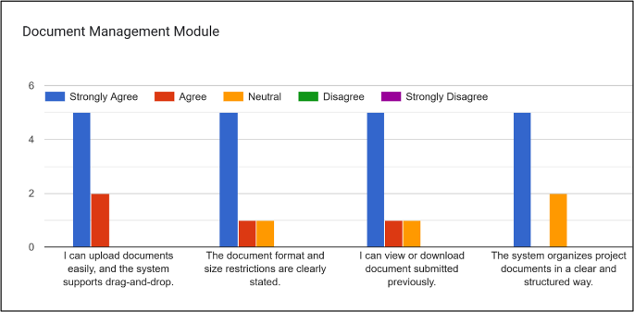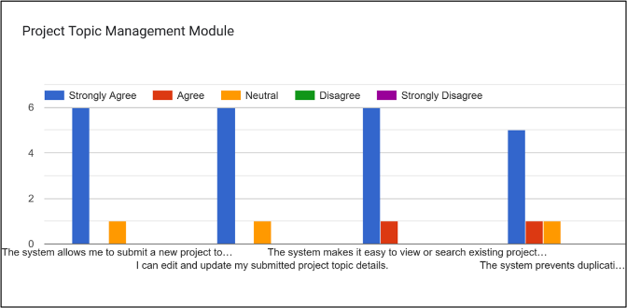
Fig. 24(a) Document Management Module Feedback Fig. 24(b) Project Topic Management Module Feedback

The schedule management module feedback, as shown in Figure 25(a) allow users to view supervisors’ availability, schedule meetings, update links, and receive notifications. Based on usability testing, six participants “Strongly Agree” while one as “Agree” and “Neutral”. The generate report module feedback, as shown in Figure 25(b), allows supervisors and coordinators to view, generate, and download reports in Excel or PDF. Based on usability testing, five participants “Strongly Agree,” and two participants as “Agree” and “Neutral”

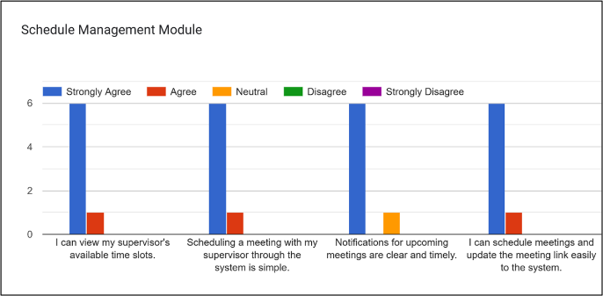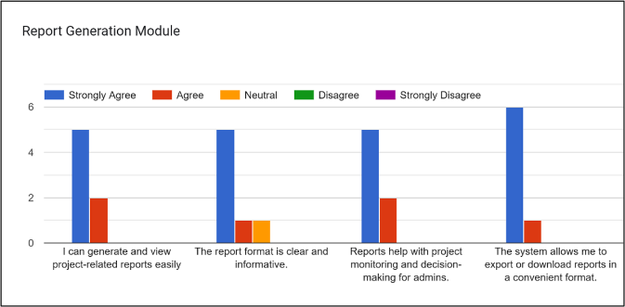
Fig. 25(a) Schedule Management Module Feedback Fig. 25(b) Generate Report Module Feedback

The evaluation management module feedback, as shown in Figure 26 allows allows students to view feedback provided by supervisors. Students receive notifications when evaluations are updated and can respond, or question based on feedback. Based on usability testing, six participants “Strongly Agree” and one participant evaluated as “Agree” and “Neutral”.

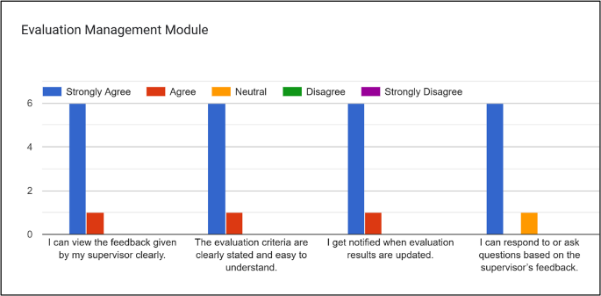
Fig. 26 Evaluation Management Module Feedback
- Conclusion
This project aims to develop an online FSKTM FYP Management System for the faculty of Computer Science and Information Technology at University Tun Hussein Onn Malaysia. It will be utilized by students, supervisors, and project coordinators. The main benefit of this system is its potential to provide more convenience and greater accessibility for managing final year projects, allowing for an easier and faster process that makes information retrieval more efficient compared to the current manual system, through the administration features provided. Besides, establishing and maintaining an effective online FSKTM FYP Management System requires the coordination of user input, active communication, and attention to details. Properly developed, a well-managed online FSKTM FYP Management System will lead the faculty to a higher level of productivity and performance by generating new benefits for students, supervisors, and project coordinators as well. The online FSKTM FYP Management System will increase the efficiency of the faculty’s operations while maintaining a high level of academic support. Thus, an effective online FSKTM FYP Management System is well worth the time spent on its creation.
Acknowledgement
The authors would like to thank the Faculty of Computer Science and Information Technology, University Tun Hussein Onn Malaysia for the support and encouragement throughout the process of conducting this study.
Conflict of Interest
Authors declares that the study was conducted independently and no conflicts of interests concerning the publication of the paper.
Author Contribution
The journal requires all authors to take public responsibility for the content submitted for review. The author contributions are detailed as follows: study conception and design: Sarvine A/P Arumugam, Dr. Suhaimi Bin Abd Ishak; data collection: Sarvine A/p Arumugam, Dr. Suhaimi Bin Abd Ishak; analysis and interpretation of results: Sarvine A/P Arumugam, Dr. Suhaimi Bin Abd Ishak; draft manuscript preparation: Sarvine A/P Arumugam, Dr. Suhaimi Bin Abd Ishak. Both author and supervisor reviewed the results and approved the final version of the manuscript.

References
- Abah, J. A., Honmane, O., Age, T. J., & Ogbule, S. O. (2022). Design of single-user-mode computer-based examination system for senior secondary schools in Onitsha North Local Government Area of Anambra State, Nigeria. VillageMath Educational Review (VER), 3(1). https://papers.ssrn.com/sol3/papers.cfm?abstract_id=4061818
- Amirsoleimani, A., Alibart, F., Yon, V., Xu, J., Pazhouhandeh, M. R., Ecoffey, S., ... & Drouin, D. (2020). In‐memory vector‐matrix multiplication in monolithic complementary metal–oxide–semiconductor‐memristor integrated circuits: Design choices, challenges, and perspectives. Advanced Intelligent Systems, 2(11), 2000115. https://onlinelibrary.wiley.com/doi/abs/10.1002/aisy.202000115
- Anugraha, J., Vishwa, R., & Vigneshwari, S. (2024, July). Web-based portal for hierarchical project management. In AIP Conference Proceedings (Vol. 3075, No. 1). AIP Publishing. https://pubs.aip.org/aip/acp/article-abstract/3075/1/020027/3304968
- Aristovnik, A., Ravšelj, D., & Murko, E. (2024). Decoding the Digital Landscape: An Empirically Validated Model for Assessing Digitalisation across Public Administration Levels. Administrative Sciences, 14(3), 41. https://www.mdpi.com/2076-3387/14/3/41
- Booch, G. (2005). Object-oriented analysis and design with applications (3rd ed.). Addison-Wesley Professional.
- Burke, C. M., & Morley, M. J. (2023). Toward a non‐organizational theory of human resource management? A complex adaptive systems perspective on the human resource management ecosystem in (con) temporary organizing. Human Resource Management, 62(1), 31–53. https://onlinelibrary.wiley.com/doi/pdfdirect/10.1002/hrm.22132
- De Nardis, L., Mohammadpour, A., Caso, G., Ali, U., & Di Benedetto, M. G. (2022). Internet of things platforms for academic research and development: A critical review. Applied Sciences, 12(4), 2172. https://www.mdpi.com/2076-3417/12/4/2172/pdf
- Dennis, A., Wixom, B. H., & Tegarden, D. (2018). Systems analysis and design: An object-oriented approach with UML (6th ed.). Wiley.
- Dudar, V. L., Riznyk, V. V., Kotsur, V. V., Pechenizka, S. S., & Kovtun, O. A. (2021). Use of modern technologies and digital tools in the context of distance and mixed learning. Linguistics and Culture Review, 5(S2), 733–750. http://www.lingcure.org/index.php/journal/article/download/1416/160
- Dwivedi, Y. K., Hughes, L., Baabdullah, A. M., Ribeiro-Navarrete, S., Giannakis, M., Al-Debei, M. M., ... & Wamba, S. F. (2022). Metaverse beyond the hype: Multidisciplinary perspectives on emerging challenges, opportunities, and agenda for research, practice, and policy. International Journal of Information Management, 66, 102542. https://www.sciencedirect.com/science/article/pii/S0268401222000767
Appendix A
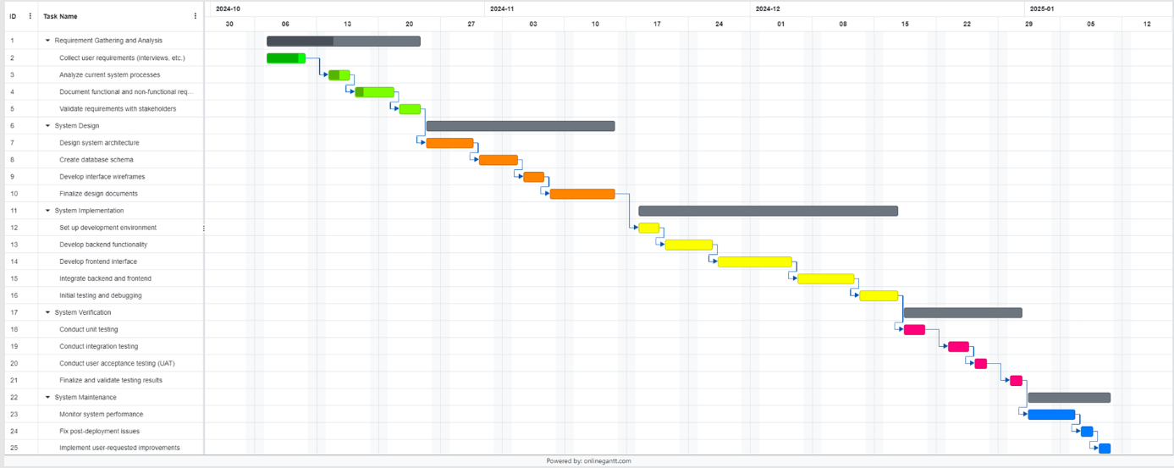
Fig. A.1 Gantt Chart

Appendix B
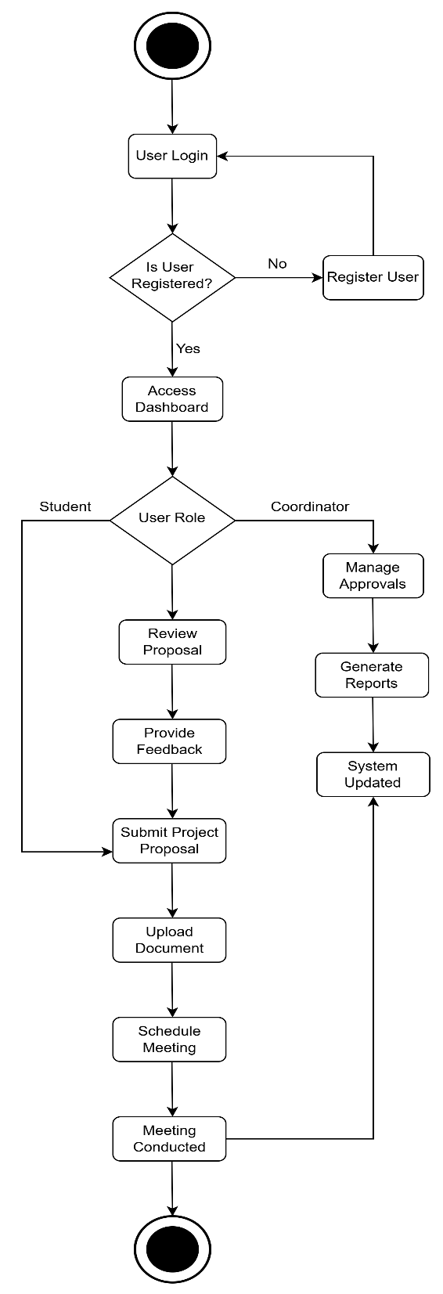
Fig. B.1 Flowchart

Appendix C
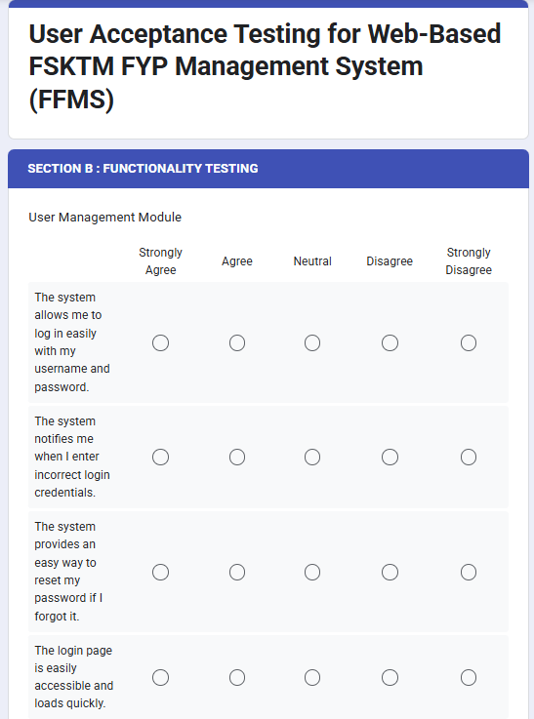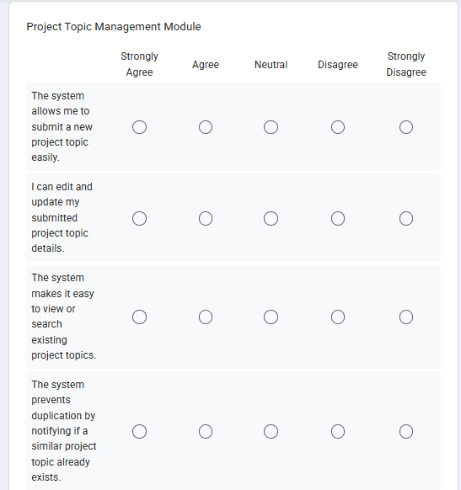
Fig C.1(a)Google Form for User Module (b) Google Form for Project Topic Module
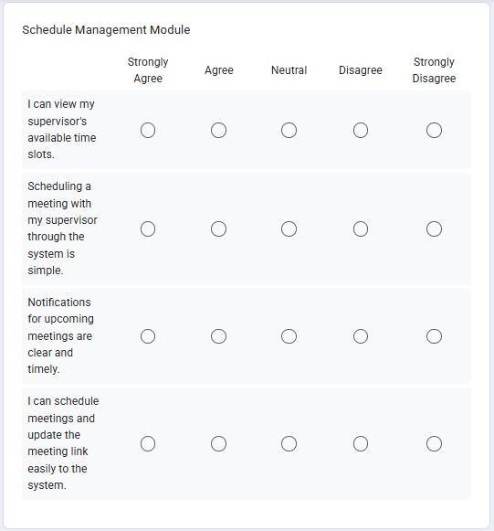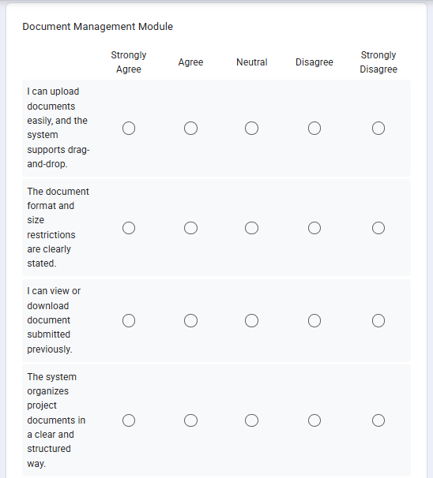
Fig C.2 (a)Google Form for Schedule Module (b) Google Form for Document Module

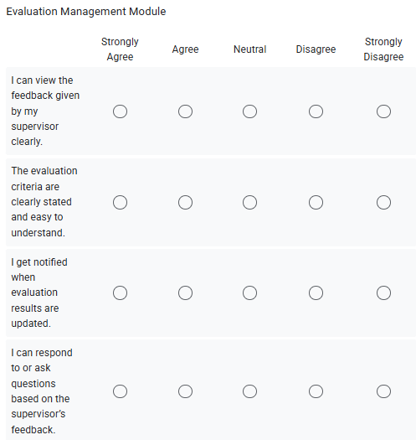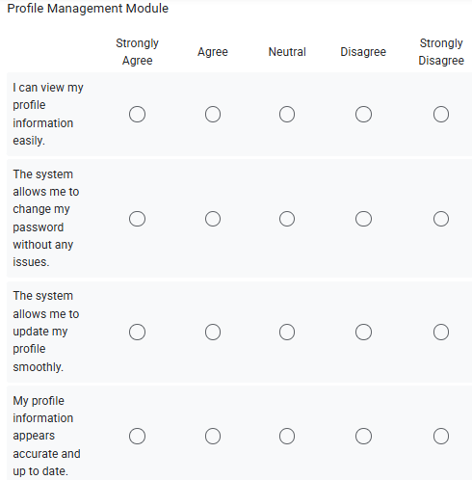
Fig C.3 (a) Google Form for Evaluation Module (b) Google Form for Profile Module

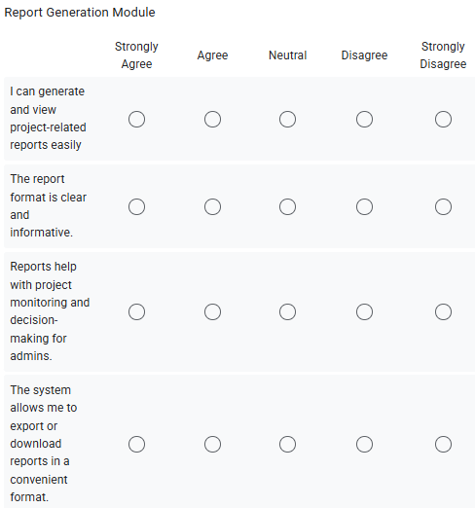
Fig C.4 (a) Google Form for Report Module

