AR Makeup Tester: Design and Development of Augmented Reality based on Makeup Tester to support Product Testing

Tineswaran Chandran¹, Muhammad Fakri Othman¹*

¹Faculty of Computer Science and Information Techology,
Universiti Tun Hussein Onn Malaysia, Parit Raja, Batu Pahat, Johor, 86400, MALAYSIA

*Corresponding Author Designation

DOI: https://doi.org/10.30880/aitcs.2022.03.01.002
Received 31 July 2021; Accepted 19 April 2022; Available online 31 May 2022

Abstract: Augmented reality is a real-world environment enhanced with computer generated objects. The implementation of Augmented Reality in cosmetic industry enriched user experience especially in virtual makeup tester. In this pandemic era, makeup boutiques and stores are no longer using physical makeup testers to prevent the spread of coronavirus. Customers had to buy makeup kits without testing them. Therefor a virtual makeup tester using Augmented Reality is proposed that allow customers to test their makeup product virtually in real time before purchasing them online. Therefore, Multimedia Mobile Content Development methodology together with Unity Engine and Microsoft Visual Studio is used to develop and test AR Makeup Tester that works as a virtual cosmetic tester. The testing results using System Usability Scale shows the user acceptance level of AR Makeup Tester is 92%, which falls in acceptable range. AR Makeup Tester will allow user to test cosmetic products safely and increase sales of cosmetic products.

Keywords: Augmented Reality, Makeup Tester, Face Filters

- Introduction
Augmented Reality (AR) is one of the biggest trends right now as more smartphones and many other devices are made compatible with AR. Firstly, what is an Augmented Reality (AR)? AR is the technology that expands our physical world, adding layers of digital information onto it and it appears in direct view of an existing environment and adds sounds, graphics, or videos to it [1]. In a nutshell, AR is an overlay digital content on top of real things like camera, environment and can even be our face. In this globalization, more application developers are moving towards creating AR based applications and explore the use of AR for a variety of fields from military research, gaming technology, and an interdisciplinary field [2]. Now with the current pandemic situation, all makeup boutiques and stores are no longer using physical makeup testers. This is a way to prevent the spread of coronavirus. So, consumers had to buy makeup kits without testing them. This proposed application will ease consumers to test their makeup kit virtually and at the same time prevent the spread of viruses. Even way before this pandemic era, there were several lawsuits filed against big cosmetics companies due to consumers getting infections from their makeup tester. For example, a woman from Los Angeles sued Sephora after she contracted a herpes related cold sore from a lipstick sample from Sephora’s Hollywood store [3]. The objectives of AR Makeup Tester are to design an application that can test makeup virtually, to develop an application that able to purchase makeup products virtually and to test makeup products in real time and in any place.
AR Makeup Tester application will ease users by enabling them to test makeup virtually and avoid the use of physical makeup testers. Users can test makeup products from three makeup products from lipstick, blusher, and eyeliner. This android-based free application will direct the user to the main page once the application icon is pressed from the phone menu. The main page will consist of three icons representing three makeup products while the rest of the page will be covered with objects on the front-facing camera. Once a user clicked on each makeup product, different shades and colors were available for that makeup product. Then, once the user chooses the desired shades or colors, an overlay object developed with face tracking and depth tracking technology will appear on the user's face in real time. User can click the ‘Buy Now’ button which will direct user to an online site to purchase the item online.
This proceeding paper consists of five sections that covers the project development. Section 1 describes the background of the project such as problem statement, the objectives that led to the development of this project, the objectives achieved and the scope of the application. In section 2, systemic analysis of scholarly articles and other sources related to the application development such as technology used were discussed. Next, section 3 discusses the phases of the application development using Multimedia Mobile Content Development (MMCD). While in section 4, discussion results from beta testing and user acceptance test were discussed. Finally, section 5 discusses the final result of the developed application.
2. Related Work
2.1 Makeup Tester
Before purchasing a makeup product, customer will often want to test their makeup product on themselves and that is why stores like Ulta, Sephora and makeup counters in department stores let shoppers try out their products first with testers [4]. It is to ensure whether the makeup product will look good on themselves. Makeup testers are unboxed or unwrapped makeup products on display, where potential buyers can use them. This will be beneficial for customers since they know exactly what they are buying are using the testers while the cosmetic boutique can save money on refund. SimplySiti is a Malaysian local brand founded by Dato Siti Nurhaliza in 2010 that offers makeup products like blusher, lipstick, eyeliner and many other cosmetic products to customers in their online site or boutique [5].
2.2 Technology Implemented
Augmented Reality (AR) is an emerging form of experience which in the physical world is added by computer graphics and tied to specific location or activities [6]. AR is the blending of interactive digital elements like haptic feedback and dazzling visual overlays that will make the line between real and virtual world slimmer. While face tracking is a process of detecting and tracking the presence of a human face in a digital video frame over a period [7]. This technology is the base technology for human face analysis and facial recognition. When a face-tracking camera captures a video image, it will transmit the video into Facial Tracking software.
2.3 Comparative Analysis of Existing and Proposed Application
The current applications related are examined to discover any issues or difficulties that users may have. The comparison of existing applications with proposed application was done. The three existing test applications which are Maybelline Makeover Online [8], YouCam Makeup Application [9], Snapchat Application [10], shown in Figure 1. All these applications are available on Google Play Store or iOS App Store.

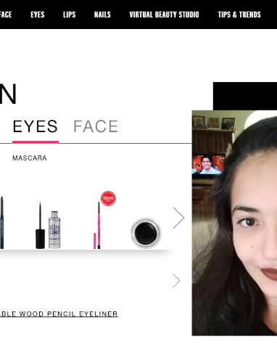
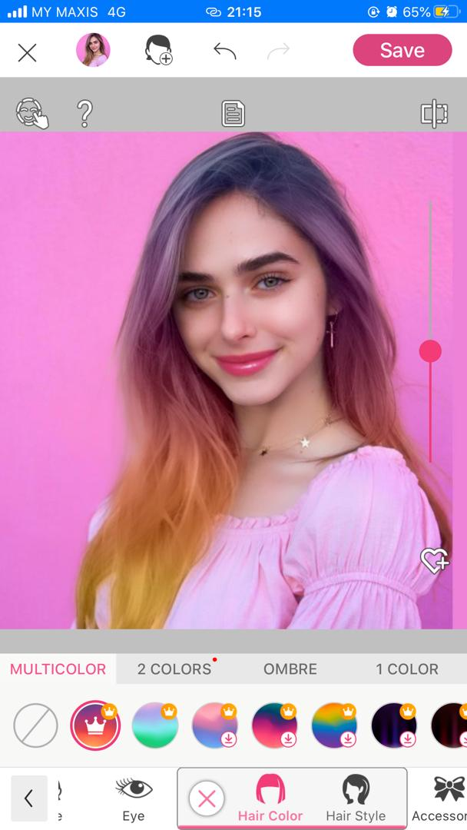
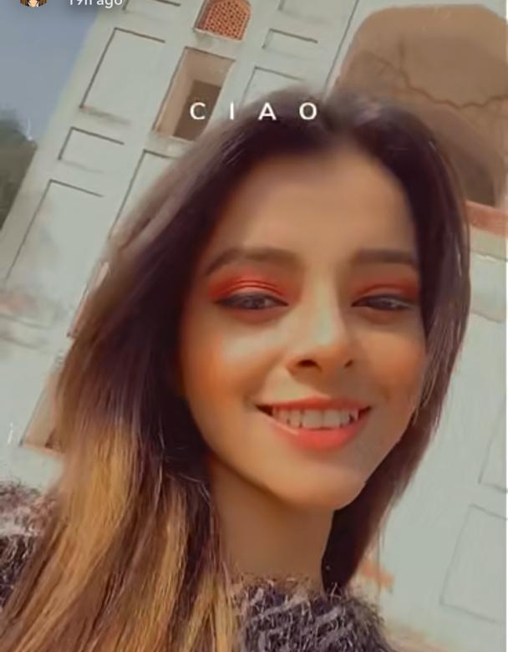

(a) (b) (c)
Figure 1(a): Maybelline Makeover Online [8], Figure 1(b): YouCam Application [9], and Figure 1(c) Snapchat Application [10] Main Interface
Table 1. Comparative analysis between existing applications and proposed application
Application  Features | Maybelline Makeover Online | YouCam Application | Snapchat Application | AR Makeup Tester
Operating System | Windows x64 | Android/iOS | Android/iOS | Android
Application Price | Free | In-app purchases | In-app purchases  (Only in US) | Free
Scope | Worldwide | Worldwide | Worldwide | Nationwide
Registration/Log In | Unavailable | Available | Available | Unavailable
Guided by Cosmetic Brand | Guided | Not guided | Not guided | Guided
Focus on virtual tester | Focused | Not focused | Focused | Focused

Based on Table 1, a comparative analysis between existing application and proposed application is performed. Not all current applications are suitable to be a good makeup tester. Therefore, AR Makeup Tester is developed to be a suitable virtual makeup tester.
3. Methodology
The methodology chosen to develop AR Makeup Tester is Multimedia Mobile Content Development. Multimedia Mobile Content Development is a methodology designed based the characteristics of an agile development model and using Flash Light (FL) technology. This output from this technology is supported by many mobile phones available. This methodology was intended to help developers to increase the application development speed and ensure the application developed will performed as planned [11]. This methodology has five main phases which are application idea creation, analyze the structure, design the process, develop the main functions and testing.

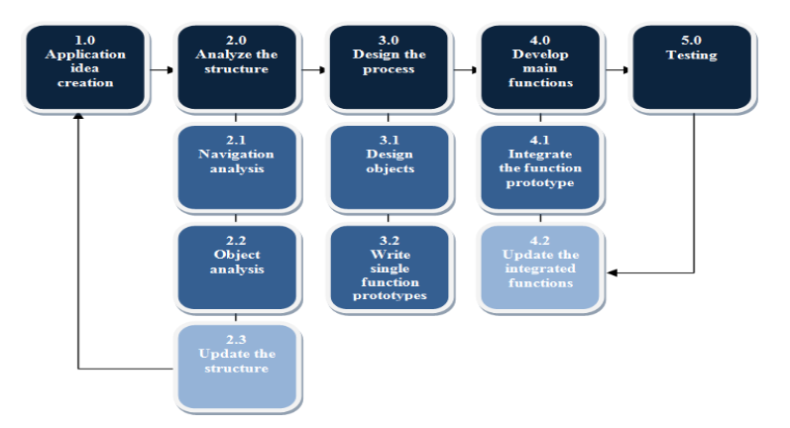

Figure 2: MMCD Model [11]
3.1 Application Idea Creation
Market analysis was performed and the information needed to start the application was prepared. An interview session was held with local Malaysian Makeup Artist, Mrs. Kausalya Venugopal to find out how this current pandemic affected the cosmetic industry in our country. Some of the information needed was problem statement, objective, scope and user requirement for AR Makeup Tester. Developer also will produce a timeline Gantt Chart to estimate and plan the time needed to complete the project.
Table 2. Hardware requirements
Hardware | Specifications
Laptop | - Acer Predator Helios 300
Central Processing Unit | - Intel Core i5-8300H CPU @ up to 4 GHz
Random Access Memory (RAM) | - 8GB DDR4 2666 MHz
Graphics Processing Unit (GPU)  Operating System | - Nvidia GeForce GTX 1060 6GB DDR5  - Windows 10

Table 3. Software requirements
Software | Specifications
Unity 2020.1.17f1 | - For the application development.
Microsoft Word | - For application’s documentation.
Visual Studio 2019 | - For application’s scripting.
Project Manager | - For project’s Gantt Chart
Adobe Photoshop CC 2018 | - For producing application’s logo and icon
Table 4. Functional requirement
Functional Requirement | Description
User Interaction Support | - The system shall provide user to test makeup product virtually.  - The system shall provide user to test makeup product in real time.  - The system shall provide user to choose different makeup products.  - The system shall provide user to choose different makeup shades/colors.  - The system shall provide user to purchase makeup products tested from online site.
Autonomous System Activity | - The system shall automatically show all makeup shades/colors available for each product.  - The system shall automatically show an overlay 3D object on user’s face once shades/color chosen.  - The system shall automatically direct user to online site to purchase makeup product once ‘Buy Now’ button clicked.  - The system shall automatically show all available makeup products to user.  - The system shall automatically load AR Camera once user proceed from main screen.

Table 5. Non-functional requirement
Non-Functional Requirement | Description
Usability | - Users can access this application anytime and wherever they are.
Implementation | - This application shall be able to operate by using any Android device with a front-facing camera and Android 8.0 above.
Performance | - This application can load any 3D objects on face within 3 seconds and must be an offline-based application.
Legal | - Users can only view the contents in this application but cannot modify the contents.
Cultural | - This application will be developed in English as it is a universal language.

3.2 Analyse the Structure
Two subcomponents will be mainly discussed in this phase which was the navigation of the application and the objects used in development process. For the navigation analysis, the flow of the application will be determined as shown in Appendix A. Content structure also will be introduced in this phase for the object analysis as shown in Figure 3.
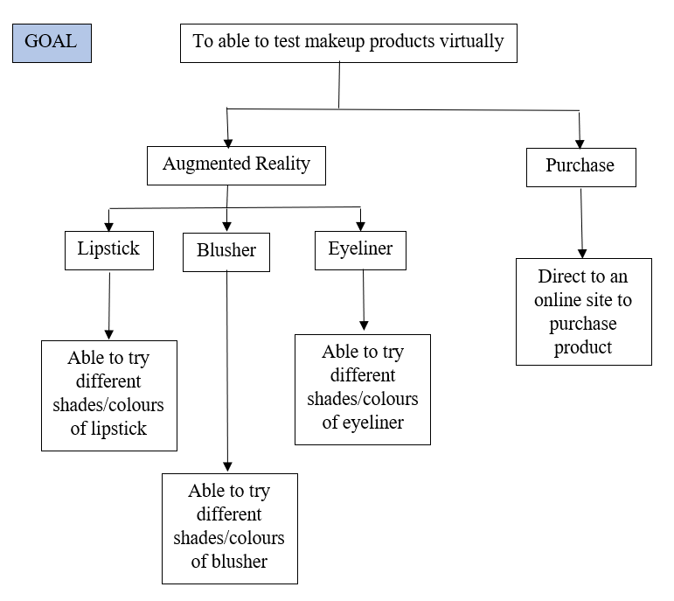
Figure 3: Content structure
3.3 Design the Process
This phase of the methodology consists of two components which are design the object and the single function prototype. This phase starts with prototyping the application and moves to the actual build of the application. All the objects used in AR Makeup Tester will be developed in this phase too. By the end of this phase, a complete prototype will design and developer will prepare to build the application based on prototype designed in next phase.
Table 6. User interface design
User Interface Design | Description
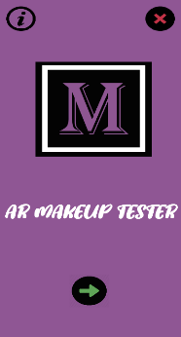 | Start Screen  - There are three buttons which are continue, exit and info.  - Continue button will proceed to product panel.  - Exit button will proceed to exit panel.  - Info button will proceed to application use instruction.
 | Exit Screen  - There are two buttons given in this screen.  - The tick button will exit the application as user confirms to exit.  - The cross button will proceed back to start screen.
Table 6. User interface design (cont)
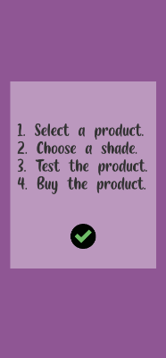 | Information Screen  - User can learn how to use this application in this screen.  - There is a button and a panel in this screen.  - The panel instructs user on how to use the application.  - The button will proceed back to start screen.
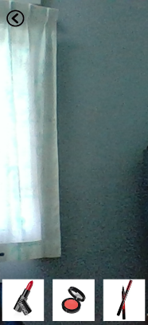 | Product Screen  - User can choose their makeup product in this screen.  - There four buttons and an AR Camera in this screen.  - Three of the buttons is for each of the makeup product which are lipstick, blusher and eyeliner.  - Another button is back button to return start screen.
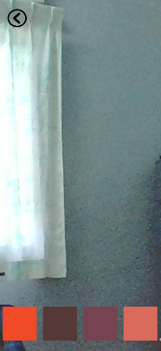 | Shades/Colors Screen  - User can choose shades/colors for the product they picked earlier in this screen.  - There two category of buttons and an AR Camera in this screen.  - The first category is the navigation button which is a back button to return product screen.  The second category is the shades/colors buttons.
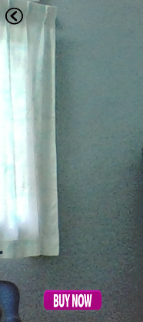 | Product Test Screen  - User can test their makeup product in this screen.  - There are two buttons and an AR Camera in this screen.  - The back button will proceed back to previous screen.  The ‘Buy Now’ button will provide to an online site to purchase the product.

3.4 Develop Main Functions
All functional and non-functional requirements previously declared will be developed. The buttons of the AR Makeup Tester will be linked to form a proper working application. This phase usually takes a longer time than other phase because the actual development of AR Makeup Tester will be carried out in this phase. C-sharp language was used in Microsoft Visual Studio to develop the requirements for the application.
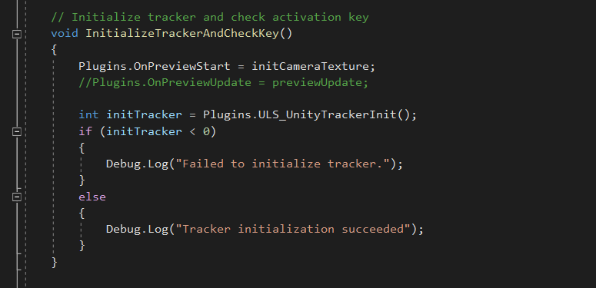
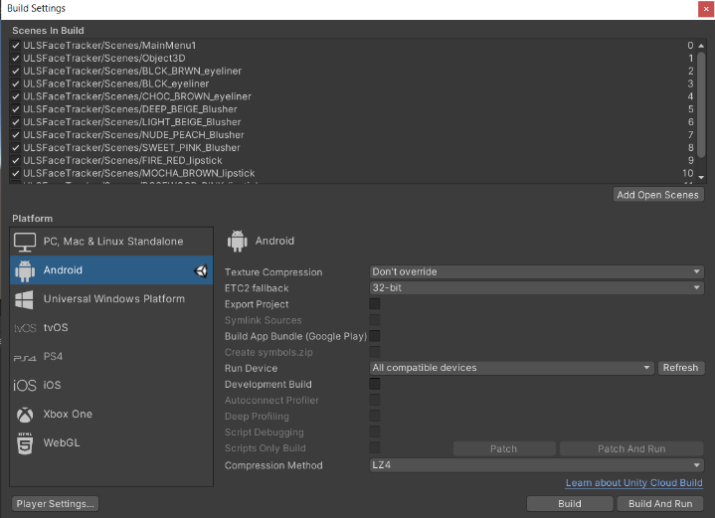
Figure 4: Build settings and scripting
3.4 Testing
AR Makeup Tester will be tested every time once a function is developed throughout the development process. Once all the functions and requirements were fully developed, alpha testing will be carried out by developer. In alpha testing, the functionality of buttons, screen navigation and face tracking were tested. Some of the results were tabulated in Table 7.
Table 7. Alpha Testing
Test | Expected Result | Actual Result |  | Actions Taken
Information Button | Access Information Panel. | Works well. |  | Not taken.
Proceed Information Button | Proceed to Start Page from Information Panel. | Works well. |  | Not taken.
Exit Button | Kill the application. | Works well. |  | Not taken.
Confirm Exit Button | Confirm kill the application. | Works well. |  | Not taken.
Cancel Exit Button | Back to Start Page from exiting the application. | Works well. |  | Not taken.
Start Button | Proceed to Main Menu to use the application | Proceeds to Main Menu but the AR Camera is not working. |  | AR Camera was initialized in the script.
Back Button | Back to previous interface. | Works well. |  | Not taken.
Buy Now Button | Navigates to online site to buy cosmetic product. |  | Does not do anything. | Script was debugged and buttons were linked to the corresponding URLs.
Cosmetic Product Button | Access the chosen cosmetic product. |  | Works well. | Not taken.
Shades/Colors Button | Access the chosen shades/colors. |  | Overlaps the Cosmetic Product Interface. | Hide Cosmetic Product Interface once this button clicked.

Based on the table 7, there are few errors encountered like start button was not initializing AR Camera and shades/colors buttons overlaps cosmetic interface but these errors were resolved during eventually.
Then beta testing will be carried out by target users. A set of 10 randomly picked target users were asked to use AR Makeup Tester and then were given a questionnaire to answer. System Usability Scale (SUS) method will be used to evaluate user acceptance level based on the questionnaire answered by target users. And lastly, AR Makeup Tester will be ready to publish to any online website or online store.
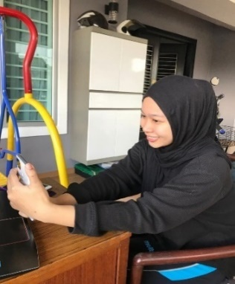

Figure 5: Target user is doing beta testing
4. Results and Discussion
This section discusses the results obtained from beta testing and user acceptance test using System Usability Scale (SUS). In beta testing, 10 target users are randomly picked to test AR Makeup Tester. Then, they were provided with a questionnaire consists of close-ended questions. The answers were scaled based on Likert Scale. Figure 6 and 7 shows outcomes from beta testing.

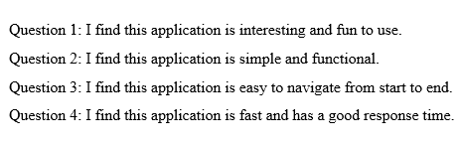
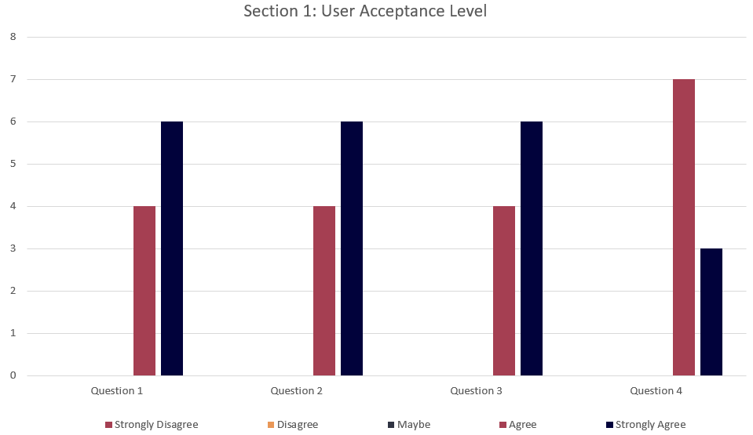

Figure 6: User acceptance level analysis

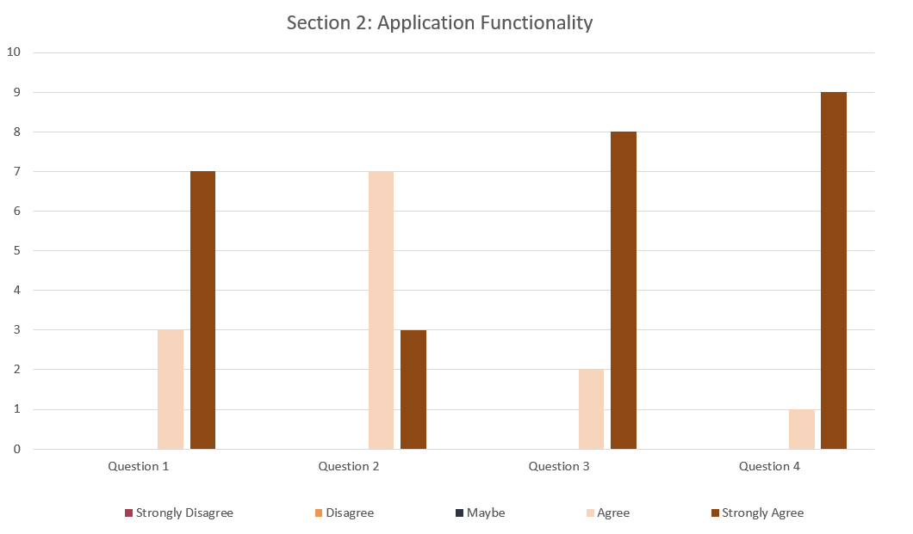
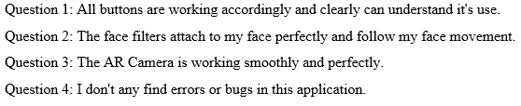
Figure 7: Functionality analysis
Figure 6 and 7 shows the questions asked in the questionnaire distributed to randomly picked target users.
Table 8. Respondent’s scores based on Likert points
No. | Question | Likert Points |  |  |  |  | Points
No. | Question | 1 | 2 | 3 | 4 | 5 | Points
1. | I find this application is interesting and fun to use. | 0 | 0 | 0 | 4 | 6 | 46
2. | I find this application is simple and functional. | 0 | 0 | 0 | 4 | 6 | 46
3. | I find this application is easy to navigate from start to end. | 0 | 0 | 0 | 4 | 6 | 46
4. | I find this application is fast and has a good response time. | 0 | 0 | 0 | 7 | 3 | 43
5. | All buttons are working accordingly and clearly can understand it's use. | 0 | 1 | 0 | 3 | 7 | 47
6. | The face filters attach to my face perfectly and follow my face movement. | 0 | 0 | 0 | 7 | 3 | 43
7. | The AR Camera is working smoothly and perfectly. | 0 | 0 | 0 | 2 | 8 | 48
8. | I don't any find errors or bugs in this application. | 0 | 0 | 0 | 1 | 9 | 49
Total |  |  |  |  |  |  | 368

Table 8 shows the tabulated data of the SUS survey. The survey obtained a total of 368 marks based on the Likert scale points. The data gathered is measure using the SUS formula:
$$Y=\frac{P}{Y} ×100 Eq.1$$

Where:
P = Total scores of respondents for each question.
Q = Total maximum of respondents scores.
Y = Percentage score.
Hence:
$$Y=\frac{368}{400} ×100$$
$$=92\%$$

The result of the survey is 92% which falls on acceptable margin when the results were compared with the scale of SUS shown in Figure 8 [12].
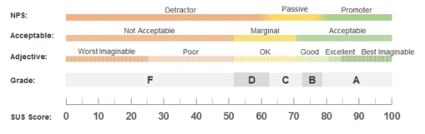
Figure 8: System Usability Scale (SUS) [12]
- Conclusion
In a nutshell, the AR Makeup Tester will be a suitable application for users to test their makeup products virtually and buy them for an online site. By following Multimedia Mobile Content Development methodology, AR Makeup Tester was successfully developed and tested in the given time frame. The objectives set before the AR Makeup Tester development process were successfully achieved too. The testing conducted helped AR Makeup Tester to identify the advantages and disadvantages of the application. The advantages of AR Makeup Tester are it has high user acceptance level which is 92% based on System Usability Scale (SUS) survey and it works well without any bugs and problem. Apart from that, AR Makeup Tester also is an icon-based application which makes it user friendly and offer easy navigation to users. AR Makeup Tester was built for Android platform hence it will reach more users. As every application has its own limitations and disadvantages, AR Makeup Tester is not an exclusion as it has its own limitations. AR Makeup Tester has only three makeup testers with limited shades available for each makeup tester. AR Makeup Tester only uses 30-point face mesh which causes some face filters do not attach very well to the face. And lastly, AR Makeup Tester only runs in Android platform only. With the limitations were listed, there are some suggestions were listed based on the current limitation of AR Makeup Tester. Firstly, add more makeup testers and add more shades available for each makeup tester. Then, replace the 30-point face mesh with a higher point face mesh so that the face filters attach well on user’s face. Develop this application in iOS platform so that AR Makeup Tester will reach more users.

Acknowledgement
The authors would like to thank the Faculty of Computer Science and Information Technology, Universiti Tun Hussein Onn Malaysia for their support and encouragement throughout the process of conducting this study.

APPENDIX A

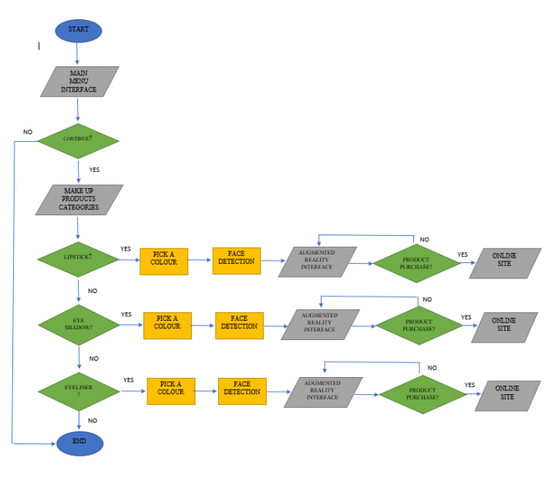
Figure 1: Flow Chart of the application

References

[1] “What is Augmented Reality technology and how does AR work - 2021,” Thinkmobiles, 15, Jun 2020. [Online]. Available: https://thinkmobiles.com/blog/what-is-augmented-reality/. [Accessed: Sept. 2, 2020].
[2] H. Altinpulluk, “CURRENT TRENDS IN AUGMENTED REALITY AND FORECASTS ABOUT THE FUTURE,” ICERI2017 Proceedings. [Online]. Available: https://library.iated.org/view/ALTINPULLUK2017CUR. [Accessed: Sept. 10, 2020].
[3] S. Clark, “Top 5 Benefits of Using AR for Your Business,” CMSWire.com, 19, Dec. 2019. [Online]. Available: https://www.cmswire.com/digital-experience/top-5-benefits-of-using-ar-for-your-business/. [Accessed: Sept. 15, 2020].
[4] K. Streit, “University Runs Tests On Germs Contained In Makeup Testers, Here's What You Need To Know,” Simplemost, 3, Nov. 2017. [Online]. Available: https://www.simplemost.com/makeup-testers-safety-hygiene/. [Accessed: Sept. 15, 2020].
[5] “SimplySiti,” Wikipedia, 21, Aug. 2020. [Online]. Available: https://en.wikipedia.org/wiki/SimplySiti. [Accessed: Sept. 17, 2020].
[6] S. C.-Y. Yuen, G. Yaoyuneyong, and E. Johnson, “Augmented Reality: An Overview and Five Directions for AR in Education,” The Aquila Digital Community. [Online]. Available: https://aquila.usm.edu/jetde/vol4/iss1/11/. [Accessed: Oct. 1, 2020].
[7] “What is Augmented Reality technology and how does AR work - 2021,” Thinkmobiles, 15, Jun 2020. [Online]. Available: https://thinkmobiles.com/blog/what-is-augmented-reality/. [Accessed: Oct. 1, 2020].
[8] “Virtual Makeup Try On - Makeup Tool - Makeup Tips,” Maybelline. [Online]. Available: https://www.maybelline.com/virtual-try-on-makeup-tools. [Accessed: Oct. 17, 2020].
[9] Beauty AR Company and Makeup AR Technology Platform. [Online]. Available: https://www.perfectcorp.com/consumer/apps/ymk. [Accessed: Oct. 17, 2020].
[10] “The fastest way to share a moment!,” Snapchat. [Online]. Available: https://www.snapchat.com/. [Accessed: Oct. 17, 2020].
[11] View of MULTIMEDIA MOBILE CONTENT DEVELOPMENT FRAMEWORK AND METHODOLOGY FOR DEVELOPING M-LEARNING APPLICATIONS. [Online]. Available: https://publisher.uthm.edu.my/ojs/index.php/JTET/article/view/481/332. [Accessed: Nov. 12, 2020].
[12] “SUS System Usability Scale,” Petra Quilitz, 30, Jun 2020. [Online]. Available: https://petraquilitz.de/sus-system-usability-scale/. [Accessed: Apr. 15, 2020].

