Tennis Ball Collector Machine

Muhammad Aizat Shahmin Azman¹, Aizan Ubin¹*

¹Faculty of Electrical and Electronic Engineering,
Universiti Tun Hussein Onn Malaysia, Parit Raja, Batu Pahat, 86400, MALAYSIA

*Corresponding Author Designation

DOI: https://doi.org/10.30880/eeee.2023.04.02.087
Received 13 July 2023; Accepted 10 September 2023; Available online 30 October 2023

Abstract: During training sessions, it is typical for tennis players to hit many tennis balls across the court. Collecting these balls manually can be time-consuming and tedious. This project intends to create an automatic tennis ball collector that relieves players of the stress of manual retrieval, allowing them to concentrate on training. The tennis ball picker machine uses vision-based technology, object-tracking techniques, and digital image processing to detect and track tennis balls. By assessing their colour, shape, and size attributes, the system properly recognizes the tennis balls' location on the court. The image sensor Pixy 2.1 CMUcam5 feeds the machine with the ball's position coordinates, enabling accurate movement control. The Pixy 2.1 camera's input of the machine's coordinates ensures efficient navigation towards the desired ball spot. Additionally, infrared sensors are added to identify tennis balls, which will be shown in the Blynk app the counting ball was collected, while the Pixy2 CMUcam5 camera sensor expands the detection range to 100 cm. A combination of an Arduino Uno microprocessor and an ESP8266 V3 allows the machine to retrieve a tennis ball in less than seven seconds every 20 cm distance of the ball. Tennis players who wish to improve their skills through concentrated practice sessions will find the automatic collector tennis ball machine to be an invaluable aid. It eliminates the requirement for manual ball collection, allowing for longer training times. The machine was tested on the Tennis Court UTHM to ensure that it worked properly in a real-world situation. Life is made easier by technological advances such as IoT system that was implemented in the project. Manual collector ball machines are a cost-effective option in instances where funds are limited. The decision between manual and automatic collector ball machines is ultimately determined by the individual's needs, budget, and preferences. Both choices have significant advantages and disadvantages, and players can choose the most appropriate option based on their needs.

Keywords: Tennis Ball Collector, Vision-Based Technology, Automatic Collector, IoT System

1. Introduction
Tennis is a sport typically played between two teams of two or four players. Each player uses a tennis racket to hit the ball over the net and into the opposing player's court. The game was established by European monks to be performed at religious events for entertainment purposes. In the initial phase, the ball was struck with the hand. Soon after, leather gloves were developed, along with racquets offering adaptable handling, and excellent hitting, and serving capabilities. The tennis ball has also undergone numerous changes, evolving from a wooden ball to an artificial fibre ball. The modern tennis ball has a diameter of around 6.54 cm and is coloured optic yellow [1]. Since its inception, tennis court dimensions have experienced a few colour and width modifications. Currently, the most prevalent tennis court dimensions for major competitions are 36 feet wide by 78 feet long [2].
Image processing is a mature field that utilizes techniques to transform images. It has a multitude of uses, including enhancing image sharpness, reducing image size, and representing object contours. The primary objective of image processing is to automatically extract information from an image with minimal user interaction. Computer graphics, on the other hand, use geometric primitives such as lines, circles, and free-form surfaces to create visuals. Machine vision analyses images by assessing geometric primitives and other features from photographs. In essence, computer graphics generate images, while machine vision interprets images. Due to the increasing quality demands of manufacturers and customers, machine vision has become a significant technology in the manufacturing and quality control industries. Machine vision employs industrial image processing by mounting cameras above manufacturing lines and cells to visually evaluate goods in real time without operator intervention [2]. Its purpose is to develop an image-based model of the real environment, extracting vital scene information from two-dimensional projections of the three-dimensional reality. The introduction of machine vision systems has facilitated advancements in numerous other fields [3].
This project involves building an IoT system for a tennis ball machine. By utilizing the Wi-Fi module ESP8266, a training method-setting application can be connected to the machine. The maximum range of the Wi-Fi ESP8266 is approximately 100 meters (328 feet) in an open, obstruction-free area with a strong wireless signal. However, in a typical indoor setting with walls and obstacles, the range will be significantly reduced due to various hindrances, including walls and other electronic devices, that can restrict the maximum range. Additionally, the ESP8266 has a maximum output power of around 20 dBm, which is relatively modest compared to other wireless modules. The output power can be boosted using an external power amplifier [3].
Various strategies must be applied to the machine vision system in order to recognize specific patterns and objects, a subject highly relevant to this project. Using the Pixy2 camera, this project aims to gather valuable information about the existence and placement of tennis balls, which will then serve as input for the Tennis Ball Machine Navigation System [4].
Last but not least, there has been a notable change in the integration of advanced technology in tennis ball collection machines from earlier iterations to modern designs. Modern machines make use of cutting-edge technology like computer vision, sensors, and wireless connectivity, as opposed to older machines that depend on more basic mechanical mechanisms for ball collection. Accuracy, effectiveness, and user experience have all increased as a result of this transition. Modern machines use sophisticated vision-based systems with cameras and image processing algorithms, as opposed to earlier models that frequently used simple mechanisms for ball detection. Real-time data monitoring, adaptive navigation, and exact ball identification are all made possible by these systems. Additionally, modern machines have friendly user interfaces that show real-time statistics, such as the number of balls gathered, and may even be operated remotely using mobile apps [5]. These developments demonstrate the shift toward tennis ball collectors that are more intelligent, adaptable, and user-centric, which is consistent with the general trend of utilising technology to improve sports equipment functionality [6].
2. Materials and Methods
Figure 1 shows the circuit and the component connection using Fritzing software for the Tennis collector ball machine that uses a battery of 12vdc with a switch to power up the machine. Based on the circuit Arduino uno will be connected with 1 motor driver to control 4 motors for the navigation system. Then, it also connected with Pixy 2.1 and servo motor for detention ball and movement for 150 degrees from left to right. Next, ESP 8266 is for IoT implementation in this machine that will be connected to an IR sensor to count the ball and On or Off the motor Rs385 by using the Blynk app.
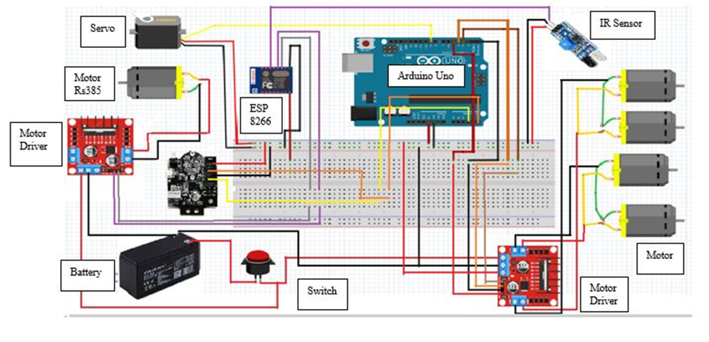
Figure 1: The connection of the circuit for the Tennis collector ball machine using Fritzing
Figure 2 shows how the smart tennis collecting ball operates. When the device is linked to the machine, the ball recognition system will activate to locate the ball using a Pixy 2.1 camera with an angle of 150 degrees from left to right and a maximum scanning distance of 100 cm. Then, when the ball is discovered, the navigation system will be engaged to travel to the ball's location. When the machine is close to the ball, the user must press a button on the Blynk app to activate the collecting system and count the number of balls gathered. After monitoring the number of balls gathered and completing a collection, the user must press the switch off on Blynk to stop the collecting system.
Figure 3 shows the nine components including the Motor RS385 and the IR sensor for the collector system are shown in the top view. Pixy 2.1, which uses a Servo motor Sg90 in its identification system, is another option. There is just one driver involved in the navigation system for all four motors, and that driver is l289N. Battery 12VDC and a single on/off switch round up the components needed to power the microcontroller (Arduino Uno) and Internet of Things (IoT) system (ESP8266 v3).
Figure 4 shows a different side view of the design at the UTHM tennis court. The first diagram shows the side that has a switch button to turn the machine on and off. Second, the front view shows the Pixy 2.1 camera and the collecting system, and the third diagram is a picture of when the machine is heading towards the ball.

Figure 2: Tennis Ball Collector Machine Operation Flow Chart

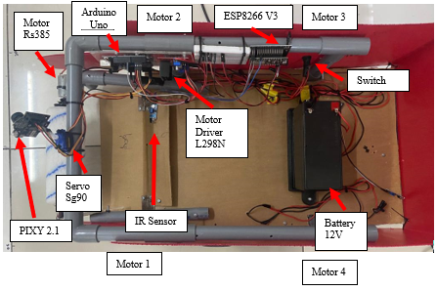
Figure 3: The arrangement component part
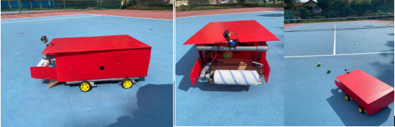
Figure 4: Complete design
3. Results and Discussion
All components installed at the Tennis ball collector machine have been tested. The result table was obtained from the testing and is discussed in this section.
3.1 Results
Using Figure 5, as a guide, the measurement for the distance that has previously been done to ensure that the distance is accurate.
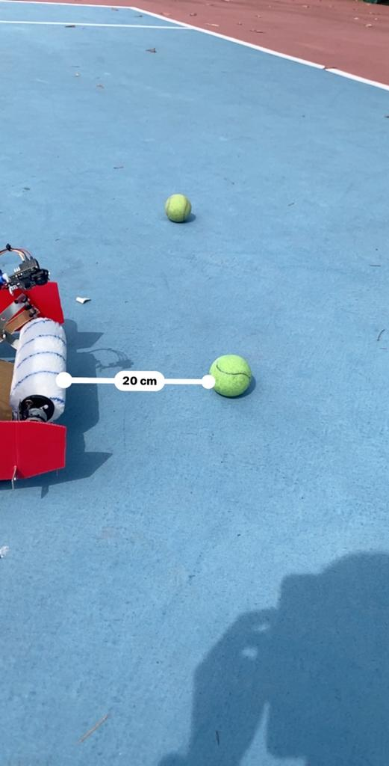
Figure 5: Distance machine with ball
According to Table 1, the range minimum and maximum for the detecting ball at a distance of camera pixy 2.1 are shown to be respectively minimal and maximum. The values in Table 1 range from 20 cm to 140 cm. According to those numbers, the Pixy 2.1 camera can identify objects up to a distance of 100 cm.
Table 1: The distance of the ball
Distance (cm) | Respond
20 | Detect
40 | Detect
60 | Detect
80 | Detect
100 | Detect
120 | Fail
140 | Fail
According to the findings in Table 2, which compiles data on the amount of time it takes for the machine to reach forward to the ball starting from 20 cm and going up to 100 cm, there is a significant difference in the amount of time it takes. Every 20 cm distance the time taken for the machine to finish collecting the balls is 5 seconds. Here, the minimum result is 20 cm taking 5 seconds and the maximum is 100 cm taking 25 seconds which has been tested.
Table 2: The time taken to the ball

Distance (cm) | Time(s)
20 | 5
40 | 10
60 | 15
80 | 20
100 | 25

3.2 Blynk Application
In accordance with Figure 6, the display counting ball can be monitored in real-time using a smartphone via the Blynk application to ensure that the balls have been collected, and another button on the dashboard is used to turn the collecting system on and off. Here, the number of balls counted and shown is 27, as 27 balls were used during testing to ensure the application was functioning well to receive the data from the machine in Figure 7.
 | 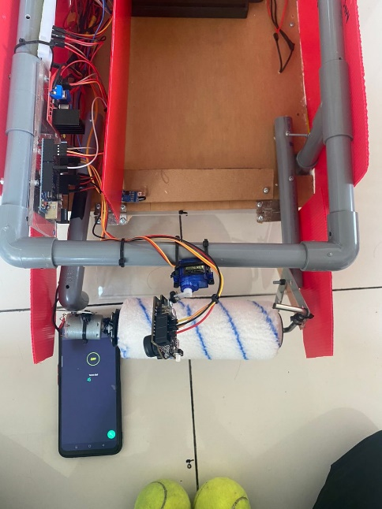
Figure 6: Blynk application | Figure 7: Collector system functioning

3.3 Position of The Ball
Based on Figure 8, by using the serial monitor on the Arduino IDE, the value displayed is the position of the ball by coordinates x and y to activate the navigation system to make the motor forward to the ball, and when the camera doesn’t find the ball, the camera will stop the motor. Here, the result shows that the detection camera greatly affects the movement of the motor towards the ball.

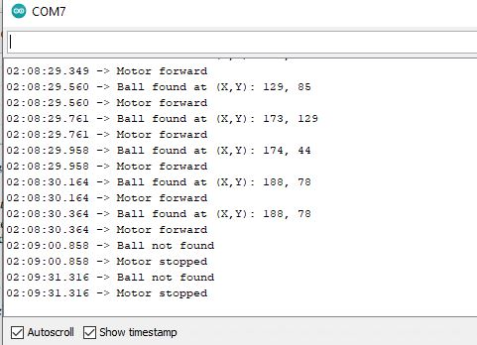
Figure 8: Position of the ball
4. Conclusion
In conclusion, the findings from the tennis ball collecting machine suggest that the recognition system operates based on range detection. Through testing ranging from 20 cm to 140 cm, the maximum range of the system was determined to be 100 cm. A ball that is within the range of 100 cm will be reached by the machine in around 25 seconds. Integration of Pixy 2.1 for recognition requires proper configuration according to the surrounding settings, such as adjusting for varied lighting conditions when used indoors or outdoors. This can be done depending on whether the device is being used inside or outside. These findings highlight how important it is to optimize the range of the identification system, take into consideration any speed requirements, and adjust the settings on the camera to guarantee that the tennis ball-collecting machine operates as effectively as possible.
Acknowledgement
The authors would also like to thank the Faculty of Electrical and Electronic Engineering, Universiti Tun Hussein Onn Malaysia for its support.
References
[1] S. D. Perkasa, P. Megantoro, and H. A. Winarno, “Implementation of a Camera Sensor Pixy 2 CMUcam5 to A Two Wheeled Robot to Follow Colored Object,” Journal of Robotics and Control (JRC), vol. 2, no. 6, pp. 469–501, Nov. 2021, doi: 10.18196/jrc.26128.
[2] International Tennis Federation.“ITF approved tennis ball,classified surface & recognized court a guide to product & Test Method,”Bank Lane,Reohamption Landon:ITF,pp.6-56,(2012).
[3] R. Mehta, F. Alam, and A. Subic, “Review of tennis ball aerodynamics,” Sports Technology, vol. 1, no. 1, pp. 7–16, Jan. 2008, doi: 10.1080/19346182.2008.9648446.
[4] R. Muthukrishnan and M. Radha, “Edge Detection Techniques For Image Segmentation,” International Journal of Computer Science and Information Technology, vol. 3, no. 6, pp. 259–267, Dec. 2011, doi: 10.5121/ijcsit.2011.3620.
[5] Z. Zhu, Y. Gao, and S. Gu, “Tennis Ball Collection Robot Based on MobileNet-SSD,” IEEE Xplore, Dec. 01, 2021. https://ieeexplore.ieee.org/abstract/document/9642172).
[6] J. Mesquita, D. Guimaraes, C. Pereira, F. Santos and L. Almeida, "Assessing the ESP8266 WiFi module for the Internet of Things," 2018 IEEE 23rd International Conference on Emerging Technologies and Factory Automation (ETFA), Turin, Italy, 2018, pp. 784-791, doi: 10.1109/ETFA.2018.8502562.

