Nature Pet’s House
Nur Aisya Rocky, Nurul Syafiqah Che Ani, Nurainaa Insyira Mohd Sani, Nor Baizura Hamid*
Department of Civil Engineering, Centre for Diploma Studies,
Universiti Tun Hussein Onn Malaysia, Pagoh Higher Education Hub,
84600 Pagoh, Johor, MALAYSIA

*Corresponding author: norbaizura@uthm.edu.my
DOI: https://doi.org/10.30880/mari.2025.06.03.008
Article Info | Abstract
Received: 1 March 2025  Accepted: 1 May 2025  Available online: 30 June 2025 | The Nature Pet's House project combines pet care with sustainable practices, emphasising cleanliness, energy efficiency, and cost savings through the use of natural odor-control materials and solar energy. This study aims to create a clean, environmentally friendly, and cost-effective environment for pets by using organic materials and renewable energy sources. Methodologically, the study used surveys to collect data on the preferences of pet owners and conducted tests using equipment to assess the effectiveness of materials and energy sources on the developed model. The results of the questionnaire analysis showed a significant acceptance and preference for natural odor-control materials such as charcoal among the respondents, which was 47% of the total number of respondents of 100 people. Of those surveyed, 51%–75% agreed that charcoal effectively reduces pet odours. The project lowers operating expenses and increases energy efficiency in the pet care industry by utilizing solar energy. The technique measured voltage and current using a multimeter. Using a multimeter in this project allows for precise measurement of electrical voltage, current, and resistance, ensuring the optimal performance and efficiency of the solar energy system used to power lighting, exhaust fans, and DC fans. The electric voltage and current produced by the Nature Pet's House model were 12.42 V and 2.85 A, respectively. Based on the findings, it is evident that using charcoal has benefits, including enhancing pet comfort and owner satisfaction while having a less negative environmental impact. The project's main objective is to explore how integrating eco-friendly technologies could enhance pet care and promote sustainable practices. The contributions of our study are study conception and design, data collection, analysis and interpretation of results, and draft manuscript preparation.
Keywords
Petcare, Charcoal, Solar, Odor Control, Pet’s House
1. Introduction
This study investigates the multifaceted benefits of charcoal as a deodorizer and solar energy as an economically viable and environmentally friendly power source for pet care, aiming to mitigate long-term electricity costs. Charcoal, commonly used as a fuel, doubles as an effective adsorbent, particularly in gas purification, eliminating sulfur, toxic gases, and smoke odors [1]. Its activated form selectively absorbs specific gases and chemicals in the air, making it ideal for odor control. Solar energy emerges as a practical alternative to power essential pet care devices such as fans and lights, especially during nighttime. Given the substantial electricity demand solely for pet-related purposes, solar power offers a cost-effective solution, particularly in regions with abundant sunlight like Malaysia. Furthermore, solar energy aligns with environmental sustainability, being a renewable and eco-friendly energy source. This study aims to evaluate the efficacy of charcoal as a deodorizer and the feasibility of solar energy for pet care through the development of a Nature Pet’s House. Testing will encompass assessing voltage and power output, along with the odor control effectiveness of charcoal. Surveys distributed to pet owners will provide invaluable insights into their experiences and preferences regarding pet care practices. The Nature Pet’s House project is a study focusing on pet care within residential environments, aimed at creating a model to address the discomfort faced by pet owners and surrounding communities. The objectives and targets of this study include obtaining insights from pet owners regarding the odor control materials used for pets, producing the Nature Pet’s House product, and testing the electricity generation from solar panels installed on the model.
To create a clean and fresh environment, the use of natural odor control agents has become increasingly popular compared to fragrances. This is because deodorizers can effectively eliminate foul odors, unlike fragrances that merely mask them temporarily. Two well-known agents for air purification are charcoal and baking soda. Charcoal, also known as carbon, possesses the ability to absorb gases in the air. Its structure creates interconnected pores that trap molecules, resulting in physical gas absorption phenomena [2]. Activated charcoal is often chosen to reduce continuous small-scale pollution due to its affordability and effectiveness in air and water purification [3]. Additionally, baking soda, also known as sodium bicarbonate, acts as a neutralizer for both acids and alkalis, effectively eliminating unpleasant odor [4]. Its natural neutralizing abilities make it versatile for various applications, such as preventing kitchen odors, neutralizing body odors, and the smell of pet urine [5].
This project aims to explore the potential of using solar energy as a substitute for electrical power in the context of energy provision for daily applications. Solar energy is a clean and renewable energy source, that has seen significant development and widespread adoption, playing a vital role in combating global warming and meeting growing energy demands. The use of solar can also reduce the negative impact on the environment, highlighting its environmental benefits [6]. Traditional energy sources, with their limited supply and harmful environmental effects, underscore the importance of transitioning to clean alternatives like solar energy [7]. This eco-friendly energy source not only contributes to a harmonious society but also addresses global warming caused by factors like population growth and industrialization [8]. Photovoltaic power generation, a widely employed method, harnesses solar energy by converting sunlight into electricity through photovoltaic cells within solar panels [7].
Table 1 presents a comparison between pet houses/cages commonly used by pet owners in the market and the Nature Pet’s House. Through this comparison, it becomes evident that Nature Pet’s House offers various benefits, providing advantages to pet owners over other pet cages. This is because Nature Pet’s House provides good ventilation through its use of an exhaust fan, utilizes an eco-friendly solar power source, and includes effective odor control with charcoal. These features ensure a healthier and more comfortable environment for pets while also being convenient and cost-effective for pet owners.

Table 1 Comparison between pet houses
Type of pet’s house | Pet cage | Modern Pet cage | Nature Pet’s House
Image | 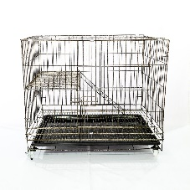 | 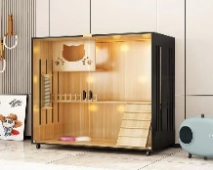 | 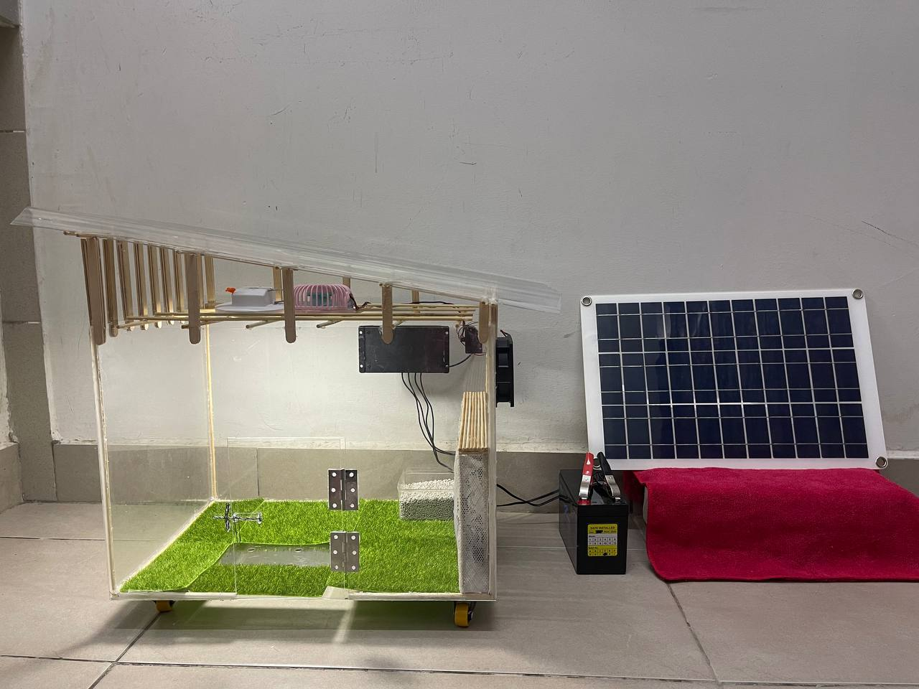
Wall material | Metal / Plastic | Wood and Glass | Acrylic
Lighting type | Natural lighting | Lamp | Lamp and natural lighting
Ventilation type | None | None | Exhaust fan
Power Source | None | Electricity | Solar
Placement | Indoor and Outdoor | Indoor only | Indoor and Outdoor
Odor Control Material | None | None | Charcoal
Cleanliness | Easy to clean | Hard to clean | Easy to clean
- Material and Method
The study was carried out according to the flow chart in Fig. 1. The procedures followed during this study are indicated in the diagram. The study methodology is essential for effective research as it encompasses methods, approaches, and techniques used to achieve research objectives based on valid data. It details specific methods and techniques to aid understanding of their application, describing the research process in detail. This section explains the methods used to study a problem, including research design, instruments, sample, and data analysis procedures.
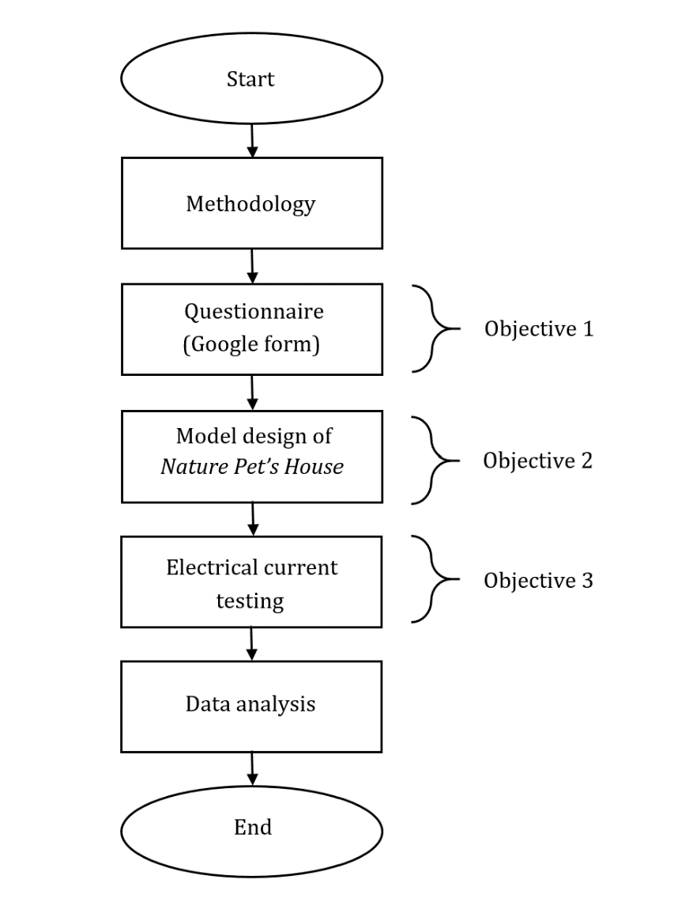
Fig. 1 Flowchart of the study

  - Materials
Solar panels, acrylic, polycarbonate roofs, an exhaust fan, charcoal, and an LED lamp were utilized in this study to design Nature Pet’s House, which incorporates charcoal as an odor reducer emitted by pet feces. Table 2 shows the material and their respective function in Nature Pet’s House.

Table 2 Material and function of Nature Pet’s House
Material | Function
Solar | Absorbs solar energy and converts it into kinetic energy, powering both the LED bulb and the fans used within Nature Pet's House
Led bulb | Provides illumination inside Nature Pet's House.
Acrylic | Allows natural light to penetrate, preserving a natural environment within pet houses.
Polycarbonate roof | Allow natural light to penetrate, preserving a natural environment within pet houses.
Exhaust fan | Acts as a ventilation system, expelling polluted air from the interior.
Charcoal | Absorbs unpleasant odors from animals.
DC fan | Regulate internal temperatures, effectively cooling Nature Pet's House

In conclusion, Nature Pet’s House integrates various materials and technologies to create a comfortable and environmentally friendly habitat for pets. Solar panels provide sustainable energy for lighting and cooling, while acrylic and polycarbonate roofs maximize natural light. An exhaust fan ensures proper ventilation, and charcoal helps maintain a clean and odor-free environment. The combined use of these materials and technologies ensures a pleasant and healthy space for pets.
  - Methods
    - Questionnaire
The first objective can be achieved through a questionnaire survey. Questionnaire surveys are a common research tool used by researchers to gather data. This is because questionnaires provide concise and comprehensive data that meet researchers' needs.
Based on the research data, a questionnaire was distributed to pet owners to understand how they care for their pets, given that the management of pets varies for everyone. This questionnaire has been distributed to 100 respondents which are pet owners online via Facebook using Google Form. The questionnaire comprises two parts: Part A collects respondent data, while Part B gathers respondents' experiences regarding pet management at home.
    - Model Design of Nature Pet’s House
The Nature Pet's House exemplifies a novel approach to sustainable pet care infrastructure, integrating solar panels to power essential components such as LED lighting and an exhaust fan. These panels harness renewable solar energy, ensuring continuous operation while minimizing costs and environmental impact. The house's design prioritizes functionality and ecological responsibility, incorporating advanced ventilation systems and activated charcoal for effective odor control.
Constructed using durable materials like acrylic and polycarbonate, the Nature Pet's House offers a harmonious environment that promotes pet well-being and aligns with modern ecological standards. Fig. 2 shows a detailed model design of Nature Pet’s House, including the front view in Fig. 2 (a), the side view in Fig. 2 (b), and the side view in and the side view in Fig. 2 (c). It is designed in AutoCAD; accompany this description. These visual representations illustrate the layout and structural integrity of Nature Pet's House, showcasing its innovative features aimed at improving pet comfort, environmental sustainability, and owner convenience in residential settings.

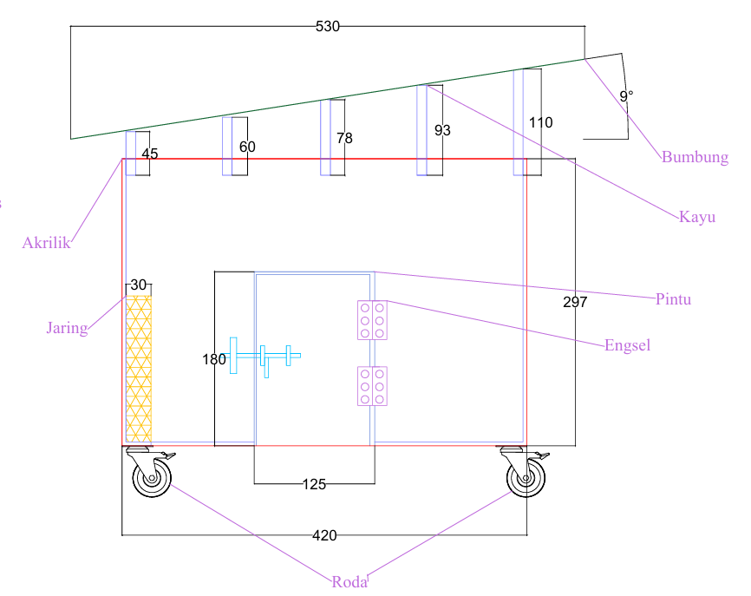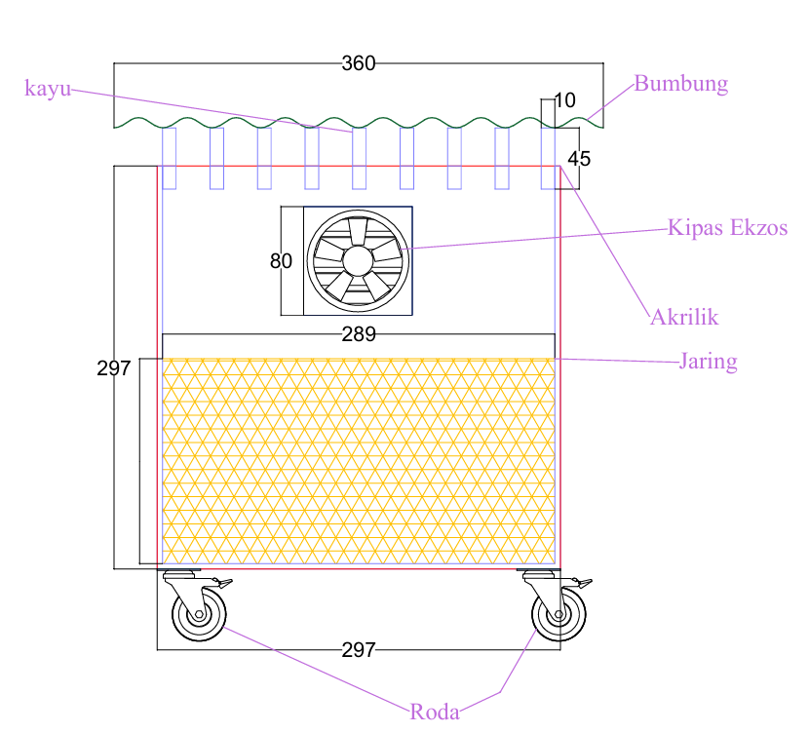
- (b)

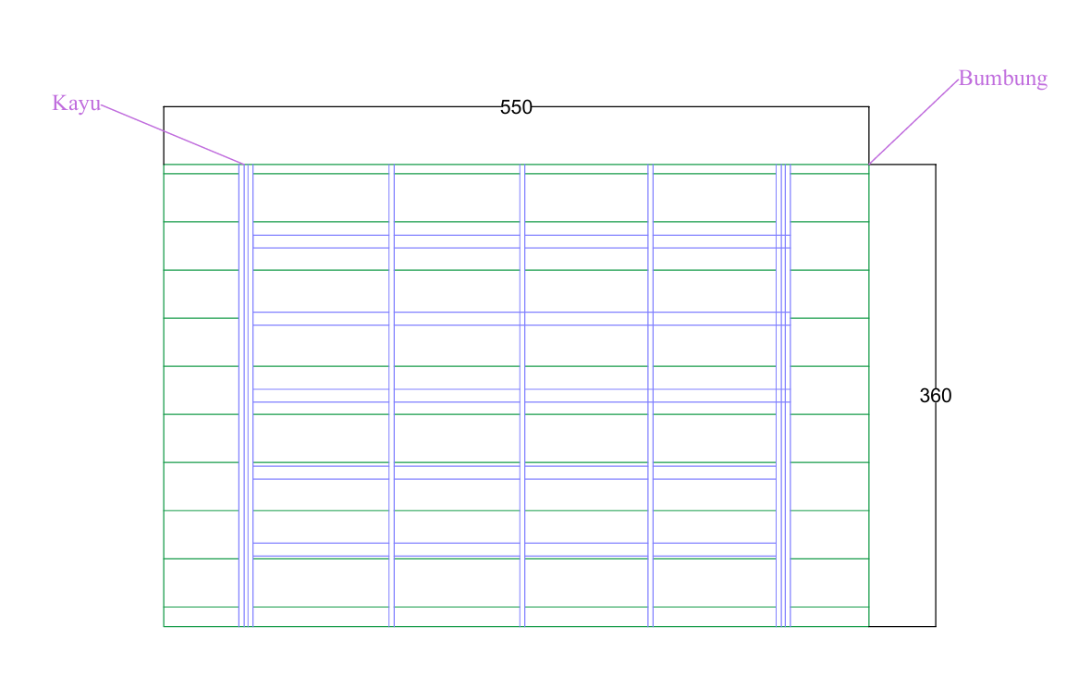
(c)
Fig. 2 Model Design using AutoCAD. (a) Front View, (b) Side View, (c) Plan View
2.2.3 Electrical Current Testing
The use of a multimeter device is the key to measuring electrical voltage, resistance, and electric current to the solar energy system of this Nature Pet's House project. In this project, solar energy is used to generate electricity for lighting bulbs, exhaust fans, and DC fans. The use of a multimeter as in Fig. 3 has been used to identify the voltage and current achieved to produce lamps, exhaust fans, and DC fans. Solar lighting affects the flow of current (Watts) in a light bulb. If the absorption of sunlight is constant and produces a lot of electricity, then the highest readings of the multimeter for lighting the light bulb can be identified. Thus, the readings of the voltage and current used for the ignition of the light bulb can be known.

Fig. 3 Multimeter
- Results
This section presents the findings and analysis from the conducted questionnaire, the development of the AutoCAD model, and the electrical current testing. The questionnaire results provide insights into respondent’s experiences and opinions on pet management, particularly focusing on natural material used by pet owners as odor control. The AutoCAD model illustrates the design and functionality of the “Nature Pet's House," highlighting key features such as odor control, ventilation, and lighting. Lastly, the electrical current testing evaluates the efficiency and reliability of the solar-powered components, including the fan, exhaust fan, and lighting system. Together, these elements offer a comprehensive understanding of the project's effectiveness and areas for potential improvement.
  - Questionnaire (Google Form)
The results from the questionnaire in Part B highlight concerns regarding respondents’ experiences with pet management at home. Fig. 4 illustrates the responses to the statement about whether pets should be housed in cages or pet houses. According to the data, 36% of respondents strongly agree and 17% agree with the statement. In contrast, 6% strongly disagree, 9% disagree, and 32% remain neutral. These findings suggest a mixed opinion on the necessity of caging pets, indicating that not all types of pets should be confined in this manner.

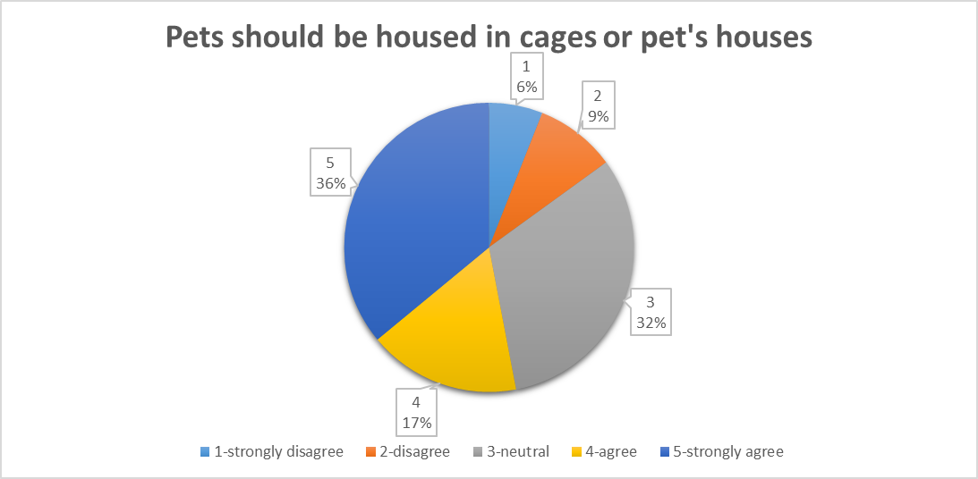
Fig. 4 Pets should be housed in cages or pet's houses

Fig. 5 presents the results related to the hygiene aspect of pet management, focusing on the statement that the first statement is hygiene in pet care is important and the second statement is cages or pet houses need to be cleaned at least three times a week. For the first statement, which emphasizes the importance of hygiene in pet care, 86 out of 100 respondents strongly agree, 11 agree, and 3 are neutral. Regarding the second statement, 52 respondents strongly agree, 36 agree, 3 strongly disagree, and 9 are neutral about the necessity of cleaning cages or pet houses at least three times a week. This shows that the majority of respondents take hygiene aspects in pet care management seriously.
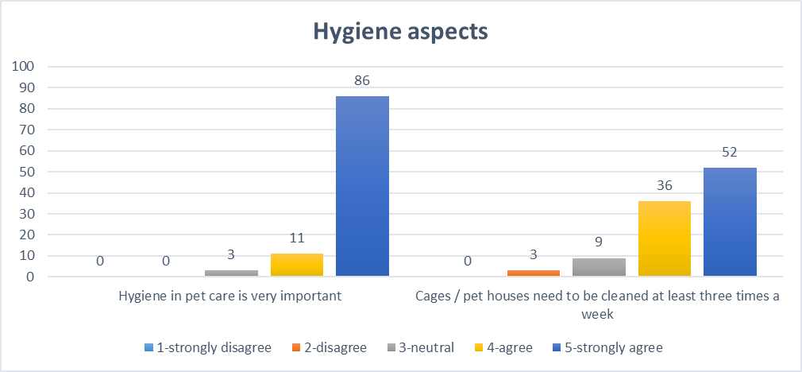
Fig. 5 Hygiene aspects

Fig. 6 displays the results related to the odor aspects of pet management, based on the statement that the first statement is pet waste odor can cause discomfort to pet owners and neighbors and the second statement is that foul odors from pet waste contribute to odor pollution. For the first statement, 75% of respondents strongly agree and 16% agree that pet waste odor can cause discomfort. For the second statement, 74% of respondents strongly agree and 15% agree that foul odors from pet waste contribute to odor pollution. This is shows that majority of respondents have the same problem which is pet odor management.

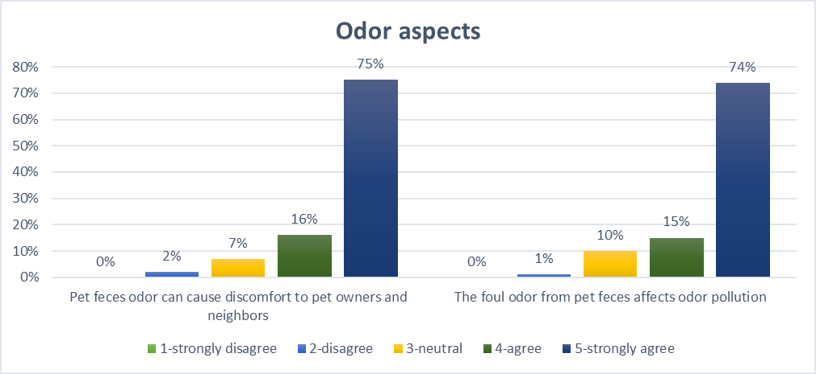
Fig. 6 Odor aspects

Fig. 7 and Fig. 8 illustrate the results regarding natural odor control materials used by pet owners and the effectiveness of the odor control materials. Fig. 7 identifies charcoal as the most used natural odor control material, chosen by 47% of pet owners. Fig. 8 shows that 56% of respondents find these odor control materials to be effective of 51% -75%. This effectiveness is attributed to charcoal's porous structure, which allows it to absorb gases and trap unpleasant odors. Additionally, charcoal is easy to obtain and easier to use.

Fig. 7 Natural odor control material used by pet owners.

Fig. 8 The effectiveness of odor control materials.
  - Model Design of Nature Pet’s House
Survey results from pet owners reveal several key issues related to pet management at home. A significant 36% of respondents strongly support the idea that pets should be housed in dedicated cages or pet houses, while 6% strongly disagree. The importance of hygiene is highlighted by 86% of respondents who strongly agree that maintaining cleanliness in pet care is crucial. Additionally, 75% of respondents strongly agree that pet waste odor causes discomfort, indicating a significant need for effective odor control solutions.
To address these concerns, Nature Pet’s House incorporates several innovative features. Solar panels are strategically placed to capture sunlight and convert it into electrical power, providing a sustainable energy source for essential equipment like LED lamps and fans. This not only ensures that the house operates efficiently but also supports eco-friendly practices by reducing reliance on non-renewable energy sources.
The design also includes an advanced ventilation system with an integrated exhaust fan to regulate air circulation. This system effectively expels stale air and maintains a fresh interior environment, addressing concerns about air quality and comfort for pets. Additionally, acrylic and polycarbonate roofs are utilized to maximize natural light penetration, creating a well-lit environment and reducing the need for artificial lighting during the day. For effective odor management, the house incorporates activated charcoal, which absorbs unpleasant odors from pet waste and ensures continuous air purification. These features collectively address the survey’s concerns about housing, hygiene, and odor control, providing a practical and eco-friendly solution for pet owners.
Fig. 9 Nature Pet’s House
Fig. 9 illustrates the design of Nature Pet’s House, showcasing how the model integrates sustainable technologies and innovative features to address key concerns identified by pet owners. The house effectively incorporates solar panels for sustainable energy, an advanced ventilation system, natural lighting through acrylic and polycarbonate roofs, and activated charcoal for odor control. These elements not only enhance the well-being of pets by providing a comfortable and clean-living environment but also reflect a strong commitment to environmental responsibility. By prioritizing both functionality and eco-friendly practices, Nature Pet’s House supports a harmonious living space for pets and their owners, aligning with the survey's findings and addressing critical issues related to pet housing, hygiene, and odor management.
3.3 Electrical Current Testing
As shown in Table 3, the readings were taken three times and recorded using a multimeter. The average data obtained for voltage was 12.42 V. While the current reading, the average reading that can be read is 2.85 A. Consistency in current readings indicates the accuracy of the measuring device used and the stability of the electrical system being tested. Variable multimeter readings are caused by inconsistent lighting. Unstable solar illumination and influenced by weather, and time of day can cause variations in the amount of solar energy absorbed by solar panels. Therefore, in obtaining stable and consistent voltage readings, lighting factors should be controlled and taken into account in the data analysis. With this, the readings of the data obtained show that the brightness of the light bulb and the predominance of the exhaust fan and fan on the Nature Pet's House model can work properly.
Table 3 Electrical Current Testing
 | First Reading | Second Reading | Third Reading | Average
Voltage (V) | 12.40 | 12.32 | 12.55 | 12.42
Current (A) | 2.86 | 2.85 | 2.85 | 2.85
4. Conclusion
In conclusion, the Nature Pet’s House project successfully achieved its primary objectives, providing valuable insights into the application of natural deodorizers, the effectiveness of green technology, and the creation of a functional model for pet care. The survey analysis highlighted that most pet owners are aware of and use natural deodorizers like charcoal to mitigate pet odors. This demonstrates the practicality and effectiveness of natural solutions in maintaining a clean and pleasant environment for both pets and their owners.
Furthermore, the project emphasized the importance of sustainable practices in pet care management through the integration of solar technology. The solar panel system, tested under controlled conditions, proved to be efficient and reliable in generating sufficient power to operate essential components like fans and lighting within the Nature Pet’s House. This aligns with our objective of promoting environmentally friendly solutions, showcasing how renewable energy can be practically utilized in everyday applications.
Lastly, the development and testing of the Nature Pet’s House model illustrated a comprehensive approach to enhancing pet welfare. The model's design incorporated features such as adequate ventilation, natural lighting, and odor control, addressing common concerns of pet owners. The project's success in creating a functional, sustainable, and aesthetically pleasing pet house highlights the potential for innovative solutions in pet care, fulfilling our objective of producing a practical and effective product. The Nature Pet’s House not only meets the needs of pets and their owners but also contributes to the broader goal of environmental sustainability.
Acknowledgment
The authors would like to thank the Centre for Diploma Studies (CeDS), Universiti Tun Hussein Onn Malaysia for their support. In addition, a heartfelt thank you to all team members for their dedication to the project and mutual support in making it a success.
Conflict of Interest
Authors declare that there is no conflict of interest regarding the publications of the paper.
Author Contribution
The authors confirm contribution to the paper as follows: study conception and design, data collection, analysis, interpretation of results, draft manuscript preparation: Nur Aisya binti Rocky, Nurainaa Insyira binti Mohd Sani, Nurul Syafiqah binti Che Ani. All authors reviewed the results and approved the final versionof the manuscript.

References

[1] | C. Rodriguez Correa, and A. Kruse, "Biobased functional carbon materials: Production, characterization, and applications—A review," Materials, vol. 11. no. 9, pp. 1568, 2018.
[2] | T. J. Bandosz, "Removal of inorganic gases and VOCs on activated carbons," In Adsorption by carbons, pp. 533-564, 2008.
[3] | S. Sircar, "Gas separation and storage by activated carbons," In Adsorption by carbons, pp. 565-592, 2008.
[4] | N. Qamaruz-Zaman, Y. Kun, and R. N. Rosli, "Preliminary observation on the effect of baking soda volume on controlling odour from discarded organic waste," Waste Management, vol. 35, pp. 187-190, 2015.
[5] | V. Lansky, "Baking Soda: Over 500 Fabulous, Fun, and Frugal Uses You've Probably Never Thought of Book Peddlers," 2009.
[6] | A. Krama, L. Zellouma, B. Rabhi, S. S. Refaat, and M. Bouzidi, "Real-time implementation of high-performance control scheme for grid-tied pv system for power quality enhancement based on mppc-svm optimized by pso algorithm," Energies, vol.11, no. 12, pp. 3516, 2018.
[7] | R. Afzal, Y. Tang, and H. Tong, "An integrated coupled inductor capacitor dc–dc high step‐up converter," International Journal of Circuit Theory and Applications, vol. 51, no. 6, pp. 2798-2818, 2023.
[8] | Q. Dou, T. Whatley, T. H. Syed, W. Wei, and H. Wang, "Carbon nanomaterials–polymer composites for perovskite solar cells: preparation, properties and applications," Journal of Materials Chemistry A, vol. 10, no. 37, pp. 19211-19230, 2022.

