The Influences of Competence and Motivation on Teacher Performance at Integrated Quran Primary School Nurul Islam Johar Karawang
Dalfanida Rahmawati¹, Asep Jamaludin¹*, Nandan^{1,} Amran Harun², Md Asrul Nasid Masrom³
¹ Management Study Program, Faculty of Economics and Business, Buana Perjuangan University Karawang, Jl. HS
Ronggo Waluyo, Teluk Jambe, Karawang 41361 West Java, INDONESIA
² Centre of Business Development, Faculty of Technology Management and Business, Universiti Tun Hussein Onn
Malaysia, 86400 Batu Pahat, Johor, MALAYSIA
³Center of Sustainable Infrastructure and Environment Management, Faculty of Technology Management and
Business, Universiti Tun Hussein Onn Malaysia, 86400 Batu Pahat, Johor, MALAYSIA

*Corresponding Author: asepjamaludin@ubpkarawang.ac.id
DOI: https://doi.org/10.30880/rmtb.2024.05.02.012
Article Info | Abstract
Received: 30 September 2024  Accepted: 01 November 2024  Available online: 01 December 2024 | This paper aims to analyse the influences of competence and motivation on teacher performance. The competence variable comprises knowledge, understanding, abilities and skills, value, attitude and interest. Motivation consists of the need for achievement, expanded relationships, and power. This is an associative quantitative research, and a questionnaire was used to collect the data. The study’s sample is 52 teachers from the Basic School of the Integrated Quran Nurul Islam Johar using a saturated sampling technique when the sample size equals the population. The data was analysed by the use of multiple linear regression using SPSS 29 software. This study showed that competency significantly influences teacher performance, while surprisingly, motivation was insignificant. Therefore, the school management must emphasise training, managing human resources, and improving the quality of learning, which would eventually enhance performance.
Keywords
Teacher competence, work motivation, teacher performance
- Introduction
Human resources refers to the people in the organisation. Human resources are essential because people or humans are the most significant element and are always available in an organisation. Management faces difficulties with human resources since the effectiveness of human resources affects not just management but also other areas of success. The corporation will continue functioning efficiently if its members or human resources can. In other words, the company depends on performance.
Teachers are an essential part of the educational process and are very influential in the continuity of education. Currently, teachers are required to become professionals in education. Teaching is a profession or position that requires special skills. Nobody outside the school sector can perform this kind of work. The teaching profession encompasses instruction and training; instruction entails maintaining and advancing moral principles, and training helps students acquire new abilities.
A teacher's performance is defined as their capacity to execute their professional duties as teachers and learners at school. It guides students to acquire knowledge and ethics (Muspawi, 2021: 101). This definition supports Nurhasanah's question (2009: 8), which states performance reflects the overall level of success a person achieves during a specific period while completing tasks, compared to a set of standards such as standard work results, targets, goals, or pre-established criteria that have been agreed upon.
According to the Law of the Republic of Indonesia, N0. 14 of 2005, better known as the Teachers and Lecturers Law, is good news for teachers as educators, namely the recognition of teachers as professionals. Artikel 1 point (4) from the Law declared professional is work or activity a person performs. It is a source of income that requires skills, skills, or abilities meeting specific quality standards or norms and requires professional education. It means that, on the one hand, there is recognition, which is very valuable for teachers. Still, on the other hand, there is guidance for hard work for teachers because to become a professional, you need several requirements which are not easy to fulfil, including having the necessary competencies.
This includes teacher performance, as seen from the ability of the teacher to undertake all tasks that are his responsibility. Excellent and high performance possessed by a teacher can help develop a school with many achievements and skilled students who are capable of competing in the current global era; some factors, including competence and motivation, can influence teacher performance in an educational institution (Susanto et al., 2021:1). As from year to year the development of the school is increasing. If a teacher's performance decreases, it can harm and impact the school. The total population is 52, according to the results of a pre-survey on 52 samples of Nurul Islam Integrated Quran SD teachers' performance as follows:
This is in contrast to BCA's Bank initiative to integrate environmentally friendly practices into their operations as an effort to reduce global warming, as shown in the results obtained in Figure 1. As follows:
Table 1 Results of Pre-Survey Performance of Nurul Islam Integrated Quran Elementary School Teachers (Researcher Data Collection, 2024)
No. | Question | No | Yes
1. | Does the teacher give lessons effectively and efficiently? | 12 | 40
2. | Are you always punctual in teaching? | 26 | 26
3. | Do you have a teaching method that is diverse? | 38 | 14

The pre-survey results in Table 1 explain that the performance of Nurul Islam Integrated Quran Primary School teachers was measured by indicators of diverse learning methods, with 38 out of 52 teachers stating that Nurul Islam Integrated Quran Elementary School teachers did not have diverse learning methods. A teacher's excellent and high performance can help develop a school. Teacher performance needs to be improved so that school development goals are achieved.
According to Arifin Hidayat (2020:2), it must be acknowledged that success or failure and whether development in the field of education is developing or not depends on competence and commitment; alignment between teacher goals and educational goals must be efficient and effective in every implementation. Considering the enormous contribution of teachers to academic progress, efforts to improve teacher quality are significant. Based on this, teachers should be appreciated by issuing policies to enhance teacher competence and welfare, including providing teacher rewards to create professional, qualified, dignified, and prosperous teachers. According to Kadek (2019), ability or competency factors can influence performance because, with high ability, employee performance can be achieved. According to the results of the pre-survey on 52 samples, the competence of Nurul Islam Integrated Quran Elementary School teachers is as follows:
Table 2 Pre-Survey Results of Nurul Islam Integrated Elementary School Quran Competency (Researcher Data Collection, 2024)
No. | Question | Low | Tall
1. | What teaching skills does the teacher have? | 42 | 10
2. | What competencies does the teacher have? | 15 | 37
3. | What interest do you have in teaching? | 8 | 44

The pre-survey results in Table 2 explain that indicators of knowledge, understanding, abilities, skills, values, and attitudes measure the competency of Nurul Islam Integrated Quran Elementary School. The teaching skills possessed by the Integrated Quran Elementary School teacher Nurul Islam are on a low scale of 42 out of 52 teachers. There is a need for evaluation, which causes teachers to state that their competency skills in teaching are not practical or not met.
A teacher's motivation is correlated with their attempts to meet their needs. This incentive pushes educators to complete assignments to satisfy their demands. Thus, there is a relationship between motivation and competence, which eventually develops the teacher's performance. The commitment to having motivation in the learning process, with good discipline, makes the teacher perform satisfactorily. On the other hand, a teacher with low work motivation will have low work discipline, leading to low teacher performance, too. The total population of Nurul Islam Integrated Quran Elementary School is 52. Based on the results of a pre-survey on 52 samples, the motivation of Integrated Quran Elementary School teachers is as follows:
Table 3 Pre-Survey Results of Nurul Islam Integrated Quran Elementary School Motivation (Researcher Data Collection, 2024)
No. | Question | Low | Tall
1. | What is your teacher's level of hope for getting sustenance from what you do? | 43 | 9
2. | What is your teacher's level of hope for getting a rank/position from what you do? | 20 | 32

The pre-survey results in Table 3 explain that the motivation of Nurul Islam Integrated Quran Elementary School, as measured by the level of hope of getting sustenance from what one does as a teacher, is still low for 43 out of 52 teachers. There needs to be an evaluation regarding meeting the need to sustain what is done as a teacher.
According to the results of previous research conducted by Arifin Hidayat (2020:10), the research results show that partial competency (X1) on teacher performance (Y) has an effect of 8.2%, which is positive and significant. Meanwhile, according to Nelawati Tanius (2018:9), the results of her research prove that motivation (X2) on teacher performance (Y) has a significant influence of 68.44%. Susanto et al. (2021:1) found that competence (X1) and motivation (X2) on teacher performance (Y) are stated to have a positive and significant effect.
The phenomenon described above is why researchers use competency and motivation factors to determine teacher performance at the Terpada Nurul Islam Elementary School, Johar Karawang. These factors are currently significant problems to solve, so they are not sustainable. The aims of this research are:
- To determine the effect of competency on teacher performance at the Nurul Islam Johar Karawang Integrated Quran Elementary School.
- To determine the effect of motivation on teacher performance at the Nurul Islam Johar Karawang Integrated Quran Elementary School.
- Literature review
According to Malayu SP Hasibuan (2016:19), management is the science and art referring to managing the use of human resources and other resources effectively and efficiently to achieve specific goals. Meanwhile, GR Terry assisted in planning, organising, initiating, and regulating actions to establish and accomplish goals using human resources and other resources, which is the standard process that makes up management (Sukama, 2011:6).
  - Human Resource Management
Mangkunegara, 2001 in Lijan Poltak Sinambela (2019:7) highlighted that the administration and usage of an individual's resources are human resource management. Furthermore, it is said that to accomplish corporate goals and human resources plans, organise, coordinate, carry out, and supervise the acquisition, development, and provision of services as well as the integration, maintenance, and division of labour, according to Malay SP. Hasibuan in Ni Wayan Dian Irmayanti (2021:1) stated that the science and art of managing employee relationships and roles to maximise productivity and help the organisation, employees, and society achieve its goals is known as human resource management.
  - Competence
Competence is a person's underlying characteristics about how well a person performs at work or the fundamental traits of a person that are causally related to or have a causal relationship with the reference criteria (Meita Pragiwani, 2020: 120). According to Mulyasa (2013:20), the teaching profession comprises a variety of scientific, personal, technological, social, and spiritual talents that determine the standard level of competence for professionalism. Based on Darmayanti's (2020: 106) statement, competency is the capacity to perform a task based on knowledge and abilities and reinforced by the work ethic demanded by the position. Sutrisno (2015:202), however, postulated that there are six indicators in the concept of teacher competency as follows: 1) Knowledge (knowledge), 2) Understanding (understanding), 3) Ability/Skills (skill), 4) Values ​​(value), 5) Attitude (attitude), 6) Interest (interest).
  - Motivation
Motivation is a psychological action that can arise due to several factors originating both from within and outside a person; through work motivation, a person will be able to carry out their work responsibilities optimally and thus, targets/goals can be achieved (A.Jamaludin & Nandang, 2022). Motivation is the passion to do well due to injection from outside or because there are different forces, such as influencing subordinates to be motivated to complete work according to organisational needs (Yohanes Susanto, 2021: 146). According to Nelwati Tanius (2018:16), motivation propels someone to act or accomplish a goal. Motivation can also be defined as a strategy or aspiration to succeed and avoid failure. Put differently, motivation is the process of achieving an objective. McClelland, in Muhammad Ridho (2020:7), however, stated that there are three indicators of motivation: 1) the need for achievement, 2) the need to expand social relationships, and 3) the need for power.
  - Teacher Performance
Mangkunegara (2017:67) mentioned that good performance resulted from an employee producing high-quality work while completing assignments in line with his obligations. Meanwhile, Kasmir (2016: 182) stated that performance is the outcome of the labour and conduct used to finish the assigned tasks and duties within the allotted time frame. Prinsa (2018:394) explains that a teacher's success in finishing their work is measured by their performance as an educator. Another opinion from Supardi (2016:54) states that teacher performance is the capacity of a teacher to carry out learning tasks in the classroom and to be accountable for the pupils under his supervision by raising their academic performance or learning outcomes. Prinsa (2018:394) states three indicators of teacher performance: planning learning programs, implementing learning activities, and evaluating or assessing learning outcomes.
  - Hypothesis Development and Research Framework
- The Influence Of Competency On Teacher Performance
A teacher's performance is defined as their capacity to execute his professional duties as a teacher and learner at school and his responsibility for guiding students to acquire knowledge and ethics (Mohammad Muspawi, 2021). Teaching is a profession that requires specific qualifications and competencies. Competence is the essential characteristic of an individual in an organisation in carrying out their work performance in a job carried out at an institution. According to Sutrisno (2016:203), competency is the capacity to perform tasks and work that refers to the established job requirements. It is based on skills and knowledge and is supported by attitudes and their application to work performance. Teachers must have a complete set of competencies as stated in Law no. 14 of 2005 concerning Teachers Article 10 Paragraph 1, which states that the competencies that teachers must have are the competencies as intended in Article 8, including social competencies, personality competencies, pedagogical competencies, and professional competencies obtained through professional education. Teachers with good competence will influence teacher performance, which is supported by the research conducted by (Arifin Hidayat, 2020) with the results of his study that competence influences teacher performance. Ni Kadek (2019) explains that ability or competency factors can influence performance because, with high ability, employee performance will be achieved. The theory explains that teacher competence and work motivation are what influence the teacher's performance, which is supported by the results of the research conducted by Susanto et al. (2021: 1), thus, it is concluded that:

H1: Competence has a positive and significant effect on teacher performance
- The Influence Of Motivation On Teacher Performance
Motivation is the desire to act because of external influences or different conditions, such as influencing subordinates to complete work according to organisational needs (Susanto, 2021). Factors that affect performance are motivation from within oneself in the form of needs and motivation from the work environment, as well as from the team and superiors. This explains that motivation influences performance, which is also attested to by the findings in research conducted by (Nelawati Tanius, 2018: 9), that indeed motivation impacts teacher performance. Susanto et al. (2021: 1), who presented the results of their research, proves that there is a significant influence of teacher competence and work motivation on teacher performance. Therefore, it is hypothesised that:

H2: Motivation has a positive and significant effect on teacher performance
  - Framework
The following is the framework for the study.
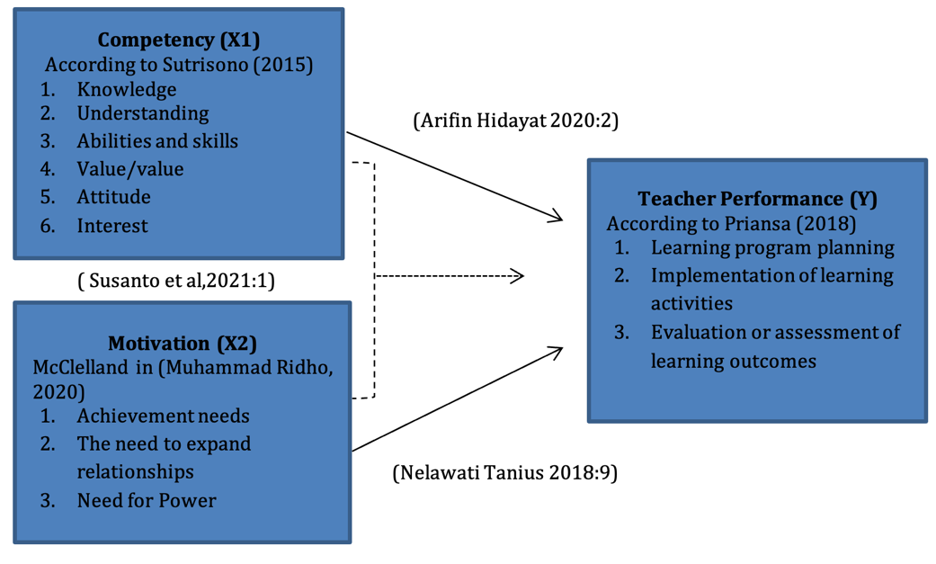
Fig. 1 Framework of Thought

- Research Methods
This study uses an associative type and a quantitative methodology. As stated by Juliandi, Irfan and Manurung in the research of Afandi & Bahri (2020), the purpose of associative research is to determine the relationship between two independent variables, X1 and X2 and the related variable Y, as well as the strength of their influence. This study aims to determine how much competence and motivation influence teacher performance at the Nurul Islam Johar Karawang integrated Koran elementary school. Therefore, quantitative methods are used to collect data, which can then be analysed statistically to determine the relationship and influence between these variables.
This study's population consisted of all 52 teachers at the Nurul Islam integrated Koran elementary school. Population is a collection of items or subjects with particular qualities that researchers select for examination before judgments are made from the research results (Sugiyono, 2018). Some of the population units are samples (Djali, 2021). All teachers at the Nurul Islam Integrated Quran Primary School, Johar Karawang, were taken as samples because the population was less than 100, so the total research sample was 52 people, which corresponds to the number of teachers at the Nurul Islam Integrated Quran School, Johar Karawang. The saturated sampling method, as explained by Sugiyono (Supardi & Anshari, 2022), is used when the population is the same as the sample.
The data collection techniques used a questionnaire distributed to all teachers at the Nurul Islam Integrated Quran Elementary School, Johar, Karawang. The questionnaire was given to respondents and contained questions about the influence of competence (X1) and motivation (X2) on teacher performance (Y). Respondents rated themselves on a scale of 1 to 5, where one is “strongly disagree” and five is “strongly agree”. Direct interviews were conducted between researchers and teachers to obtain further information about the research subject. The questions are asked to the concerned teacher. The competency variable had 19 question items, the work motivation variable had nine questions, and the teacher performance variable had 12 questions. This research used multiple linear regression analyses for data analysis using SPSS 29 software.

- Results And Discussion
  - Validity Test
The validity test for the Competency variable has 19 question items, the work motivation variable has nine questions, and the Teacher Performance Variable has 12 questions as follows.

Table 4 Competency Variable Validity Test Results
Variable | Items | R table | R count | Information
Competency (X1) | 1 | 0.300 | 0.604 | Valid
Competency (X1) | 2 | 0.300 | 0.568 | Valid
Competency (X1) | 3 | 0.300 | 0.520 | Valid
Competency (X1) | 4 | 0.300 | 0.497 | Valid
Competency (X1) | 5 | 0.300 | 0.542 | Valid
Competency (X1) | 6 | 0.300 | 0.508 | Valid
Competency (X1) | 7 | 0.300 | 0.452 | Valid
Competency (X1) | 8 | 0.300 | 0.570 | Valid
Competency (X1) | 9 | 0.300 | 0.514 | Valid
Competency (X1) | 10 | 0.300 | 0.498 | Valid
Competency (X1) | 11 | 0.300 | 0.502 | Valid
Competency (X1) | 12 | 0.300 | 0.401 | Valid
Competency (X1) | 13 | 0.300 | 0.397 | Valid
Competency (X1) | 14 | 0.300 | 0.394 | Valid
Competency (X1) | 15 | 0.300 | 0.433 | Valid
Competency (X1) | 16 | 0.300 | 0.377 | Valid
Competency (X1) | 17 | 0.300 | 0.432 | Valid
Competency (X1) | 18 | 0.300 | 0.316 | Valid
Competency (X1) | 19 | 0.300 | 0.407 | Valid

Table 4 indicates that all the questions of this research variable are valid because the value of the count (Pearson correlation) is greater than the r-table.
Table 5 Motivational Variable Validity Test
Variable | Items | R table | R count | Information
Motivation (X2) | 1 | 0.400 | 0.400 | Valid
Motivation (X2) | 2 | 0.400 | 0.526 | Valid
Motivation (X2) | 3 | 0.400 | 0.550 | Valid
Motivation (X2) | 4 | 0.400 | 0.603 | Valid
Motivation (X2) | 5 | 0.400 | 0.504 | Valid
Motivation (X2) | 6 | 0.400 | 0.488 | Valid
Motivation (X2) | 7 | 0.400 | 0.420 | Valid
Motivation (X2) | 8 | 0.400 | 0.411 | Valid
Motivation (X2) | 9 | 0.400 | 0.523 | Valid
Table 5 shows that all questions for this research variable are valid because the rcount (Pearson Correlation) value is greater than the r-table.

Table 6 Validity Test of Teacher Performance Variables
Variable | Items | R table | R count | Information
Teacher Performance (Y) | 1 | 0.400 | 0.462 | Valid
Teacher Performance (Y) | 2 | 0.400 | 0.519 | Valid
Teacher Performance (Y) | 3 | 0.400 | 0.436 | Valid
Teacher Performance (Y) | 4 | 0.400 | 0.470 | Valid
Teacher Performance (Y) | 5 | 0.400 | 0.414 | Valid
Teacher Performance (Y) | 6 | 0.400 | 0.420 | Valid
Teacher Performance (Y) | 7 | 0.400 | 0.483 | Valid
Teacher Performance (Y) | 8 | 0.400 | 0.418 | Valid
Teacher Performance (Y) | 9 | 0.400 | 0.405 | Valid
Teacher Performance (Y) | 10 | 0.400 | 0.479 | Valid
Teacher Performance (Y) | 11 | 0.400 | 0.501 | Valid
Teacher Performance (Y) | 12 | 0.400 | 0.442 | Valid
Source: Researcher Data Processing (2024)
Table 6 shows that all questions for this research variable are valid because the count value (Person Correlation) is > greater than the r-table.
  - Reliability Test
Examined objects undergo reliability testing after they are deemed legitimate. It is considered trustworthy if a variable consistently provides consistent answers to questions. Calculations are assisted with SPSS 29. The following table gives the results for the reliability of each variable.

Table 7 Variable X1 (Competency)

Reliability Statistics
Cronbach's Alpha | N of Items
0.800 | 19
Since the Alpha value is 0.800 > 0.60, it is considered that variable X1 is reliable.
Table 8 Variable X2 (Motivation)

Reliability Statistics
Cronbach's Alpha | N of Items
0.603 | 9

Since the Alpha value is 0.603 > 0.60, it is considered that variable X2 is reliable.

Table 9 Variable Y (Teacher Performance)

Reliability Statistics
Cronbach's Alpha | N of Items
0.647 | 12
Since the Alpha value is 0.647 > 0.60, it is considered that variable Y is reliable.

  - Normality Test

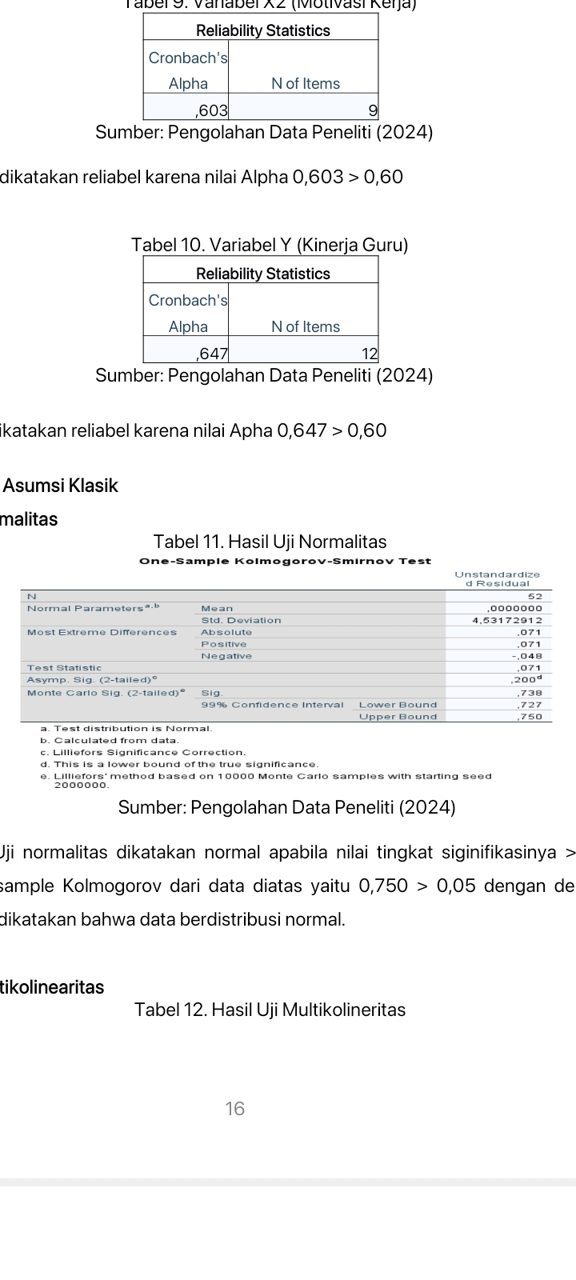
Fig. 2 Normality Test Results

If the value of the significance level is > 0.05, the test is considered normal. The results of the Kolmogorov sample of the data in the figure above are 0.750 > 0.05, so it can be said that the data is usually distributed.

  - Multicollinearity Test

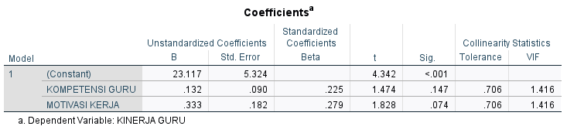
Fig. 3 Multicollinearity Test Results

If the VIF (variance inflation factor) is less than or <10 and the tolerance value is more than > 0.1, then multicollinearity in the model. According to the data above, it is known that the VIF value of variables X1 and X2 is 1.416 < 10, and the tolerance value is 0.706 > 0.1, so the data does not experience multicollinearity.

  - Heteroskedasticity Test
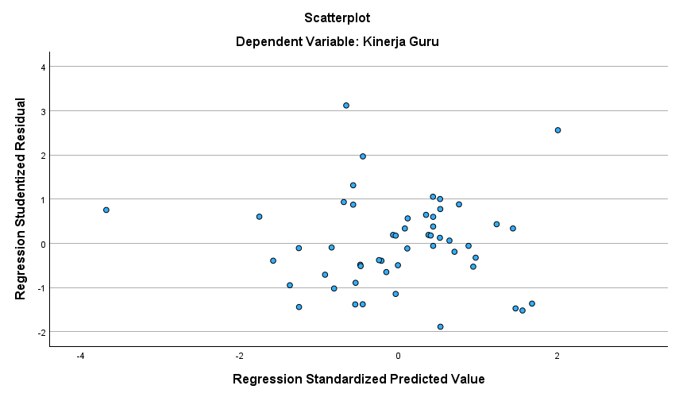

Fig. 4 Heteroskedasticity Test

If the dots spread above or below and form a specific pattern, heteroscedasticity does not occur. Based on the diagram above, it can be said that it does not show heteroscedasticity.
  - Multiple Linear Regression Test

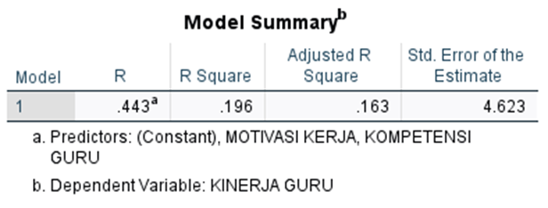
Fig. 5 Determination Test Results

The data processing results shown in the table above show that the determination value found in the R-square is 0.196, which indicates that the independent variable competency (X1) and motivation variable (X2) influence the teacher's work by 19.6%, the remaining 80.4% is affected by another variables that were not examined in this study.
  - Partial t-Test

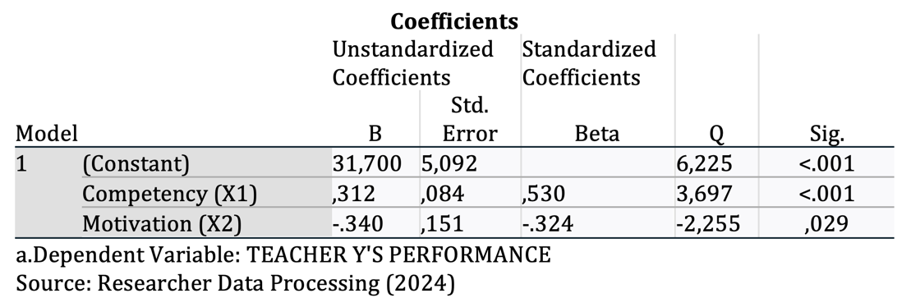
Fig. 6 t Test Results

Suppose the sig value is < 0.05 and the t value is > the t table value. In that case, it means that there is an influence of the variable on Y. Based on the table above, the t-test results (partial) prove that the significant value of the effect of competence (X1) on (Y) is 0.001 <0.05 and the t value is 3.697> t table value of 2.009, which means that there is a significant effect of competence (X1) on teacher performance. Meanwhile, the impact of motivation (X2) on Y is 0.029 < 0.005 and the t value of -2.225 < the t table value of 2.009, which means that motivation has no significant effect on teacher performance.
  - The Influence of Competency on Teacher Performance
Competence positively affects the improvement of teacher performance at Nurul Islam Johar Karawang Integrated Quran Elementary School. That is, teachers' performance will increase because they have adequate competence. Based on the results of SPSS 29 calculations, the T-test shows the value: sign. < 0.05, then there is an influence of these variables. This research's results align with (Arifin Hidayat, 2020:10).
  - The Influence of Motivation on Teacher Performance
There is no effect of motivation in improving teacher performance at Nurul Islam Johar Integrated Islamic Primary School in Karawang. By the calculation results through SPSS 29, in the T-test results, the significance value of motivation (X2) on teacher performance (Y) is 0.029 < 0.05, and the t value is -2.225 <2.009; it is known that there is no significant influence of motivation on teacher performance. The results of this research are not in line with Nelawati Tanius (2018:9).
- Conclusion
Considering the analysis results above, it can be concluded that competency significantly influences teachers' performance at the Nurul Islam Johar Karawang Integrated Quran Elementary School. The motivation does not affect and is not essential to the teacher performance of the Nurul Islam Johar Karawang Integrated Quran Elementary School.
      - Improved Teacher Training: According to research, teacher competence influences performance. Therefore, schools and the government must improve training programs and teacher competency development. Training can be focused on developing teaching skills, implementing effective learning methods, etc.
      - Human Resource Management: in accordance with research results showing a relationship between motivation to work and teacher performance, human resource management in schools is critical. School principals and management must consider factors that can increase teacher work motivation, such as incentives or other rewards.
      - Improving the Quality of Learning: Schools can design strategies to enhance classroom learning quality by paying attention to teacher competency and work motivation. Teachers with good competence and high motivation tend to provide more effective teaching and motivate students to learn better.
Acknowledgement
The authors would like to thank University Buana Perjuangan Karawang and Universiti Tun Hussein Onn Malaysia for its support.
Conflict of Interest
Authors declare that there is no conflict of interests regarding the publication of the paper.
Author Contribution
The authors confirm contribution to the paper as follows: study conception and design: D.R., A.J., N., A.H. and M.A.N.M.; data collection: D.R., A.J., N., A.H. and M.A.N.M.; analysis and interpretation of results: D.R., A.J., N., A.H. and M.A.N.M.; draft manuscript preparation: D.R., A.J., N., A.H. and M.A.N.M. All authors reviewed the results and approved the final version of the manuscript.

References
Abdilah, Fadil, Asep Jamaludin, and Nandang Nandang (2022). Analisis Motivasi Kerja Pada PT. Markoni Mandiri Perkasa. Eqien-Jurnal Ekonomi dan Bisnis , 1.03 (2022), 14-21.
Busro, Muhammad (2019). Teori-Teori Manajemen Sumber Daya Manusia, Prenadamedia Group, Jakarta.
Darmawan Rahma (2020). Pengaruh Kompetensi, Motivasi, dan Kepuasan Kerja terhadap Kinerja Karyawan pada PT Elnusa TBK. Jurnal Ekonomi, 6(1).
Dessler, Gary (2019). Manajemen Sumber Daya Manusia, Edisi Kesepuluh, Prehalindo, Jakarta
Deswarta (2017). Pengaruh Kompetensi dan Motivasi terhadap kepuasan kerja dosen Fakultas Tarbiyah dan Keguruan UIN Sultan Syarif Hasim Riau. Jurnal Valuta, 3(1).
Dewi Anggia, Tiara (2015). Pengaruh Profesionalisme Guru dan Motivasi Kerja terhadap Kinerja Guru Ekonomi SMA se-Kota Malang. 3(1).
Hasibuan, Malayu, S. P. (2016). Manajemen: Dasar, Pengertian, dan Masalah. Edisi Revisi. Jakarta, Bumi Aksara.
Kasmir (2016). Manajemen Sumber Daya Manusia (Teori dan Praktik), Cetakan ke-1, PT Raja Grafindo Persada, Jakarta.
Mangkunegara, Anwar Prabu (2011). Manajemen Sumber Daya Manusia Perusahaan. Bandung, PT.Remaja Rosda Karya.
Moehariono (2012). Pengukuran Kinerja Berbasis Kompetensi. Raja GrafindoPersada, Jakarta.
Mokhlas (2016). Pengaruh Kompetensi dan Motivasi terhadap Kinerja Pegawai dengan Komunikasi sebagai Moderating pada Kecamatan Gayamsari Kota Semarang. Jurnal.
Robbin, P. S. (2006). Perilaku Organisasi, Alih Bahasa, Tim Indeks, Gramedia: Jakarta.
Sedarmayanti (2009). Sumber Daya Manusia dan Produktivitas Kerja, Mandar Maju, Bandung.
Sedarmayanti (2011). Manajemen Sumber Daya Manusia, Reformasi Birokrasi dan Manajemen Pegawai Negeri Sipil (cetakan kelima), Bandung, PT Refika.

