

RESEARCH PROGRESS IN MECHANICAL AND MANUFACTURING ENGINEERING
RPMME
e-ISSN: 2773-4765

Vol. 5 No. 2 (2024) 1-12
https://publisher.uthm.edu.my/periodicals/index.php/rpmme

Investigation of Microstructural and Mechanical Properties Of AA6061 Reinforced MgO Particle
Raudhah Othman1*, Muhammad Shazerin Farhan1

1 | Fakulti Kejuruteraan Mekanikal dan Pembuatan,  Universiti Tun Hussein Onn Malaysia, Parit Raja, 86400 Batu Pahat, Johor, MALAYSIA
*Corresponding Author: raudha@uthm.edu.my
DOI: https://doi.org/10.30880/rpmme.2024.00.00.000

Article Info | Abstract
Received: 29 October 2024 Accepted: 20 November 2024 Available online: 01 December 2024 | The present work deals with the fabrication of AA6061 metal matrix composites reinforced with different weight percentages of MgO (0%, 1%, 2%, and 5%,) produced using the powder metallurgy route. A low pressure of 318 MPa was applied for compacting the composites, which were then sintered at a temperature of 560°C for one hour. Optical microscopy was performed to study microstructural behavior, while EDAX analysis was conducted to ensure the presence of MgO particles. The Vickers microhardness test was conducted, revealing that the minimum hardness value of 19.24 VHN was obtained with no addition of MgO particles and the maximum hardness value of 30.86 VHN was obtained with the addition of 5% MgO particles. Additionally, compression tests were conducted to evaluate the compressive strength  and overall mechanical performance of these compositions by increasing MgO content. The minimum compressive value of 18.7083 MPa was obtained with no addition of MgO particles, and the maximum compressive value of 29.0835 MPa was obtained with the addition of 5% MgO particles.
Keywords
Compacting,sintering,
Microstructural,
Powder metallurgy

Introduction
Aluminum matrix composites are intensively studied due to their excellent strength, relatively high density, and function at high temperatures. These composites offer high strength, good workability, excellent machinability, and a high resistance to compression. Among the 6xxx series, AA6061 is a well-known aluminum alloy, regarded for its superior mechanical strength, making it suitable for replacing heavier metals in various applications at both ambient and heated temperatures [1].

Powder metallurgy is an excellent way to achieve stronger bonding between the matrix and nanoparticles [2]. Magnesium oxide (MgO) is a suitable reinforcement alternative due to its high melting point (T_{m} = 2800°C), compressive strength, hardness, and excellent thermodynamic stability. The mechanical properties of the composites are improved by the addition of MgO particles. Specifically, the hardness of the material increases with the addition of fine MgO particles. The Vickers hardness of the composites increases with finer MgO particles. An increase in MgO content up to 5% leads to an increase in the density of the composite. As the MgO content increases, the compression of the composite specimens increases.

© 2024 UTHM Publisher. All rights reserved.

This is an open access article under the CC BY-NC-SA 4.0 license.

This article reports on the microstructural and mechanical properties of AA6061 reinforced with MgO particles, which were integrated by powder metallurgy. The results show significant improvements in hardness and compression strength with the addition of MgO, indicating its potential for diverse engineering applications.

Despite its many advantages, aluminum also has a few disadvantages. One significant disadvantage is that it loses strength at high temperatures. Furthermore, while aluminum is generally resistant to corrosion, it can still corrode in severe circumstances, reducing its endurance. It also has moderate wear resistance, making it unsuitable for high-friction applications. Aluminium transmits electricity well. However, it is not as efficient as other materials. Furthermore, welding aluminum can be difficult due to the necessity for specialised procedures, particularly with unusual patterns and thickness. Despite these limitations, aluminum is still a popular and versatile material, with continuous research aimed at enhancing its performance for various applications. Therefore, this study aims to fabricate an Al-reinforced MgO matrix composite and to identify the correlation between the properties and microstructure with the alloy composition [3, 4].

Materials and Methods
  - Preparation of Composites
The AA6061/MgO composites were produced by using powder metallurgy. Table 1 shows the composition of AA6061 powders that were precisely weighed and mixed for 6 hours in a high-energy ball mill. A separate die and punch were created for compacting metal powders. The composition of MgO powder is displayed in Table 2. Green compacts, size 13 mm in diameter and 20±2 mm in height were produced through cold compaction at 318 MPa using a Carver Hydraulic Press Test System. The green compacts were then sintered in a tube furnace for an hour at 560°C. Fig. 1 and 2 show SEM images of AA6061 and MgO powders, respectively. Meanwhile, Fig. 3 shows the composites of AA6061 reinforced with MgO (0%, 1%, 2%, and 5%).
Table 1 Composition of AA6061
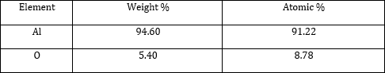
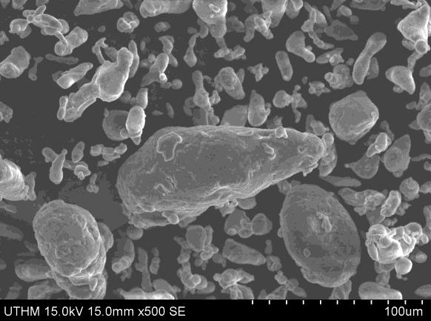
Fig.1 SEM image of AA6061 powders

Table 2 Composition of MgO
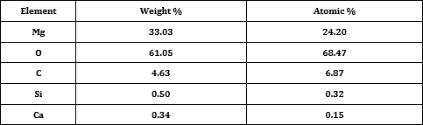

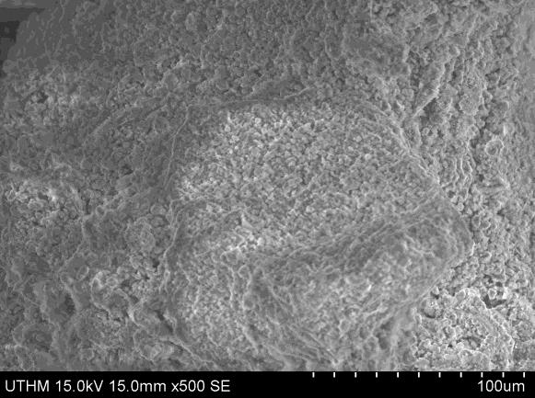
Fig.2 SEM image of MgO powders

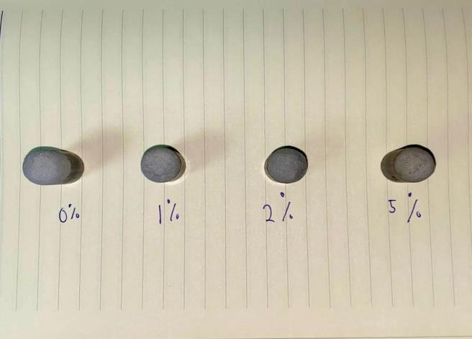
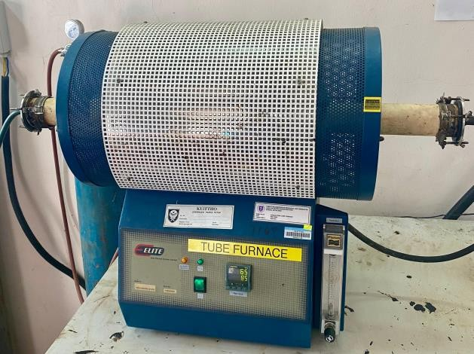
Fig.3 Samples After Compaction Fig.4 Tube Furnace

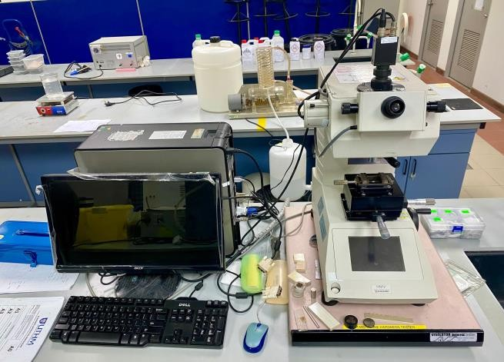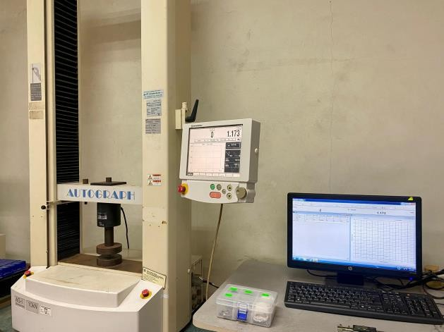
Fig.5 Vickers Micro Hardness Test Fig.6 Universal Testing Machine

Hardness Test
A Vickers micro-hardness tester was used to measure the hardness results. The test was done on polished samples of AA6061 and its composites. It was carried out at five different locations on each sample, and the average values are calculated. Fig. 5 shows the Vickers micro-hardness tester that was used for these measurements.

Compressive Strength Test
The compression test process begins with measuring the samples' length and width with a vernier caliper. These measures are crucial to identifying stress and strain. The samples are then placed in a Universal Testing Machine (UTM) (Fig. 6), which ensures they are properly aligned to prevent uneven loading. The UTM then applies a compressive load to the sample at a constant rate. During this procedure, the UTM records the force applied and the sample's deformation.

Results and Discussion
  - Microstructural Analysis
Figure 3 shows the samples after cold compaction. After compaction, the samples were sintered in a tube furnace at 560°C for one hour. Before conducting optical microscopy, the samples were polished and grinding using 200, 400, 600, and 800 grit abrasive paper, and then polished with diamond paste. Fig. 7 shows optical micrographs of AA6061 reinforced with MgO at 0%, 1%, 2%, and 5%. MgO particles were consistently dispersed throughout the matrix. Fig. 7(a) demonstrates that the AA6061 sample without reinforcement has increased porosity, with a big number of fine, round pores due to the low applied pressure [3]. Fig. 7(b) shows excellent bonding between AA6061 and MgO particles, with very few pore holes and a high density due to the small MgO particles mixed with the matrix material. Fig. 7(c) shows consistent particle distribution, although there are a few bigger voids, non-uniform cavities were caused by improper pressing [5]. Fig. 7(d) shows a homogeneous particle distribution, but with a few large, non-uniform pores. Porosity is more pronounced because MgO nanoparticles are less aggregated in powder metallurgy.

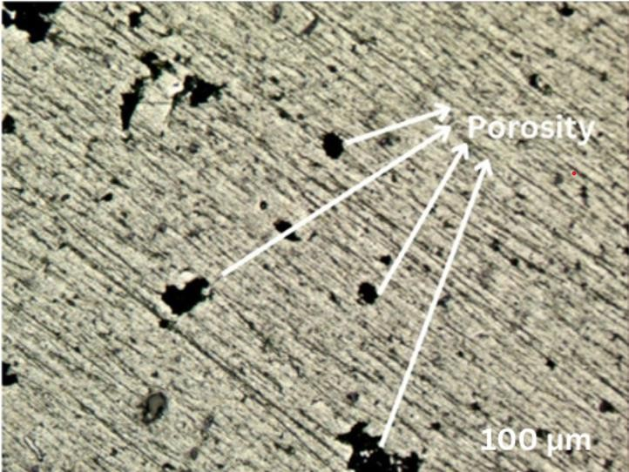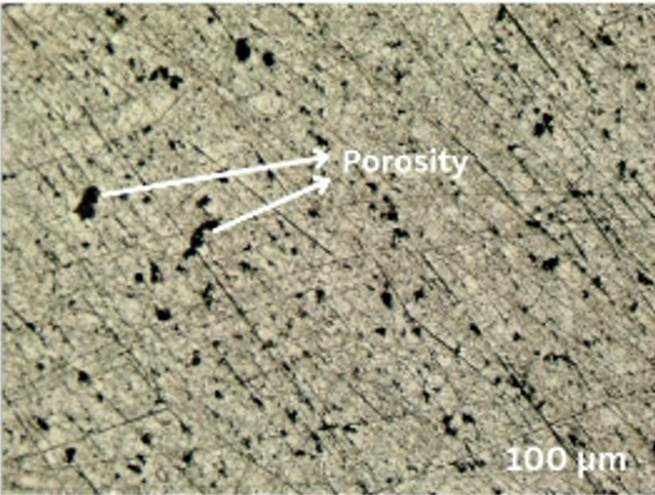
(a)
(b)
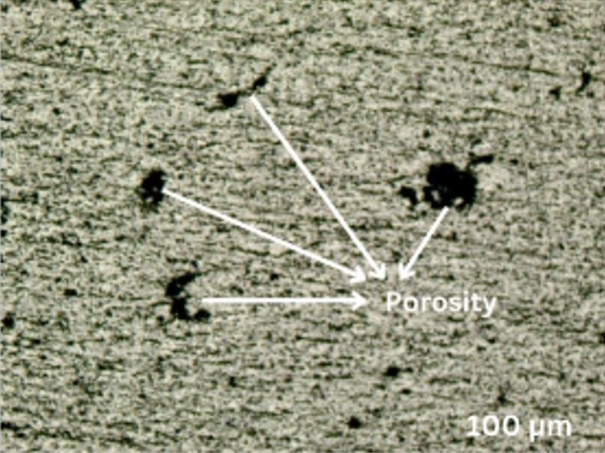
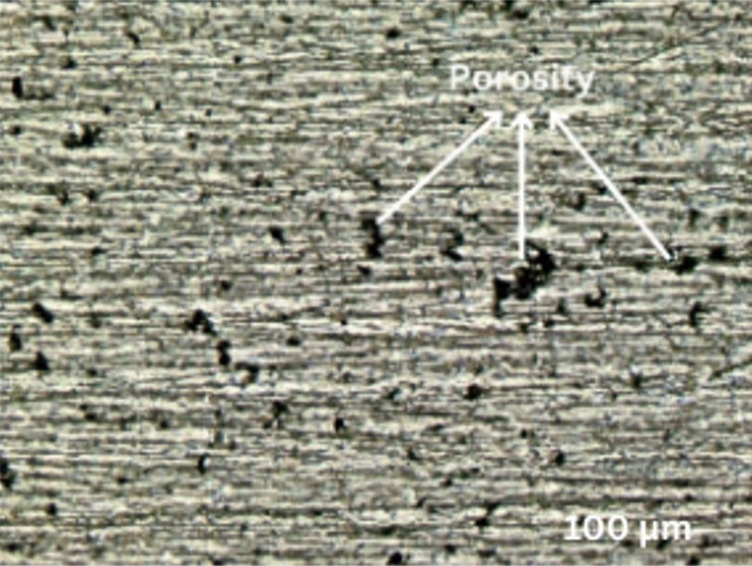
(c)
(d)
Fig.7 Optical Micrographs of AA6061 reinforced with MgO (a) 0% (b) 1% (c) 2% (d) 5%

Density and porosity
The study focused into how various composition of MgO affected the apparent porosity of Al reinforced with MgO. Starting with 0% MgO, the material obtained a porosity of 14.0792%. Adding 1% MgO resulted in a substantial decrease in porosity to 13.8024%, indicating a denser material structure, most likely due to enhanced particle packing [6]. At 2% MgO, the porosity decreased to 12.8295%, indicating that densification persisted although at a slower rate than with 1% MgO. Adding MgO to 5% resulted in a small drop in porosity to 12.5394%, showing continued densification results. Figure 8 shows the bar chart for porosity result of Al-MgO compositions (Fig. 8).

The bulk density measurements revealed tendencies across different MgO compositions. Initially, the sample without MgO had a baseline density of 2.0492 g/cm³, serving as a reference. Adding 1% MgO resulted in a minor rise in bulk density to 2.1226 g/cm³, indicating a slight densification effect. At 2% MgO, the bulk density increased to 2.1337 g/cm³, indicating a consistent trend of density enhancement with increasing MgO content. This unanticipated increase could be attributable to variables such as enhanced particle packing efficiency or changes in the microstructure caused by MgO addition [7]. Adding 5% MgO increased bulk density to 2.1531 g/cm³, suggesting a consistent impact. These findings show MgO's potential as a densification factor in material processing. Fig. 9 shows the bar chart for the density result of Al-MgO compositions.

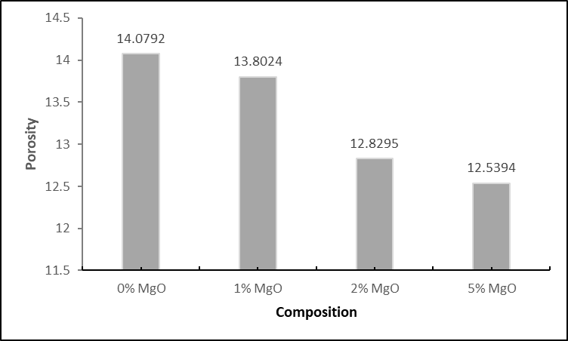
Fig.8 Bar chart for porosity result of Al-MgO compositions
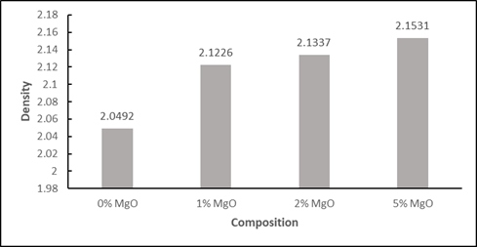
Fig.9 Bar chart for density result of Al-MgO compositions

Element Analysis
Fig.10 illustrates the EDAX pattern for AA6061 reinforced with MgO (a) 0% (b) 1% (c) 2% (d) 5%. The EDAX pattern in Fig.10 (b), (c), (d) confirms the presence of magnesium oxide particle
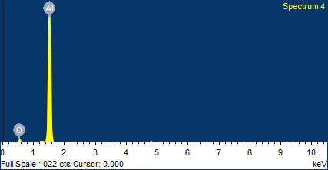
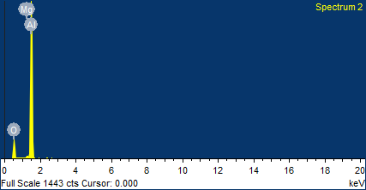

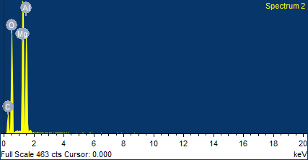
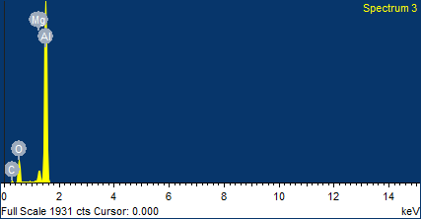
Fig.10 EDAX pattern for AA7068 reinforced with MgO (a) 0% (b) 1% (c) 2% (d) 5%

Fig. 11 shows that the amount of MgO arise from 0% to 5%, the particle uniformity and mixing improve significantly. With 0% MgO, the particles are loosely packed and unevenly dispersed, with a range of sizes and forms. Adding 1% MgO improves mixing, giving a slightly more uniform dispersion. At 2% MgO, the particles integrate better, resulting in a more uniform material structure. Finally, at 5% MgO, the material has the most homogeneous distribution, with evenly sized particles and extensive mixing, indicating that the MgO has been thoroughly incorporated into the base material.

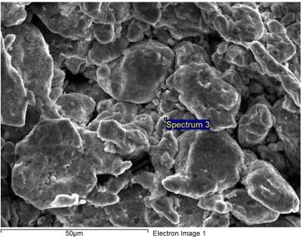
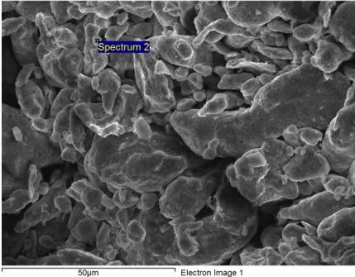
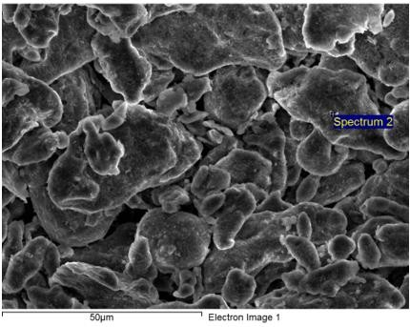
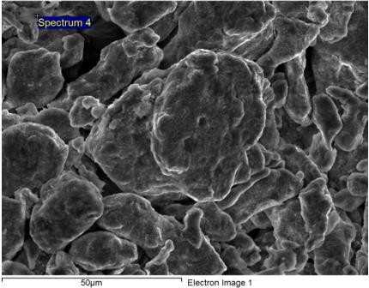
(a)
(b)
(c)
(d)
Fig.11 SEM microstructure for AA7068 reinforced with MgO (a) 0% (b) 1% (c) 2% (d) 5%

3.4 Hardness Test
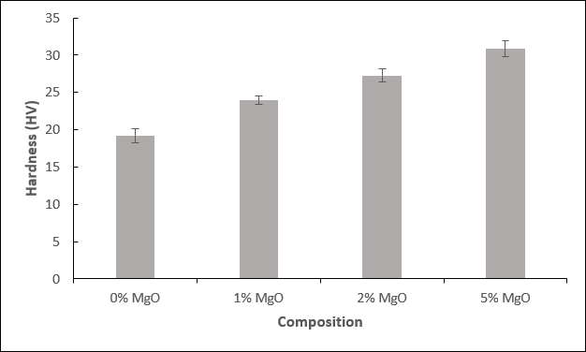
The hardness test was conducted using Vickers microhardness tester. The hardness value of AA6061/MgO composites is given in Fig 12. The hardness test results for different MgO compositions in the material showed a clear upward trend as the MgO percentage increased. At 0% MgO, the baseline hardness was 19.24, which served as a reference point for the material without MgO addition. Adding 1% MgO to the material composition resulted in a considerable increase in hardness to 23.96, demonstrating that even a modest amount of MgO can significantly improve the material's hardness. Further raising the MgO level to 2% resulted in a continuous increase in hardness, reaching 27.27, suggesting a proportionate link between MgO content and material hardness. The sample with 5% MgO had its highest mean hardness value (30.86), indicating that MgO has a major reinforcing effect on the material's hardness. Overall, the findings show that adding MgO considerably increases the material's hardness. The pattern indicates that as the MgO fraction grows, the material becomes tougher, most likely because to the enhanced bonding and structural stability provided by MgO.
Fig.12 Hardness value of each composition.

Compressive Strength Test
The study focused on how various composition of MgO affect the compression strength of Al-MgO reinforcement. Initially, with 0% MgO, the material achieved a compression strength of 18.7083MPa, which served as a starting point. Next, by adding 1% MgO, the value of compression strength increased to 20.301MPa, suggesting that it enhanced the material's ability to withstand compressive forces. This increase shows that MgO leads to strengthen bonding or structural reinforcement contained within the material. At 2% MgO, the compression strength increased significantly to 25.0978MPa, indicating a strong strengthening effect. Increasing MgO to 5% enhanced compression strength to 29.0835MPa, nevertheless at a slower rate than at lower concentrations. These findings highlight the MgO's crucial role in improving the material's compressive properties. Understanding these effects is critical for adjusting MgO content to get the necessary material strength and performance in a variety of practical applications [8]. Fig. 13 shows the bar chart for compression results of Al-MgO compositions.

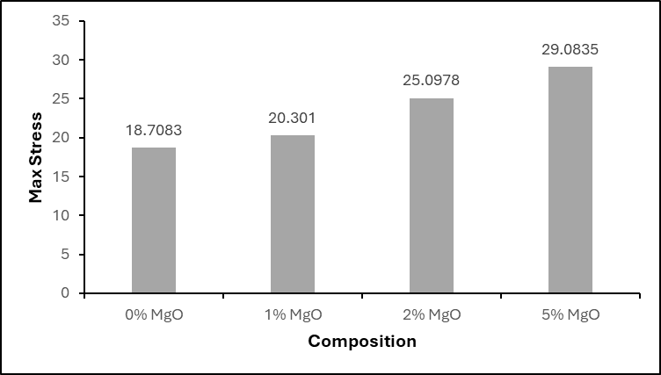
Fig.13 Bar chart for compression result of Al-MgO composition.

- Conclusion
In this research, the reinforcement between AA6061 and MgO has been successfully developed by powder metallurgy. Percent of porosity shows that AA6061 reinforcement with 0% MgO has the highest while AA6061 reinforcement with 5% MgO has the lowest percent of porosity. AA6061 reinforcement with 5% MgO has the highest density while AA6061 with 0% of MgO has the lowest density. Hardness result shows that AA6061 reinforces with 5% MgO has the highest value while AA6061 reinforces with 0% MgO has the lowest value. The compression test shows that AA6061 reinforces with 5% MgO has the highest value while AA6061 reinforces with 0% MgO has the lowest.

Acknowledgement
The author would like to express their deepest appreciation through monetary assistance by University Tun Hussein Onn Malaysia and the UTHM Publisher’s Office via Publication Fund E15216. The authors would also like to thank the Faculty of Mechanical Engineering and Manufacturing Engineering, University Tun Hussein Onn Malaysia for their support.

Conflict of Interest
Authors declare that there is no conflict of interests regarding the publication of the paper.

Author Contribution
This study was conceived and designated by [Muhammad Shazerin Farhan Bin Azmi] who also performed the research and experimental process. [Dr. Raudhah Othman @ Mustafa] contributed significantly to the interpretation of the results and provided critical revisions.

References
- A. George, M. R. Sanjay, R. Srisuk, J. Parameswaranpillai, and S. Siengchin, “A comprehensive review on chemical properties and applications of biopolymers and their composites,” International Journal of Biological Macromolecules, vol. 154, pp. 329–338, Jul. 2020, doi: 10.1016/j.ijbiomac.2020.03.120

- V. Chak, H. Chattopadhyay, and T. L. Dora, “A review on fabrication methods, reinforcements and
mechanical properties of aluminum matrix composites,” Journal of Manufacturing Processes, vol. 56, pp.
1059–1074, Aug. 2020, doi: 10.1016/j.jmapro.2020.05.042.

- P. Samal, P. R. Vundavilli, A. Meher, and M. M. Mahapatra, “Recent progress in aluminum metal matrix composites: A review on processing, mechanical and wear properties,” Journal of Manufacturing Processes, vol. 59, pp. 131–152, Nov. 2020, doi: 10.1016/j.jmapro.2020.09.010.

- J. Binner et al., “Selection, processing, properties and applications of ultra-high temperature ceramic matrix composites, UHTCMCs – a review,” International Materials Reviews, vol. 65, no. 7, pp. 389–444, Sep. 2019, doi: 10.1080/09506608.2019.1652006.

- M. Shukla, S. K. Dhakad, P. Agarwal, and M. K. Pradhan, “Characteristic behaviour of aluminium metal matrix composites: A review,” Materials Today: Proceedings, vol. 5, no. 2, pp. 5830–5836, 2018, doi: 10.1016/j.matpr.2017.12.180.

- C. Burmeister, L. Titscher, S. Breitung-Faes, and A. Kwade, “Dry grinding in planetary ball mills: Evaluation of a stressing model,” Advanced Powder Technology, vol. 29, no. 1, pp. 191–201, Jan. 2018, doi: 10.1016/j.apt.2017.11.001.

- P. L. Guzzo, F. B. Marinho de Barros, B. R. Soares, and J. B. Santos, “Evaluation of particle size reduction and agglomeration in dry grinding of natural quartz in a planetary ball mill,” Powder Technology, vol. 368, pp. 149–159, May 2020, doi: 10.1016/j.powtec.2020.04.052.

- S. N. A. Safri, M. T. H. Sultan, M. Jawaid, and K. Jayakrishna, “Impact behaviour of hybrid composites for structural applications: A review,” Composites Part B: Engineering, vol. 133, pp. 112–121, Jan. 2018, doi: 10.1016/j.compositesb.2017.09.008.

