Design of Ditch Cleaning Machine
Gerard Benedict Anak Chupak¹, Hj. Mohd Azwir Bin Azlan^{1*}
Faculty of Mechanical and Manufacturing Engineering,
Universiti Tun Hussein Onn Malaysia, Parit Raja, Batu Pahat, 86400, MALAYSIA

*Corresponding Author: azwir@uthm.edu.my
DOI: https://doi.org/10.30880/rpmme.2024.00.00.000
Article Info | Abstract
Received: 29 October 2024  Accepted: 20 November 2024  Available online: 01 December 2024 | The Design of Ditch Cleaning Machine project focuses on innovating a compact, efficient apparatus to maintain ditches crucial for managing water flow and preventing flooding. This initiative responds to the significant roles ditches play in safeguarding property, infrastructure, and agricultural productivity from waterlogging and disease spread. By following the structured George E. Dieter design process [1], including conceptual, embodiment, and detail design phases, the project aims to enhance existing technology for Malaysian conditions. Incorporating techniques like brainstorming and simulation, the project aims to optimize the machine's capability to clear aquatic vegetation and solid debris effectively. Simulation results demonstrate promising outcomes, with the machine weighing less than 80 kg and efficiently cleaning a 2000 m² area in just 2 hours. Ultimately, this effort seeks to advance environmental conservation and meet the diverse needs of ditch maintenance across Malaysia.
Keywords
Ditches Cleaning Machine, George E. Dieter design process, SolidWorks, Drainage maintenance.
- Introduction
Ditches play a crucial role in Malaysia, serving to remove excess water from the land surface to prevent flooding, waterlogging, and their associated damages to property, infrastructure, and health. The Department of Irrigation and Drainage (DID) holds the primary responsibility for designing, constructing, and maintaining these drainage systems, as well as educating the public on their importance[2]. The significance of efficient drainage extends beyond urban planning to agriculture, where proper water management is essential for crop health and yield. Given that 85% of marine debris originates from land-based activities, effective ditch management is imperative to mitigate the adverse effects of land degradation and flooding [3], [4].
In Malaysia, various types of ditches, such as open drains, covered drains, culverts, and storm drains, each serve specific functions in urban and rural areas. However, manual and mechanical cleaning methods present challenges, including labor intensity, environmental impact, and high costs. The presence of invasive aquatic plants further complicates maintenance, highlighting the need for improved technology and practices [5].
The project aims to address the challenges associated with manual and mechanical methods of cleaning ditches. Manual cleaning is labor-intensive, potentially dangerous, and time-consuming, especially in large areas, deep ditches, or unstable soil conditions. Workers may encounter wild animals, and manual cleaning can also damage the ditch banks and surrounding environment. On the other hand, mechanical cleaning, while more efficient, can be expensive, disruptive to traffic and other activities, and can also have negative environmental impacts such as damaging the ditch banks and surrounding areas. Therefore, the objective of the project is to design more effective and efficient ditch cleaning equipment that can overcome these challenges and provide a sustainable solution for maintaining proper drainage systems and preventing flooding and erosion. Fig. 1 shows the ditch with underwater vegetation.
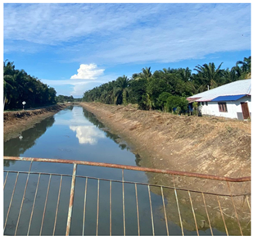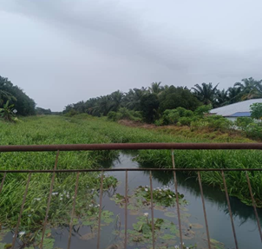
Fig. 1 Ditch before and after fully grown aquatic vegetation

Ditch cleaning machines play a vital role in various applications by ensuring proper drainage, preventing flooding, and maintaining road safety. They are essential in agriculture settings to prevent waterlogging, soil saturation, and damage to plant roots. In urban areas, these machines manage stormwater runoff and prevent flooding by maintaining clear ditches. Additionally, they are crucial for road safety to prevent accidents caused by obscured visibility.
Studies on ditch cleaning machines have explored their effectiveness in removing sediments, debris, and vegetation[6][7][8], leading to the development of innovative technologies like robotic systems and autonomous vehicles for enhanced cleaning efficiency. Research encompasses various patents presenting diverse designs and structures, each featuring unique operating mechanisms for debris collection and grass cutting[9][10][11], thereby optimizing the maintenance of ditches through advanced engineering solutions.
Research on currently available products is crucial for driving innovation and improving existing designs. An example is the WaterShark, a lake weed cutting machine engineered for exceptional performance, combining power, speed, and precision in a lightweight, battery-powered package. This emphasis on high performance and efficiency highlights the potential for advancements in similar technologies through ongoing research and development. Table 1 shows the benchmarking of the available product on the market.
Table 1 Benchmarking
Product | Figure | Power Source | Weight (lbs) | Cutting Depth | Operating Method | Price (RM) | Features
Weed cutting machine | 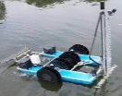 | Battery | 250 | 5 feet | Remote | 55,849.35 | Live camera, auto depth feature
Vegetation Groomer | 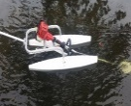 | Petrol engine | 25 | 4 feet | Manual | 2,792.47 | Depth adjuster
Gas Weed Cutter | 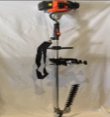 | Petrol engine | 18 | 4.5 feet | Manual | 2,462.23 | Adjustable, boat attachment
WaterBug | 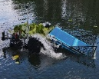 | Battery | 375 | 2 feet | Remote | 73,071 | 3 in 1 function, 500 feet range
Water Cleaning Boat | 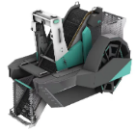 | Battery | 2425 | 10 – 60 cm | Remote | 139,635 | 24/7 autonomous operation, water quality monitoring

- Methodology
Designing ditch cleaning machines follows a structured approach that integrates the various stages of the design process. Initially, a thorough review of literature is conducted to establish a solid understanding of ditch cleaning practices and associated challenges. Subsequently, the research design phase involves collecting survey data from stakeholders involved in ditch maintenance to gain insights into current practices and the necessary features for effective cleaning equipment. The application of the George E. Dieter design process guides the subsequent phases, including conceptual design, embodiment design, and detail design[1].
Within the conceptual design phase, activities such as problem definition, information gathering, concept generation, and evaluation are carried out to outline the initial design concepts for the ditch cleaning machine. The embodiment design phase further refines the design through activities like product architecture, configuration design, and parametric design. In parametric design, specific attributes of components, such as dimensions, tolerances, materials, or finishes, are identified as design variables that can be adjusted to achieve desired outcomes. These design variables are under the control of the designer and can be manipulated to explore different design options, optimize performance, and meet specified criteria.
The final stage, detail design, focuses on specifying the design details and finalizing the product design. Throughout these stages, prototype development, evaluation, and testing are conducted to ensure the functionality, efficiency, and user-friendliness of the ditch cleaning machine. Analysis of survey data, prototype testing outcomes, and user feedback will inform the reporting and documentation of the methodology, findings, and recommendations for future research and development. This structured methodology aims to provide a comprehensive understanding of the design process and offer innovative solutions to enhance ditch cleaning practices and support environmental conservation efforts. Fig. 2 shows the Design Process Flow Chart based on George E. Dieter design process.
Fig. 2 Design Process Flow Chart

- Results and Discussion
  - Design Process
In the design process outlined in the report on the development of ditch cleaning machines, several key activities were undertaken to ensure the successful creation of an effective and innovative product. A comprehensive literature review was conducted to gain insights into existing ditch cleaning practices, challenges, and available technologies, providing a foundational understanding of the subject matter. Surveys were also conducted to gather information from contractors and drainage maintenance professionals involved in ditch maintenance, aligning the design process with the needs and expectations of the target customers. Fig. 3 shows the survey data.
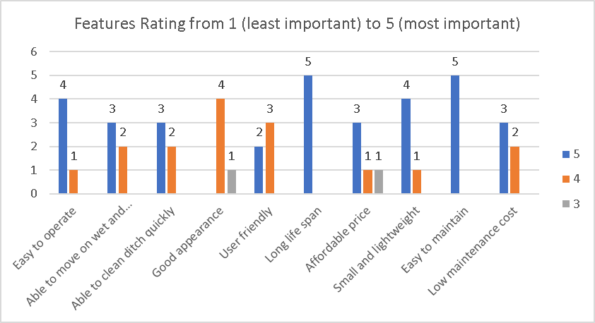
Fig. 3 Google Form Survey Data
  - Problem Definition
The objective tree in Fig. 4, based on Part 3 survey results, clearly represents product requirements. For clarity, customer requirement categories and levels are labeled "B" to "G" for clarity. Fig. 4 shows the objective tree of the ditch cleaning machine.
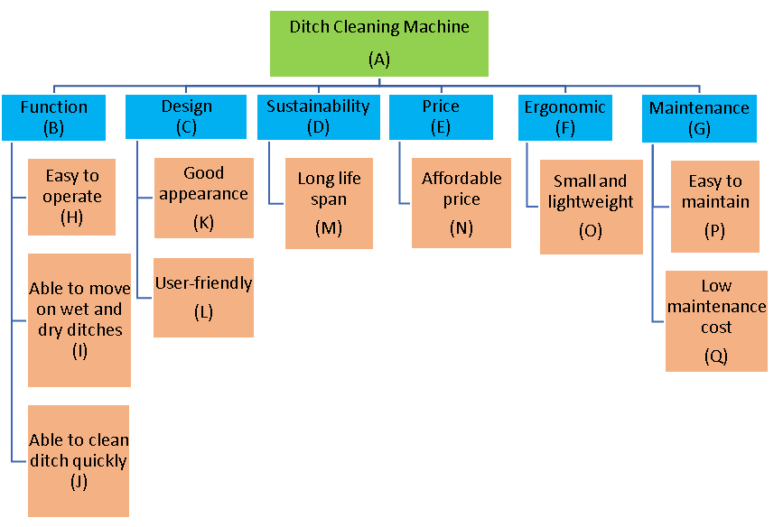
Fig. 4 Objective Tree

The product design specification (PDS) is developed during the design planning phase of the product development process. Using the survey and HOQ results, the PDS guides designers and developers in creating the final product. Table 2 shows the PDS for the Ditch Cleaning Machine. Table 2 shows the product design specifications.

Table 2 Product Design Specifications (PDS)
Introduction
Title | Ditch Cleaning Machine
Design problem | Design a ditch cleaning equipment or machine that is capable of cleaning both dry and wet ditches
Intended purpose | To remove and collect solid debris and aquatic vegetation quickly
Target customer | Contractors that deal with drainage maintenance
Special features | Able to control remotely from a distance
Customer Requirement
Functional Performance | - The machine should weigh below 150 kg  - The time taken to clean a ditch must be less than 4 hours in 2000 $m^{2}$  - The machine is able to move on water and dry surface
Operating Environment | - Suitable for any type of ditches
Price | - The price must be less than RM 30,000  - Low maintenance cost
Sustainable | - Anti-corrosion  - Longer life span
Appearance | - The appearance should be attractive in terms of shape and design
Maintenance, Repair, Retirement | - The parts should be easy to assemble and disassemble for cleaning and maintenance
Reliability, Robustness | - All parts and components should have high resistance of corrosion.  - The machine should withstand more than 4 hours per day
Ergonomics | - User friendly  - Easy to use and operate the machine

  - Concept Generation
In the design phase of ditch cleaning machines, designers utilize brainstorming, decomposition techniques, and morphological charts to efficiently generate and evaluate ideas. This process involves breaking down the product into its constituent parts, exploring design options for components, and creating visual representations to assess potential combinations. Concept maps facilitate brainstorming sessions, while morphological charts streamline the evaluation of design alternatives, aiding in selecting optimal concepts for further development. Fig. 5 below shows the function structure of the Ditch Cleaning Machine.

Fig.5 Function Structure

By employing these structured approaches, engineers can effectively analyze the performance of key components through evaluation and simulation. This enables them to make informed decisions regarding the most viable design concepts, ensuring the development of efficient and reliable ditch cleaning machines.
  - Concept Evaluation
In the design phase of ditch cleaning machines, designers use tools like morphological charts and weighted decision matrices to efficiently evaluate and select the best concepts. By consulting morphological charts, designers generate alternative combinations for key functions. The weighted rating method is then applied to assess how well each idea meets design requirements, leading to the identification of optimal design solutions. Table 3 shows the weighted rating method.
Table 3 Weighted Rating Method
Rating scale |  | 1  Unsatisfied | 2 |  | 3 |  | 4 |  | 5  Satisfied
No. | Customer Requirement |  |  | Weightage | Combination
No. |  |  |  | Weightage | 1 |  |  | 2
No. |  |  |  | Weightage | Rating | Weightage Rating |  | Rating |  | Weightage Rating
1. | Easy to operate |  |  | 0.098 | 5 | 0.490 |  | 5 |  | 0.490
2. | Able to move on dry and water surface |  |  | 0.094 | 4 | 0.376 |  | 5 |  | 0.470
3. | Able to clean ditch quickly |  |  | 0.094 | 4 | 0.376 |  | 5 |  | 0.470
4. | Good appearance |  |  | 0.088 | 4 | 0.352 |  | 4 |  | 0.352
5. | User friendly |  |  | 0.102 | 4 | 0.408 |  | 5 |  | 0.510
6. | Long life span |  |  | 0.114 | 3 | 0.342 |  | 4 |  | 0.456
7. | Affordable price |  |  | 0.219 | 4 | 0.876 |  | 4 |  | 0.876
8. | Small and lightweight |  |  | 0.067 | 4 | 0.268 |  | 4 |  | 0.268
9. | Easy to maintain |  |  | 0.065 | 3 | 0.195 |  | 5 |  | 0.325
10. | Low maintenance cost |  |  | 0.059 | 4 | 0.236 |  | 4 |  | 0.236
Total |  |  |  | 1 |  | 3.919 |  |  |  | 4.453

Following the evaluation process, designers create product sketches based on the selected combinations to visualize the final design. These sketches provide a rough assembly of chosen components, aiding in developing detailed designs using tools like SolidWorks. Through this iterative process of evaluation and visualization, engineers refine and finalize the design of ditch-cleaning machines for optimal performance and functionality.
  - Modelling
Modeling in engineering design, particularly through 3D modeling software like SolidWorks, plays a pivotal role in visualizing, analyzing, and optimizing the design of the ditch cleaning machine. By creating detailed representations of the machine's components and systems, engineers can realistically visualize its geometry, functionality, and assembly configurations, enabling precise analysis of structural integrity and mechanical interactions. Through optimization of design parameters such as blade configurations and mobility, modeling enhances the machine's productivity and performance in clearing various types of ditches. Integrated into the design process from conceptual design to detail design, modeling ensures that the final product meets the intended specifications and customer requirements, ultimately developing an innovative and efficient machine for maintaining water drainage systems.
  - Cutting Mechanism
The hedge trimmer is a critical component of the ditch cleaning machine designed to cut and trim aquatic vegetation in ditches. The hedge trimmer blade, typically made from high-carbon steel for durability and sharpness, efficiently cuts through grass and foliage. It often features dual-action configurations, moving in opposite directions to reduce vibration and ensure clean cuts. Safety features are incorporated to make the hedge trimmer user-friendly for ditch-cleaning tasks. The Scotch and Yoke mechanism within the hedge trimmer converts rotary motion into reciprocating motion for precise vegetation-cutting. This mechanism enhances cutting performance and functionality, contributing to the overall effectiveness of the ditches cleaning machine in maintaining proper water flow and preventing blockages. Fig. 6 below shows the 3D modeling of the hedge trimmer and scotch yoke mechanism.

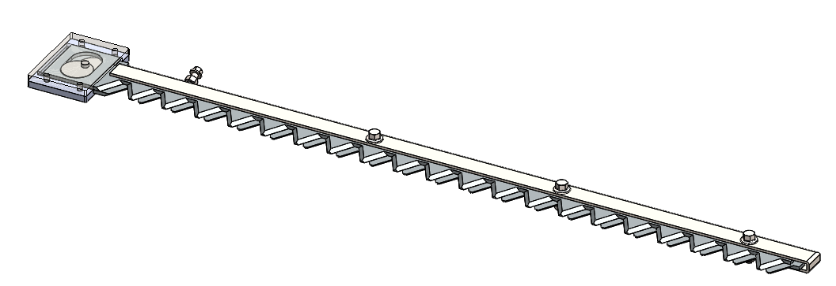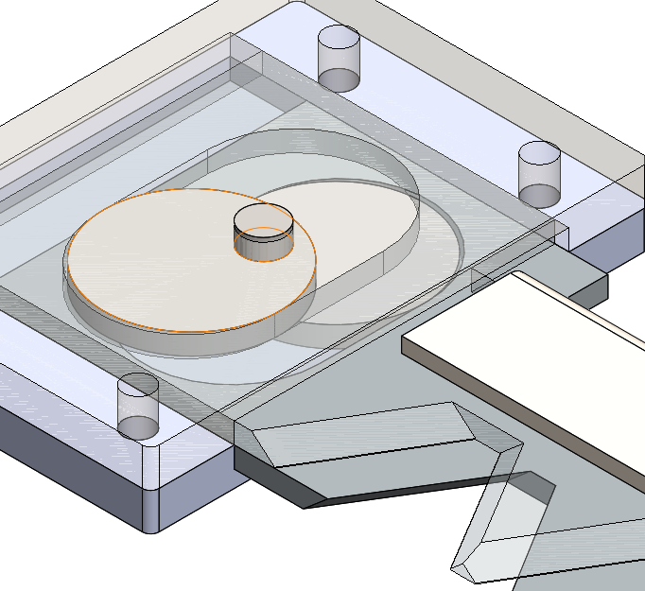
Fig. 6 Hedge Trimmer and Scotch Yoke Mechanism
  - Collecting Mechanism
The conveyor system in the design of the ditch cleaning machine is an essential component that works in conjunction with the hedge trimmer to ensure efficient cleaning of ditches. The conveyor's role is to collect and transport trimmed vegetation and solid debris, significantly maintaining proper water flow in the ditches and preventing blockages. Without the conveyor system, the effectiveness of the ditches cleaning machine in clearing debris and maintaining the ditches would be compromised. The conveyor system ensures a thorough and effective cleaning process by efficiently collecting and transporting the trimmed vegetation and debris. This component is crucial for the overall functionality of the ditches cleaning machine, working in tandem with other elements to keep the ditches clear and free from obstructions. Fig. 7 shows the 3D modeling of the conveyor.
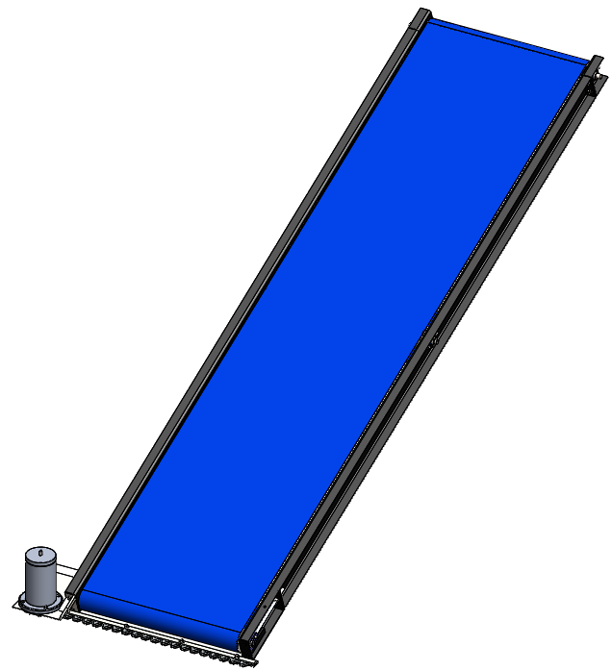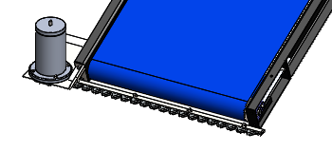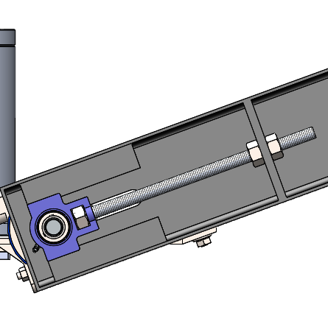
Fig. 7 Conveyor
  - Maneuverability
The chain wheel facilitates power transmission from the power source motor to the machine's wheels. This component plays a crucial part in converting the rotational motion generated by the power source into linear motion, enabling the movement of the machine on the ground. Additionally, an independent motor for turning is incorporated into the chain wheel system to provide the necessary rotational motion for effectively steering and maneuvering the machine. By efficiently transferring power to the wheels and steering mechanism, the chain wheel ensures smooth operation and mobility of the ditch cleaning machine during cleaning and maintenance tasks. Without the chain wheel component, the functionality and maneuverability of the machine would be significantly impaired, highlighting its importance in the overall design and operation of the equipment. Fig. 8 shows the 3D model of the chain wheel and motor assembly.
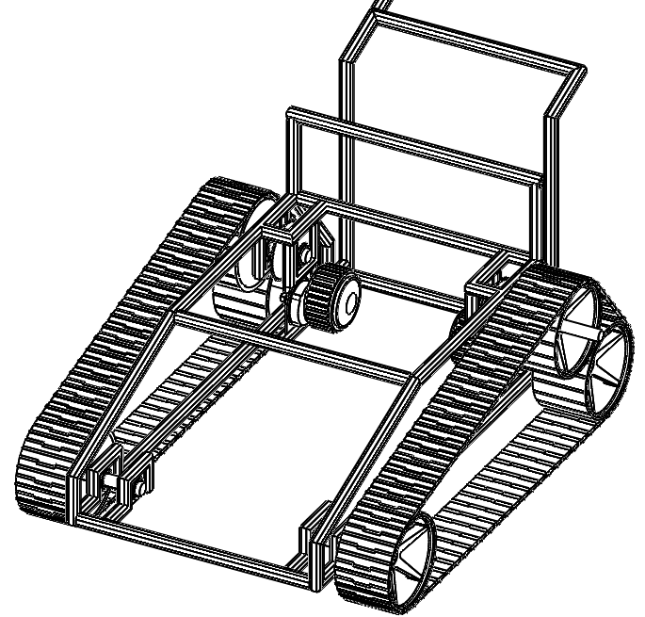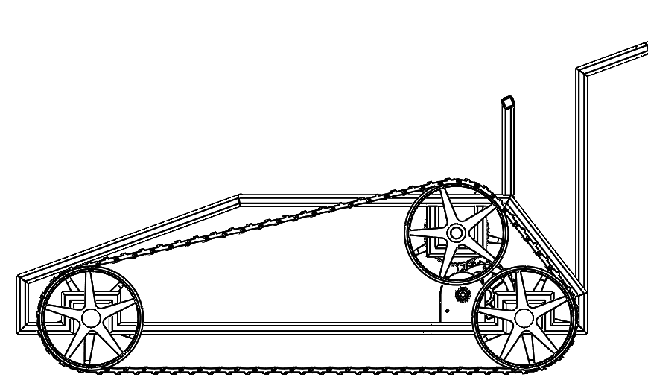
Fig. 8 Chain Wheel with Motor Assembly

  - Full Assembly of the Ditch Cleaning Machine
The full product has been assembled completely in SolidWorks, and the full assembly of the Ditch Cleaning Machine can be seen in Fig. 9 and Fig. 10 below.
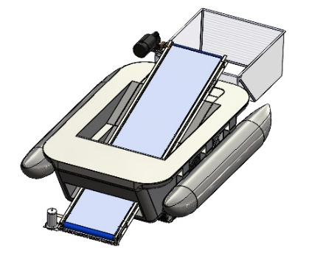
Fig. 9 Full Assembly (Isometric View)
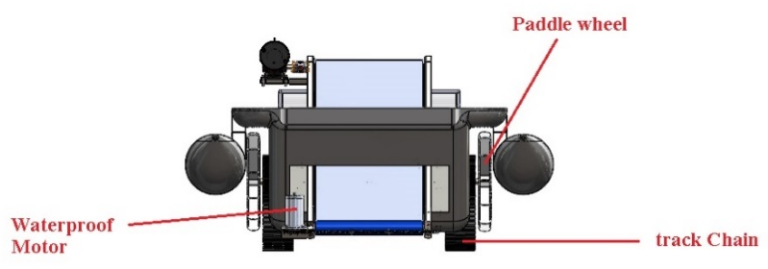
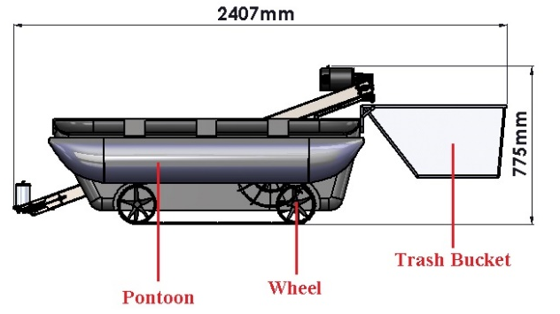
Fig. 10 Full Assembly (Front View and Side View)
  - Chain Torque Analysis
Chain torque analysis is a crucial evaluation process in the design of chain-driven systems. Chain torque analysis focuses on calculating and distributing torque along the chain to ensure efficient power transmission. This analysis involves determining torque requirements, considering load, friction, and acceleration factors, and assessing torque distribution from the motor to the wheels. By analyzing torque limitations and system efficiency, designers can optimize the chain drive design to handle maximum torque effectively, minimize losses, and ensure smooth operation and reliability of the ditch cleaning machine during its maintenance and cleaning tasks. Fig. 11 shows the free-body diagram of the analysis.
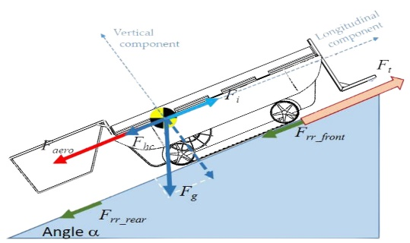
Fig. 11 Free Body Diagram
Calculate the total force with the formula,
F_{T} | = F_{rr} + F_{g} sin θ + ma (1)  = [µF_{g} sin θ] + F_{g} sin θ + ma  = [(0.6) (90 x 9.81) sin (45)] + (90 x 9.81) sin (45) + (90) (0.75)  = 1066.39 N
Now, calculate the required power of the motor,
P_{req} | = F_{t}·V 2)  = (1066.39) (0.75)  = 888.66 watt (Required power)
Assume 2 motors will be used in the design. So, each motor will be half of the weight.
T_{req} | = F_{t}·r (3)  = $\frac{1066.39}{2}$ (0.0928)  = 49.48 Nm (required torque)
ω | = $\frac{P_{req}}{T_{req}}$= $\frac{444.33}{49.48}$= 8.98 rad/s
ω  N | = $\frac{2πN}{60}$  = $\frac{\left(8.98\right)\left(60\right)}{2π}$  = 85.75 RPM
The gear ratio is calculated based on torque and speed
M_{G} | = $\frac{T_{req}}{T_{m }}$= $\frac{49.48}{11}$ = 4.50 (4)
M_{G} | = $\frac{ƞ_{m}}{ƞ_{req}}$= $\frac{395}{86.8}$= 4.55
The gear ratio is 4.5:1. Therefore, the number of teeth for small gear is 10 while 45 teeth for big gear.

  - Buoyancy Analysis
Buoyancy analysis is a critical process in the design of floating structures like pontoons in the ditch cleaning machine, focusing on assessing the ability of the structure to float and maintain stability in water. This analysis involves calculating the buoyant force acting on the pontoon based on its dimensions, weight, and the density of the surrounding water. By comparing the buoyant force to the pontoon's weight and the equipment it supports, designers can determine if it will float effectively and support the machine's weight without sinking or losing balance. Buoyancy analysis also considers factors such as weight distribution, center of gravity, and stability to ensure that the pontoon design enables the machine to navigate through ditches and water bodies efficiently while preventing tipping over or instability during operation.

Assume the total weight of the machine is 90kg to maximize the possibility of the machine to float.
ƩF  -F_{W} + F_{B}  -mg + pVg  -(75) (9.81) + (1000) (9.81) V  V | = 0  = 0  = 0  = 0  = 0.09 m³

Two pontoons will be used in the design. So, each pontoon will be half of the volume.
V | = 0.09 m³ / 2  = 0.045 m³
So, each pontoon requires 0.045 m³ of volume to float the machine as shown in Fig. 12.
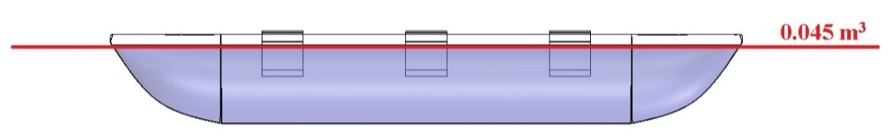
Fig. 12 Total Volume Required to Float
  - Time Taken to Clean 2000m² Area Ditch
This part focuses on how long it takes to clean a ditch with a 2000 m² area to prove that the design of the ditch cleaning machine can trim the vegetation in under 4 hours. It is one of the customer’s requirements for the functional performance of the machine. Fig. 13 highlights Parit Samion Ditches.
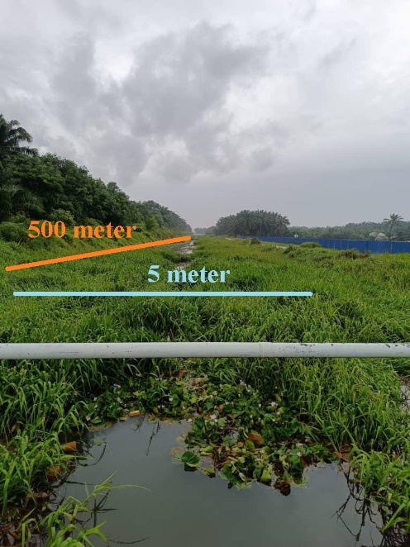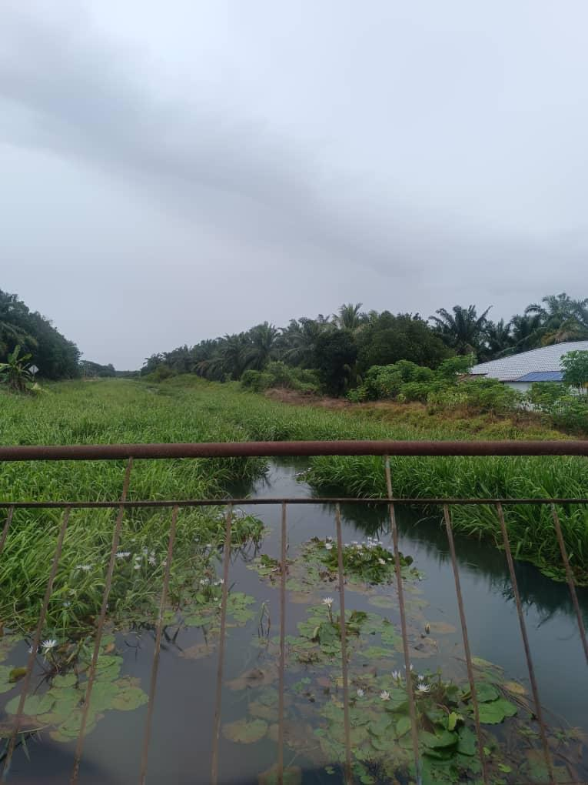
Fig. 13 Parit Samion Ditches
Blade length – 0.47 m
Velocity – 0.75 m/s (targeted speed on dry land)
Ditch area – 400m (length) x 5m (width) (as visualized in Figure 4.40)
Fig. 14 indicates the length of the cutting area.
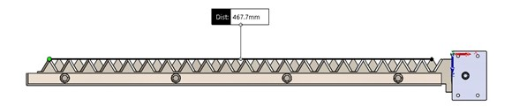
Fig. 14 Length of Cutting Area
Calculate the number of passes required
No. of passes | = length of blade/width of ditch  = 5/0.47  = 10.64
Since the number of passes must be in whole number, therefore, the number of passes is 11. Calculate the total distance covered
Total distance | = no. of passes x the length of ditch  = 11 x 400 m  = 4400 m
The total time taken
Time taken | = total distance/velocity  = 4400/0.75 m/s  = 5866.67 seconds
Convert seconds to hour
T_{hr} | = 5866.67/3600  = 1.63 hours
Therefore, the total time take to clean 2000m² area ditch take 1.63 hours.
  - Total Machine Runtime
Machine runtime is crucial for evaluating a machine's efficiency, productivity, and performance. For a specific requirement, the machine must complete a 2000 m² cycle in under 4 hours. Monitoring runtime helps in assessing utilization, planning maintenance, optimizing schedules, and managing costs. It aids in scheduling preventive maintenance, predicting component wear, and ensuring the machine operates within its limits to extend its lifespan. Analyzing runtime data also provides insights into production trends, energy use, and equipment effectiveness, enabling better decision-making to boost efficiency and productivity.
Cytron motor  Trimmer motor  Conveyor motor  Other electronic devices  (receiver, controller, etc.)  Battery capacity | - 636 W /unit x 2 motors = 1272 W  - 160 W  - 353 W  - 178.5 W (assumed 10% of total power)  - 2560 Wh /unit x 2 units = 5120 Wh
Total power | - 1963.5 W

Calculate the machine runtime
Runtime | = | Battery capacity |  | x Efficiency (5)
Runtime | = | Total power |  | x Efficiency (5)
 | = | 5120 | (0.9)
 | = | 1963.5
 | = | 2.35 hours

Therefore, the total machine runtime will be 2.35 hours

  - Product Specifications
Product specifications, or Product Design Specifications (PDS), are a critical component of the design process, outlining detailed requirements such as functional and technical aspects, performance criteria, quality standards, and cost constraints. These specifications serve as a roadmap for engineers and designers, guiding them in developing a product that meets user needs, aligns with industry standards, and is cost-effective to manufacture. By clearly defining product specifications, designers can ensure that the final product is designed and built to meet the desired functionality, performance, and quality standards, ultimately leading to a successful and market-ready product. Table 4 shows the product specifications of the machine.
Table 4 Product Specifications of Ditch Cleaning Machine
Detail | Product Specifications
Capability | Able to trim grass under 2 hours with an area 0f 2000m² on dry surface.
Operatable Runtime | 2.35 hours
Weight | 83.11 kg
Wheel Power Output | 900W (2 motors)
Trash Capacity | 6.1 kg
Dimension (m) | 2.41 (L) x 1.34 (W) x 0.77 (H)
Price | RM 11,757.51

- Conclusion
In conclusion, the Design of Ditch Cleaning Machine highlights the importance of developing innovative solutions to address the challenges associated with manual and mechanical methods of cleaning ditches. By integrating the George E. Dieter design process and conducting a comprehensive literature review, the project aims to create more effective and efficient ditch-cleaning equipment that can overcome labor intensity, environmental impact, and high costs.

Through processes such as concept generation, embodiment design, and detail design, the project focuses on refining the design of the ditch cleaning machine to meet the needs and expectations of customers’ requirements involved in ditch maintenance. Using tools like SolidWorks for modeling is crucial in visualizing, analyzing, and optimizing the design to ensure optimal performance and functionality.

Overall, the structured methodology employed in this project not only aims to enhance ditch cleaning practices but also contributes to environmental conservation efforts and supports sustainable drainage systems. By emphasizing innovation, customer needs alignment and optimization of design parameters; the project sets a foundation for the development of advanced technologies in the field of mechanical and manufacturing engineering for efficient ditch maintenance and infrastructure sustainability.
Acknowledgement
The authors would also appreciate the Faculty of Mechanical and Manufacturing Engineering, Universiti Tun Hussein Onn Malaysia for providing resources for this research.

References
[1] G. E. Dieter and L. C. Schmidt, Engineering design, 5th edition. McGraw-Hill, 2013.
[2] Department of Irrigation and Drainage (DID) Malaysia, “Urban Stormwater Management Manual for Malaysia (Manual Saliran Mesra Alam, MSMA 2nd edition)”, August 2012. ISBN 978-983-9394-24-4
[3] S. H. Fauziah et al., “Marine debris in Malaysia: A review on the pollution intensity and mitigating measures,” Marine Pollution Bulletin, vol. 167. Elsevier Ltd, Jun. 01, 2021. DOI: 10.1016/j.marpolbul.2021.112258.
[4] G. Teshome Nigatu, B. A. Abebe, B. Grum, M. G. Kebedew, and E. M. Semane, “Investigation of Flood incidence causes and mitigation: Case study of Ribb river, northwestern Ethiopia,” Natural Hazards Research, Sep. 2023, DOI: 10.1016/j.nhres.2023.04.009.
[5] S. N. Ismail, L. Subehi, A. Mansor, and M. Mashhor, “IOP Conference Series: Earth and Environmental Science Invasive Aquatic Plant Species of Chenderoh Reservoir, Malaysia and Jatiluhur Reservoir, Indonesia.”, 2019. DOI:10.1088/1755/380/1/2004
[6] Peterson Thomas K. M., “Method and apparatus for removing aquatic plants,” United States Patent, 1989.
[7] Landgraf Scott, “Apparatus and method for removing aquatic vegetation,” United States Patent, Apr. 2019.
[8] Chubb Richard A., “seaweed trimmer,” United States Patent Application Publication, 2010.
[9] Kramer William E., “Device for Removal of Aquatic Vegetation,” 1998.
[10] Cornwell Stephen Brent and Eberlein Alan Frederick, “Aquatic vegetation removal device and method,” Patent Application Publication, 2011.
[11] Amimoto Tomohiko and Takeuchi Shoji, “Aquatic plant cutting apparatus and aquatic plant recovery boat equipped with the apparatus,” United States Patent, 1991.

